East Norwich Regeneration – EIA Opinion screening

Items that should be commented on.
- Flood risk
- Traffic and transportation
- Noise and Vibration
- Air quality
- Landscape and visual impact
- Archaeology and cultural heritage
- Bio-diversity
- Lighting
- Hydrology and water resources
- Ground condition
- Socio-economic factors
- Waste management
- Cumulative environmental effects
- Construction effects on local wildlife/ hedgerows and trees/ bats/ breeding birds and river dwelling wildlife such as otters and newts
- Fragmentation of habitats

The flood risk is an obvious one to start with due to our issues with it in the past.
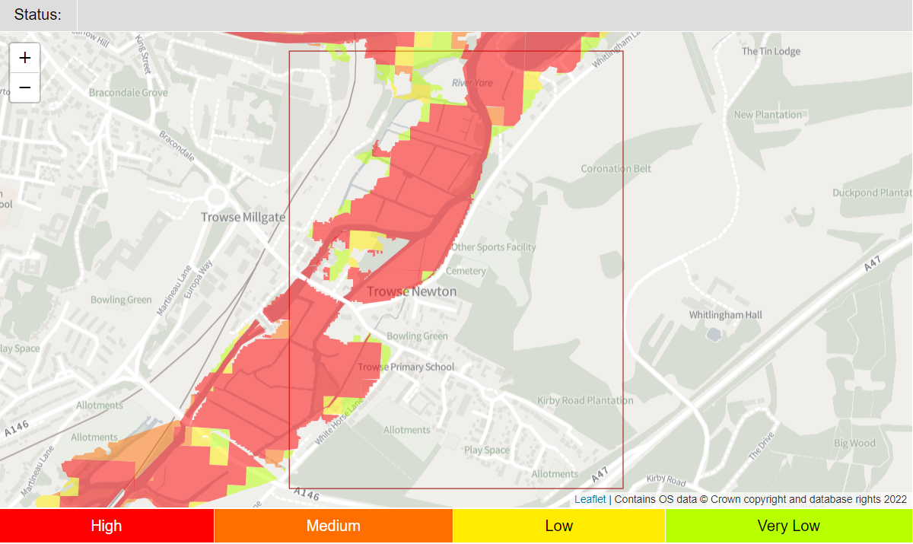
Looking at the map on our Emergency Flood plan there are significant areas of the May Gurney site that will be prone to a high risk of flooding. How this is going to be mitigated needs to be addressed but also the impact further along the flood plain. Is this going to affect the common more, and therefore the housing surrounding it? A real fear is Newton Close/the Cemetery and homes along Whitlingham Lane which could see a significant impact from not only flooding but surface water run off etc.
Flooding not only has an impact of residential dwellings but also wildlife, businesses and transport. Could a lack of mitigation essentially cut the village off in the event of a flood?

Traffic and transportation are another big issue for the village. Trowse is already used as a rat run for cars and lorries, trying to access the Martineau Lane roundabout without having to go via the problematic ring road. Our small rural roads are not built to accommodate the volume and types of traffic we are already seeing. How will developers mitigate this? Obviously, it is not just the quantity of traffic that is problematic, it is the increase in air pollution, noise and road vibration. Many properties in Trowse front very close to the road, namely Russell Terrace/School terrace/Flint Cottages and an increase in traffic and vehicle size will undoubtably increase noise and vibration for them.

Air quality is already a problem for some Trowse residents due to the fumes and smells from TARMAC plant on the river. We are very aware that Trowse as a whole, is a conservation area and detrimental air pollutants due to a large development, both in the construction phase and in habitation are going to be a factor.

Landscape and a visual impact are topics that will be addressed in part by our Neighbourhood Plan. We have some views that we would like to protect, including across the water meadow to the broad and beyond. The visual impact is going to be a major factor for residents that live on Whitlingham Lane. Currently they overlook an open area with lots of trees and light. This may not be the case if a large-scale development is put here. We feel some sympathetic planning needs to be put in place to retain a certain degree of openness for the area.

Archaeology and cultural heritage are big factors for Trowse. As the ordinal model village, set up by the Colman family in 1805 Trowse has a great historical value and a great many historical aspects that need to be preserved and if possible, enhanced by any future development. Again, this is something that is expanded upon in the Neighbourhood Plan but it is worth mentioning that not only do we have a historically important village but also an environmentally important one, by way of the broads. Having an environmentally biodiverse site, so near to the city centre is fairly unique and any development should be assessed in terms of its impact on that.
This links us to Biodiversity
- Implementing Sustainable Drainage Systems (SuDS) which mimic natural processes in managing rainfall through the use of landscape form and vegetation
- Installing roost bricks for bats and designing lighting plans in a bat-friendly way
- Putting in bird nest bricks that provide permanent nest features for declining species such as swifts
- Ensuring boundaries enable hedgehogs to move freely through a housing development.
Trowse Parish Council would like to see wildlife friendly environments and nature rich open spaces incorporated into any developments on the Deal Ground site.
Lighting for the site should also play a factor in considerations towards wildlife, light pollution and aesthetics. Being so close to Whitlingham Broad there is a significant amount of wildlife that will be affected by new light sources. Currently Trowse village is rather dark at night, but this may change if a large development has additional street lighting as well as light from dwellings and businesses. Our main concern would be for the wildlife population on and around the broad. How would any development affect the routine/corridors of bats and other nocturnal animals? Would it have a negative impact on the species, or amount of wildlife in the area? Trowse Parish Council feel that an EIA will help determine the mitigation measures needed on any development of the Deal Ground site.
As with flooding, hydrology and water resources should form part of any site assessment. TPC believes an EIA would aid a better understanding of urbanisation in hydrological terms. There is also the risk of contamination of water courses during the construction phase with potential pollutants such as fuel, and oil an obvious factor. Maybe less obvious is the risk of sedimentation caused by heavy plant operating in the area. It is thought that developers should establish the soil condition and hydrology on a bespoke basis. Local ground conditions, ground water levels and hydrology will establish which SuDS measures are the most appropriate.

The socio-economics of a site have to play a part in the planning phase. Site preparation has direct effects in terms of employment opportunities for local residents and associated spending in the local economy. A change to the amenity value of local resources and effects on PRoW, non-designated public routes and vehicle access should all be considered.

Increased waste will be a bi-product of any development but TPC are keen to ensure that this in no way affects the Broad or local residents. The effects of additional waste on the environment should be assessed to ensure that any mitigation plans are sufficient and in no way detrimental to the environment.

TPC would like to know how plans to mitigate the impact on local wildlife, trees, hedgerows, bats, breeding birds and river dwelling wildlife will be put in place. It is thought that an EIA will help identify the areas that need consideration. The local Neighbourhood Plan has identified the need for wildlife corridors within the parish and TPC would like to see this adopted on any future developments. We would also like to see an EIA for the fragmentation of wildlife habitats and disturbance of species due to increased levels of light.

