District Council Report – December 2022

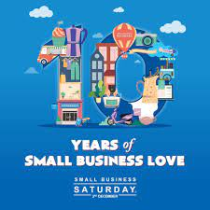
Small Business Saturday was on Saturday the 3rd December, this year we chose to celebrate Coffee Shops and Cafes in our District.
I visited the Kin Café in Hethersett, Soul Café in Harleston and Huggers Bistro in Long Stratton which I can highly recommend for a visit and we advertised these independent businesses on our website and social media.

I attended South Norfolk’s Business Breakfast last week at Barnham Broom Resort, this was a successful networking event with over 50 people attending and we had speakers N﻿eil Foley, founder of Business Growth Club and Director of Norfolk Consultants Limited, highlighting the '10 things you must do right now, to help your business grow', and J﻿ulie Bishop, founder of Jobhop, sharing 'how to take your social media profile to the next level' which was really interesting and hopefully helpful for the businesses in attendance.

We are asking that you all encourage your local residents to engage with voter ID to have the right documentation for next year’s election, which is a form of photographic ID. A list of acceptable ID can be found on our website. Also, if anyone is interested in working the elections for May 2023, please let @emma.hodds@southnofolkandbroadland.gov.uk know.

Our Town and Parish Council Forum’s are becoming more and more successful, which we are really pleased about and hope that you are attending and finding them a real benefit. Our next one is being held on Wednesday the 18th January. If you don’t get an invite for this if you let me know I can get this for you.

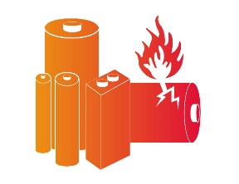
A gentle reminder to everyone regarding batteries, please do not put these in your general waste bin.
We have had a number of small fires at our waste depot and in our waste trucks, which have started from batteries in our black bins, I think people forget how flammable they are. So we ask if you throw away electricals, please remove the batteries beforehand and take them to special battery bins that can be found at Supermarkets or recycling centres.

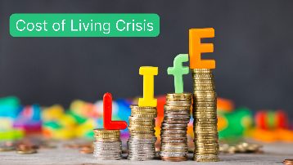
We are all aware of the Cost of Living Crisis, at our recent Cabinet Meeting we were told that 37% of residents in South Norfolk will be in fuel poverty by April 23.
Our Help Hub is working in partnership with the public and charity sector to reach out to residents who are struggling.

We are in the process of creating three food hubs and one Social Supermarket in the District, the Supermarket is for individuals who earn too much to qualify for food banks but are still struggling to buy food. We have received funding to pay out small grants to help cover costs of household bills, so far we have supported nearly 1000 households with this fund.

We have six full time and two part time members of staff in our Help Hub purely working on Debt and Budgeting support. We are now looking at employing another full time member of staff for this team as they are so busy.
We are continuing to look at what support is needed and how we can offer this.

It was disappointing to hear that the Parking Scheme didn’t go to advert in November,
I’ve been told this was because NCC had not received the final documents back from NP Law. NP Law has now advised that the earliest the scheme could be advertised is the middle of January 2023.
NCC’s intention is to advertise in January provided they receive the final documentation which they must approve first.

Merry Christmas to everyone!

