**Non-Designated Heritage Assessment**

**December 2021**

Trowse with Newton

Neighbourhood Plan 2022-2038

Table of Contents

Introduction 1

Assessment 2

NDHA A- Flint Barn, Whitlingham Country Park 2

NDHA B- Kingsley Farrington Boat Yard 3

NDHA C- Estate Cottages on Whitlingham Lane 5

NDHA D- Old Police House, Newton Close 6

NDHA E- Former May Gurney Offices along The Street 8

Appendix: Non- Designated Heritage Assets Map 12

# Introduction

Non-designated heritage assets are buildings, monuments, sites, places, areas, or landscapes identified as having a degree of significance meriting consideration in planning decisions, but which are not formally designated. They are valued as distinctive elements of the local historic environment.

Historic England provide guidance on the listing of local heritage assets to assist community groups, for example in preparing a Neighbourhood Plan[1]. Local lists complement national designations and intends to highlight heritage assets which are of local interest, to ensure they are given due consideration when change is being proposed.

Guidance table from Historic England



**Figure 1: Table criteria taken from Local Heritage Listing: Historic England Advice Note 7**

# Assessment

## NDHA A- Flint Barn, Whitlingham Country Park

|  |  |
| --- | --- |
| **Description** | Flint Barn |
| **Age** | Unknown – pre 19th century |
| **Rarity** | Average |
| **Aesthetic Interest** | A good example of a well-restored flint barn which is now used as a café for the Whitlingham Country Park. It is well-proportioned with flint and brick walls and pantiled roof, restored barn doors and windows |
| **Group Value** | As part of the character of the Broads Country Park and of Trowse as a surviving model village, the barn is a valuable asset |
| **Archaeological interest** | None |
| **Archival Interest** | There are references to the Flint Barn in accounts of activities on the river and around Whitlingham for example the Whitlingham Regatta and rowing races in the 19th and 20th centuries  <https://joemasonspage.wordpress.com/2018/08/04/historic-whitlingham/> |
| **Historical Association** | None found in terms of individual figures although Colman and other Norwich School artists frequently painted in the area and there is a strong historical association with the model village movement and provision of high quality leisure for factory workers. |
| **Designated Landscape Interest** | Important to the character of the country park |
| **Landmark Status** | None |
| **Social and Community Value** | Important to have a social and leisure space near to the village centre |

## NDHA B- Kingsley Farrington Boat Yard

|  |  |
| --- | --- |
| **Description** | Boatyard |
| **Age** | Approx 1950s |
| **Rarity** | One of very few remaining working boatyards |
| **Aesthetic Interest** | Part of the industrial heritage of the area |
| **Group Value** | Linked to the Broads network, the thriving water sports/canoe/kayak activities |
| **Archaeological interest** | None |
| **Archival Interest** | Listed on the Norfolk Historic Environment Record |
| **Historical Association** | The boatyard is part of the character of Whitlingham Country Park and the history of rowing, sailing and other water-based sports are an important legacy of the drive to provide leisure for the city dwellers and factory workers |
| **Designated Landscape Interest** | The landscape interest is part of the natural development of the area rather than a conscious design, but adds to the character and mix of industrial, residential and leisure |
| **Landmark Status** | None |
| **Social and Community Value** | Contributing to a working heritage and maintaining rare industrial skills that are distinctive  The rowing club is a well-used and important local offer which uses the country park and broads |

## NDHA C- Estate Cottages on Whitlingham Lane

|  |  |
| --- | --- |
| **Description** | Cottages |
| **Age** | Late 19th century/early 20th century |
| **Rarity** | Not necessarily extremely rare but of a distinctive style which is not common |
| **Aesthetic Interest** | Following the aesthetic style of the estate cottages and characteristic of the area |
| **Group Value** | Part of the Whitlingham/Crown Point Estate and the model village status of Trowse |
| **Archaeological interest** | None |
| **Archival Interest** | Part of the Crown Point Estate, linked to the Colman Family |
| **Historical Association** | None |
| **Designated Landscape Interest** | As above. Important to the character of the estate and model village features that |
| **Landmark Status** | None |
| **Social and Community Value** | None |

## NDHA D- Old Police House, Newton Close

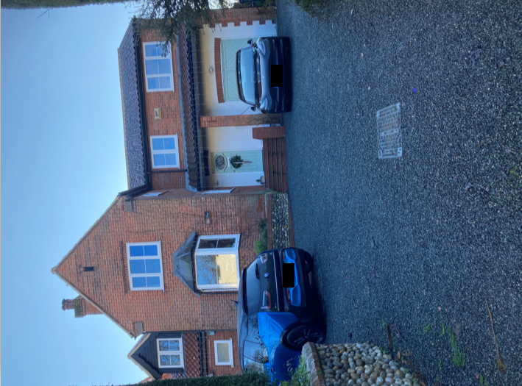

|  |  |
| --- | --- |
| **Description** | Old Police House which has now somewhat extended and called the Copper Penny. |
| **Age** | Built 1968 |
| **Rarity** | These are the only police houses in Trowse on land given to the force by the Colman family |
| **Architectural and artistic interest** | They are “of their time” and in that respect are unlike many other houses in the village. As Trowse was a working village for the Colman factory almost all of the village housing was from the late 1800’s/early 1900’s. So, the Police House’s design is very modern by comparison. They are also large detached houses compared to the rest of the village. |
| **Group Value** | The Police Houses are another part of the Model Village aspect of Trowse. They may not have been built by Colman family but the land was given to the Police to build residents for serving police officers at the time. |
| **Archaeological interest** | Built on the site of a former quarry. Originally No.5 collapsed due to this. No. 5 has since been rebuilt on piles. |
| **Archival Interest** |  |
| **Historic Interest** | Forms part of the Colman family history of Trowse |
| **Landmark Status** |  |

## NDHA E- Former May Gurney Offices along The Street

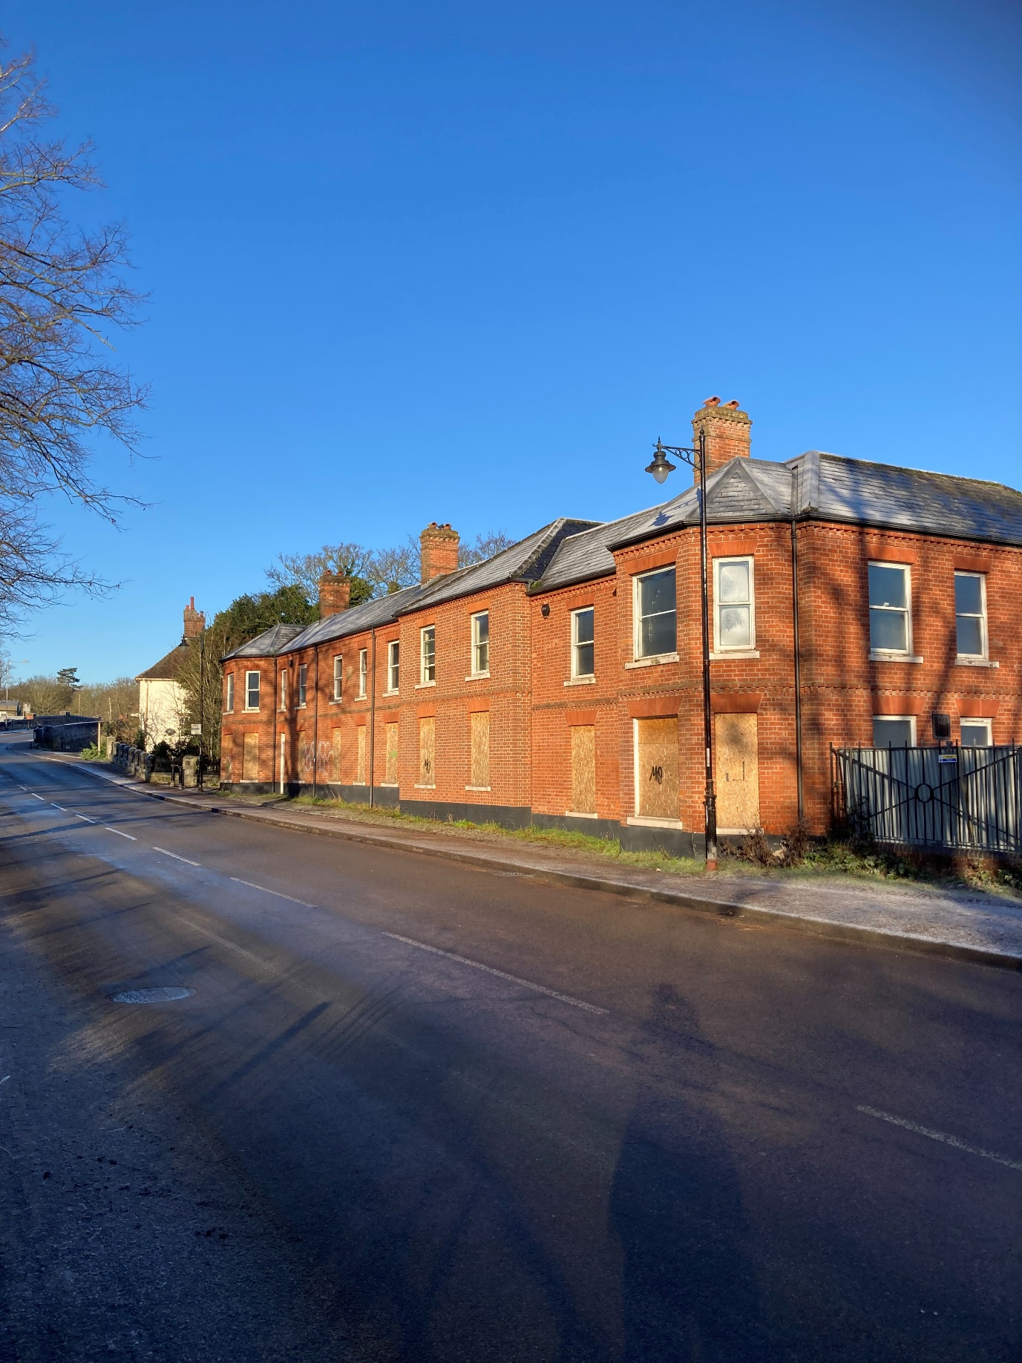

|  |  |
| --- | --- |
| **Description** | May Gurney offices |
| **Age** | 1880s |
| **Rarity** | Not rare |
| **Aesthetic Interest** | Well proportioned Victorian buildings that line the roadway of The Street, redbrick and slate construction although original windows have been removed. |
| **Group Value** | Part of the approach to the village of Trowse and the transition from the city of Norwich to the countryside park. Important to the streetscape |
| **Archaeological interest** | None |
| **Archival Interest** | The buildings are on the site of the former pub, post office, houses and shops that lined the original highway from Bracondale to Trowse (The Street) many of which were demolished when the Bracondale railway bridge was built in the 1880s to enable cattle to cross the railway without stopping the trains, or for the train traffic to hold up the droving of cattle to the market.  The site appears in historic records in the Archive Centre and in the history of Trowse and Colmans. |
| **Historical Association** | Part of the character of Trowse with its links to the cattle trading and rearing as well as mustard production |
| **Designated Landscape Interest** | Important to the streetscape |
| **Landmark Status** | None |
| **Social and Community Value** | None |

Suggestions of NDHAs from the consultation:

* Manor Rooms and adjoining house
* Railway buildings
* Building next to the church (former parish rooms)
* White Horse Pub
* The River Green café
* Kirby Road terraces
* Terraces on the common
* Church ruins in the woods
* Pumping station building
* The old village school
* Crown Point Villas
* Blockhill Cottages
* The Flint Barn at Whitlingham
* Newton Cottage
* Vulcan Cottages
* Archaeological sites at Woodhenge and on White Horse Lane
* Remains of St Andrew’s Church near Tower Cottage
* Terrace housing along the Street and White Horse Lane
* The Henge on White Horse Lane
* Trowse village sign
* The white Gothic cottage and stone cottages
* Bridge over the Tas near the church
* Railings around the common and church
* Flint wall going up the street along Kirby Road and Devon Way
* Former May Gurney / Kier buildings that line the Street
* Old disused pumping station and ancillary building
* The horse trough on the corner of the road opposite the White Horse pub
* Old telephone box near the White Horse pub
* The plaque that mentions the site of the chapel
* The plaque on the path beside Easter Cottage
* All the terrace houses built for the Colman’s employees, to acknowledge what the Colman family did for the village
* The White House
* YMCA sports hall

A number of these may already be identified as buildings of townscape significance in the Trowse Conservation Area Appraisal[2].

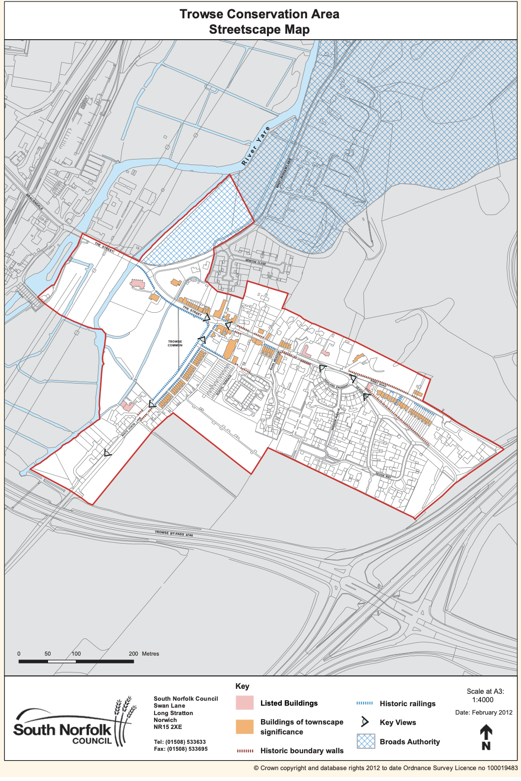

**Figure: South Norfolk Trowse Conservation Area Streetscape Map**

# Appendix: Non- Designated Heritage Assets Map

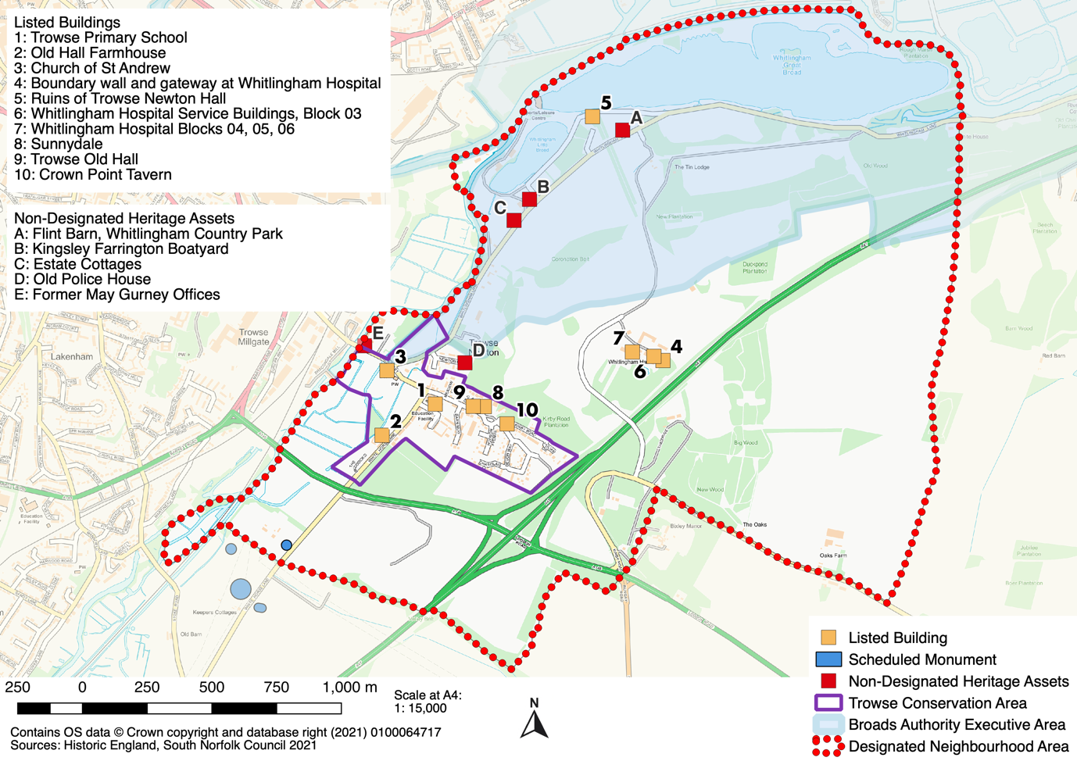

**Trowse with Newton Neighbourhood Plan 2022-2038**

1. Taken from Local Heritage Listing: Historic England Advice Note 7 - <https://historicengland.org.uk/images-books/publications/local-heritage-listing-advice-note-7/heag018-local-heritage-listing/>
2. <https://www.south-norfolk.gov.uk/sites/default/files/Trowse_with_Newton_Character_Appraisal_2012.pdf>