District Council Report – November 2022

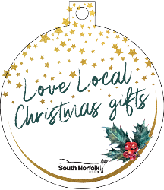
We are launching our Love Local Spend Local comms campaign to support local independent businesses during the run-up to Christmas, by promoting the idea of local gift shopping.

The plan this Christmas is to offer ‘tree bauble’ labels to hang in shop doorways and to take pictures of gift ideas and local products which we will share online, naming the product, the shop and the town/location. We will be distributing free Love Local Spend Local tote bags to encourage people to support local shops in our Market Towns.

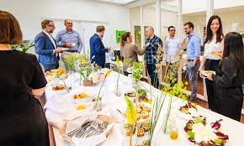
We are holding our next Business Breakfast and Networking event on Wednesday 7 December at Barnham Broom Hotel from 7.30am to 9.30am.
Hosted by South Norfolk Council, the breakfast is open to all those doing business in the local area with two speakers who offer helpful information for businesses.

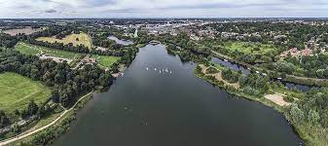
I have been working with Vic, as County Councillor on supporting Whitlingham Country Park. This is a real gem in our District and the Trust who run it have limited funds, they receive £5000 a year from SNC and otherwise the only other funds they have to maintain the Park comes from the car park and the Café on site, so we have been helping them with any grants they may qualify for and how they market the Park to increase visitors as it’s amazing how many people do not realise it’s even there. If you look at their website they hold events like bat walks and foraging and they’d like to do more with schools. There is so much nearby for visitors like the camp site and ski club and it’s a real asset for peoples health and well being.

Nominations for the Broadland and South Norfolk Business Awards 2023 are now open. The awards recognise and celebrate the amazing array of successful businesses in both districts.
Businesses will be invited to nominate themselves for an award in any of the 11 categories and residents can support their favourite pub or shop by voting for them as ‘Retailer of the Year’ and ‘Pub of the Year'.

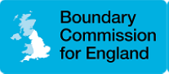
In regard to the Parliamentary Boundary Review, the Boundary Commission for England is analysing responses submitted during the first and secondary consultation stages. They will produce a report deciding whether their proposals should change based on the feedback received. The proposals for the new constituency boundaries were published on Tuesday, 8 November and the consultation will close on Monday, 5 December. This will be the last opportunity to participate in the 2023 Boundary Review. There are a few proposed changes in the South Norfolk District but not in this area.

I have been working to provide “Warm Spaces” in all areas in my Ward, ensuring that they are spread out evenly in Villages so they are more accessible for individuals wherever they live.
In Poringland, along with the Library that NCC have set up as a warm space, Henry will be offering the Mens Shed as a venue and The Royal Oak is also going to be one. We are just looking at a couple of sites in Framingham Earl which haven’t been finalised yet.
In Trowse, both Crown Point and The White Horse have agreed to be a warm space.
All of these venues will be applying for a “Warm Spaces” grant from SNC to cover some of their costs.

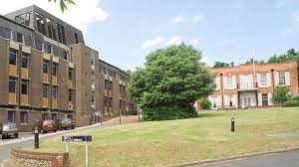
Finally, we had a very sad day on the 4th November when we finally closed the doors of South Norfolk House, and we have now moved temporarily into Broadland District Council Offices until we can all move into The Horizon building on Broadland Business Park. We have opened our base in Diss The Octagon which has been received well.

I’m pleased to tell you we have already seen the benefits of our “One Team” working in collaboration which is saving us money to re-invest in services and has ensured that we haven’t had to make any cuts and we have been able to made the decision to freeze SNC’s proportion of the Council Tax next year.

