Trowse Neighbourhood Plan

Local Green Spaces

Table of Contents
Introduction 1
Policy Context 2
Assessment 3
1. Trowse Common 4
2. Trowse Church Meadow 6
3. Trowse Meadow 7
4. Trowse Church and Churchyard 9
5. Trowse Cemetery, Whitlingham Lane 10
6. The Allotments (Dell and Blockhill) 11
Recommended Designations 12
Green Spaces not being designated 12
Trowse Woods 13
Boudicca Way 15
Whitlingham Country Park 16

Introduction

- Trowse is preparing a neighbourhood plan which will include a policy designating areas of Local Green Space which are particularly valued by the community.

- In consultation with the community in early 2021, the Neighbourhood Plan Steering Group identified 9 areas of green space. Each of these was visited and further evidence gathered on them to determine whether they meet the national criteria for Local Green Space designation.

- This document provides the assessment and evidence in support of those green spaces which have been designated in the plan.

Policy Context

- Local Green Space designation is a way to provide special protection for green areas of particular importance to local communities. The National Planning Policy Framework (NPPF) published in 2012 (revised July 2021) introduced the concept of Local Green Space designation.

- Paragraph 101. of the NPPF sets out that communities should be able to identify green spaces of particular importance through neighbourhood plans, with para 101. Determining:

The Local Green Space designation should only be used where the green space is:
a) In reasonably close proximity to the community it serves;
b) Demonstrably special to a local community and holds a particular local significance, for example because of its beauty, historic significance, recreational value (including as a playing field), tranquility or richness of its wildlife; and
c) Local in character and not an extensive tract of land.

- In addition, the National Planning Practice Guidance states:

Local Green Space designation will rarely be appropriate where the land has planning permission for development. Exceptions could be where the development would be compatible with the reasons for designation or where planning permission is no longer capable of being implemented.

- Other designations, such as Special Areas of Conservation, do not necessarily preclude or support designation as a Local Green Space. However, it is necessary to consider whether the additional designation is necessary and would serve a useful purpose.

- In applying the NPPF criteria, close proximity would normally mean easy walking distance, which based on Natural England standards would mean 1.25 miles or less.

- Consideration of whether the green space is local in character, and not an extensive tract of land, suggests spaces within a locality, rather than for example, extensive green areas in the countryside.

- The Joint Core Strategy for Greater Norwich was adopted in 2011 and includes strategic policies and a number of allocations. Planning Practice Guidance on Neighbourhood Planning sets out that plans must be in general conformity with the strategic policies of the development plan if it is to meet the basic conditions.

Assessment
- The Local Green Space Assessment Tool from My Community: Neighbourhood Planning Local Green Spaces has been used as the basis to assess each site identified by the community. This includes:
  - Trowse Common
  - Trowse Church Meadow
  - Trowse Meadow
  - Trowse Church and Church Yard
  - Graveyard on Whitlingham Lane
  - Whitlingham Country Park
  - The Allotments – Dell and Blockhill
  - Trowse Woods
  - Boudicca Way long distance path

Trowse Common
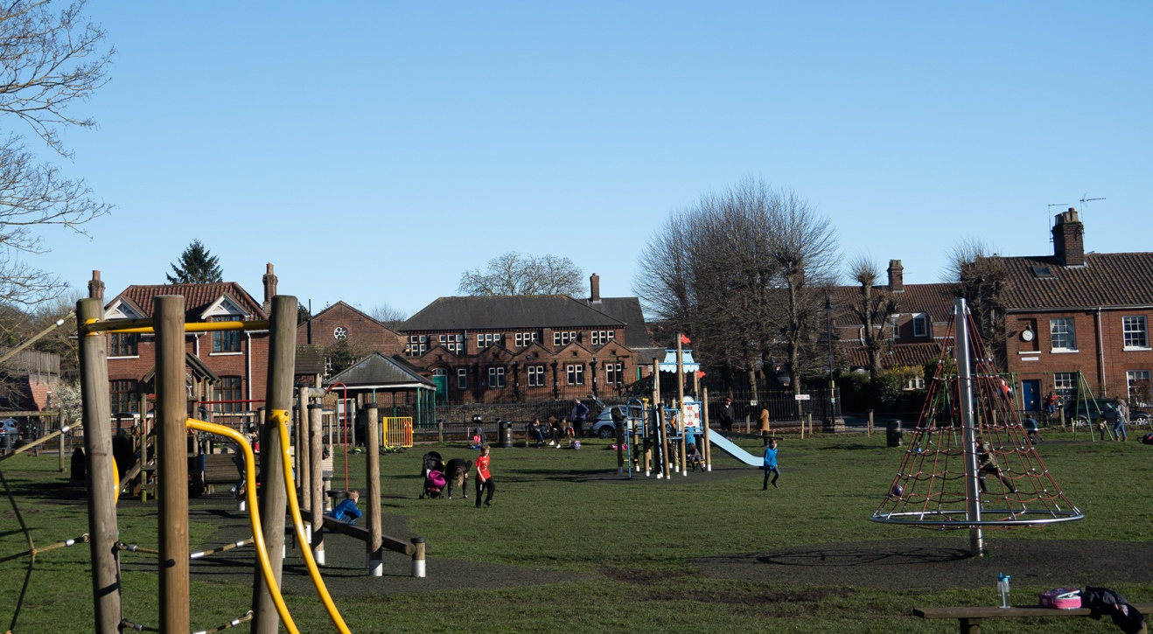

Site Details
Site | Trowse Common
Description and purposes | The central green space in the village with children’s play area and football goals. It sits on the edge of Trowse Church Meadow and has four access gates.

Checklist
Statutory designations - ie CWS, listed status, SSSI, SPA, NNR, SAC | Registered Common Land
Site allocations | None
Planning permissions | None

NPPF Criteria
Close to the community it serves. Add distance to centre of village | Located in the centre of the village
Demonstrably special to the local community (beauty, historic significance, recreational, tranquillity, wildlife or other) Add as much here as possible to determine whether the green space is demonstrably special. | The common is demonstrably special to the community for its recreational value. It attracts families from the village and also wider afield. The part of the common away from the play area is used extensively for dog walking and provides a good open space for dogs to run around. The common is also used for exercise and sporting activities for children. The common also hosts summer fetes and family picnics.  The area is also special for its natural beauty, located adjacent Church Meadow and the River Yare.  There is wildlife value, the common and trees/hedgerow which line the boundaries of it attract birds, foxes, hedgehogs, rabbits and many water fowl and creatures.  The common is a peaceful place to go and sit and read, and when you want to just take some time out in your day to reflect.  It has historical significance, playing an important focal part as Trowse developed as a Model Village.
Local in character and not extensive tract of land. Add site of green space | 1.2ha

Trowse Church Meadow

Site Details
Site | Church Meadow
Description and purposes | Meadow located behind the Common

Checklist
Statutory designations - ie CWS, listed status, SSSI, SPA, NNR, SAC | Not statutory, but the meadow is a County Wildlife Site.
Site allocations | None
Planning permissions | None

NPPF Criteria
Close to the community it serves. Add distance to centre of village | Adjacent the centre of the village and easily accessible via the common from a little bridge and gateway
Demonstrably special to the local community (beauty, historic significance, recreational, tranquillity, wildlife or other) Add as much here as possible to determine whether the green space is demonstrably special. | The meadow has great significance for wildlife. It hosts birds, butterflies, various dragonflies and insects. The meadow is used most of the year by grazing cattle which naturally keep it maintained.  It has recreational value. It is used by families walking through to another meadow at the back which sits opposite the old May Gurney site, who like to go to the river and look for water voles, tadpoles and fish.  It is a Tranquil place to visit and hums with the noise of birds and crickets in the summer, visiting it boasts natural views of the meadow, trees, and river with the church in view too.
Local in character and not extensive tract of land. Add site of green space | 1.3ha

Trowse Meadow

Site Details
Site | Trowse Meadow
Description and purposes | The water meadow which runs alongside the River adjacent Whitlingham Lane and the old May Gurney Site.

Checklist
Statutory designations - ie CWS, listed status, SSSI, SPA, NNR, SAC | The meadow is a Local Nature Reserve (Whitlingham) and also County Wildlife Site. It also falls within the Broads Authority Executive Area.
Site allocations | Adjacent the Deal Ground, part of the East Norwich Regeneration zone
Planning permissions | None

NPPF Criteria
Close to the community it serves. Add distance to centre of village | In close proximity to the village and well known for walking through, it has two access points one on the road coming into Trowse and further down Whitlingham lane.
Demonstrably special to the local community (beauty, historic significance, recreational, tranquillity, wildlife or other) Add as much here as possible to determine whether the green space is demonstrably special. | Trowse Meadow is special due to the wildlife it supports, including birds, butterflies, dragonflies and other insects. It is used throughout the year by grazing cattle which naturally keep it maintained.  It has recreational value and is used by families walking through from the road. It is popular with children and families who like to go to the river and look for water voles, tadpoles and fish. It is also known for canoeists and people will swim in the river, pitch up a picnic and will spend summery days with the family.  It also attracts fishermen and bird watchers.  It is a tranquil and peaceful place to walk through and to sit and watch the world go by. It is also famous for its paintings by artists and there are a few paintings of the meadow by local artists at the art school and in local galleries.  The meadow acts as a natural flood plain through winter.
Local in character and not extensive tract of land. Add site of green space | 2.8ha

Trowse Church and Churchyard
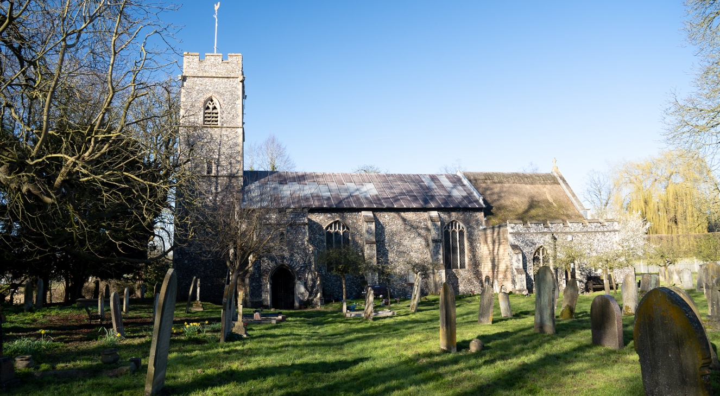

Site Details
Site | Site of the Church and Churchyard
Description and purposes | Trowse Church is on a small open piece of land, with very old graves, the church and churchyard back onto the Church Meadow and the Meadow opposite the old May Gurney site. This is a closed churchyard.

Checklist
Statutory designations - ie CWS, listed status, SSSI, SPA, NNR, SAC | The church is grade I listed.
Site allocations | None
Planning permissions | Permission given for a church car park in 2018

NPPF Criteria
Close to the community it serves. Add distance to centre of village | Within the village centre
Demonstrably special to the local community (beauty, historic significance, recreational, tranquillity, wildlife or other) Add as much here as possible to determine whether the green space is demonstrably special. | Heritage value, site of the church of St Andrew, one of the only remaining Medieval buildings in the parish.  The site has wildlife value. There are a number of trees which are home to birds and small mammals.
Local in character and not extensive tract of land. Add site of green space | 0.5ha

Trowse Cemetery, Whitlingham Lane

Site Details
Site | Trowse cemetery
Description and purposes | Cemetery for Trowse, located a little way from the parish church along Whitlingham Lane adjacent the ski slope. This is an open cemetery.

Checklist
Statutory designations - ie CWS, listed status, SSSI, SPA, NNR, SAC | None
Site allocations | None
Planning permissions | None

NPPF Criteria
Close to the community it serves. Add distance to centre of village | Close to the village centre
Demonstrably special to the local community (beauty, historic significance, recreational, tranquillity, wildlife or other) Add as much here as possible to determine whether the green space is demonstrably special. | Tranquility, the graveyard is so quiet  The graveyard has wildlife value and efforts by the community have sought to improve this. Bird and bat boxes have recently been attached to several of the trees.
Local in character and not extensive tract of land. Add site of green space | 0.6ha

The Allotments (Dell and Blockhill)
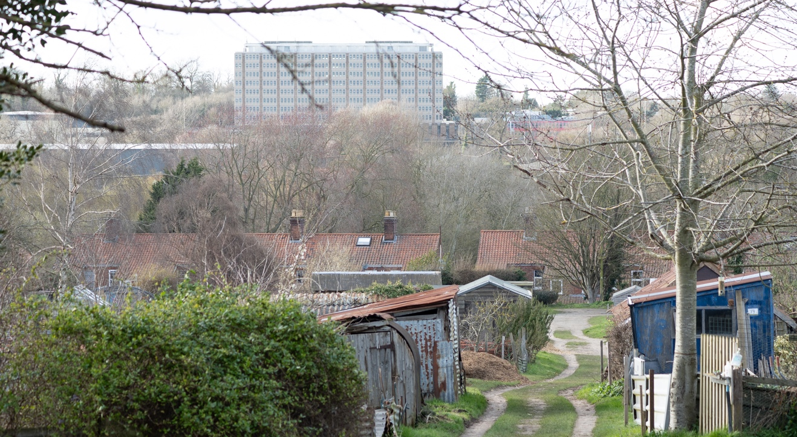

Site Details
Site | Two allotment sites, the Dell and Blockhill
Description and purposes | Allotment sites used by residents to grow local produce

Checklist
Statutory designations - ie CWS, listed status, SSSI, SPA, NNR, SAC | None
Site allocations | Blockhill allotments is adjacent to Phase 2 of the Millgate Meadow site allocation off White Horse Lane
Planning permissions | None

NPPF Criteria
Close to the community it serves. Add distance to centre of village | Within close proximity of the village centre and most homes
Demonstrably special to the local community (beauty, historic significance, recreational, tranquillity, wildlife or other) Add as much here as possible to determine whether the green space is demonstrably special. | Recreational value. The allotments are hugely popular and there is a waiting list for both sites, they are rented out by residents of Trowse.  The allotments have recently had communal spaces created where produce is shared, they are quiet places to walk through and a lovely social space.  Wildlife value. Allotment holders are encouraged to plant fruit trees and wildflowers, and are also encouraged to look after the green space encouraging more birds, hedgehogs and bumblebees to visit. There are beehives on Blockhill allotments.
Local in character and not extensive tract of land. Add site of green space | Dell allotments 0.4ha  Blockhill 1.5ha

Recommended Designations

- From the assessment work, 7 Local Green Spaces have been determined to meet the national criteria for designation. These are highlighted below.

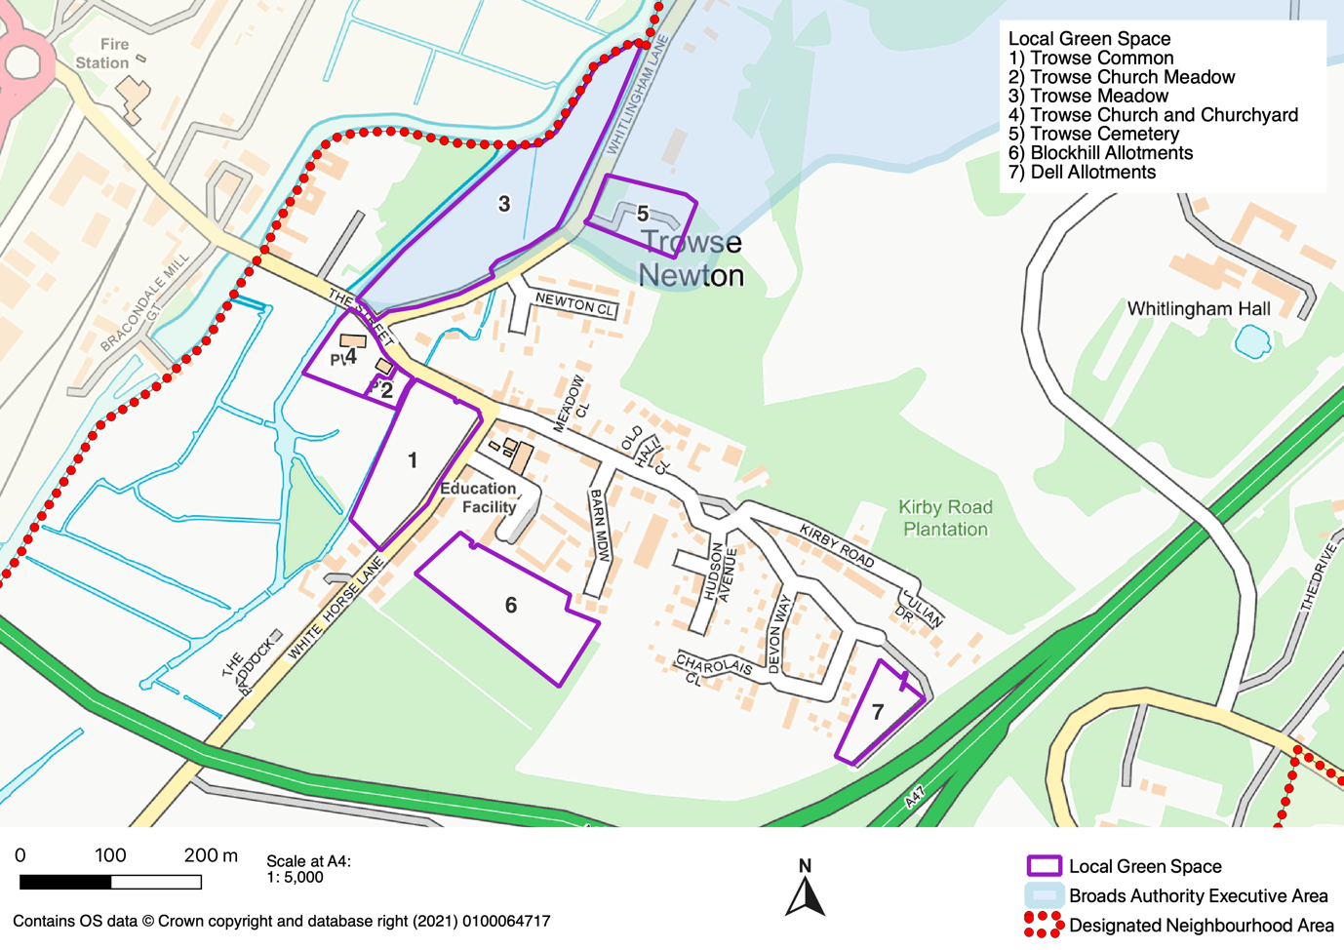

Green Spaces not being designated

- Three green spaces put forward by the community were considered not to meet the criteria, the reasoning for which is provided below:

Green Space | Reason not designated
Whitlingham Country Park | This green space is too large and could be considered an extensive tract of land. It also has a range of other designations which already afford it protection.
Trowse Woods | This green space is 6.7ha which could be considered an extensive tract of land. The woodland also has a number of existing protections.
Boudicca Way long distance path | This is a well-established long-distance path, part of which travels through Trowse. The guidance on designating Local Green Spaces indicates that there is no need to designate linear paths.

Trowse Woods
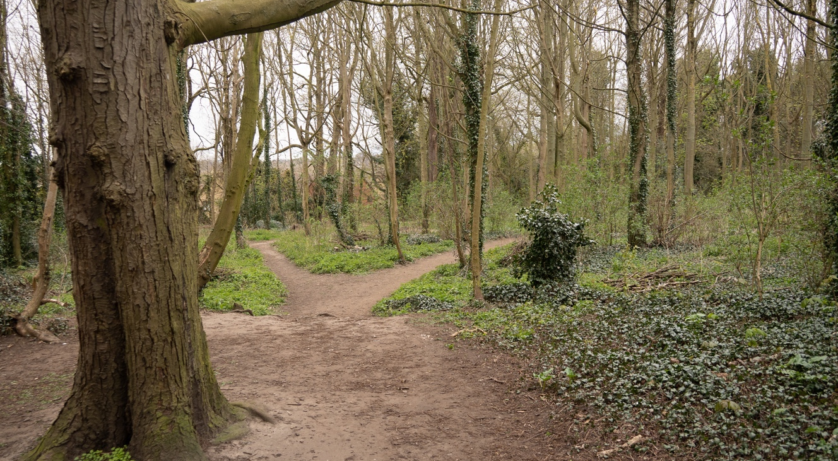

Site Details
Site | Trowse Woods
Description and purposes | These woods start from Whitlingham Lane and continue all the way up to Kirby Lane cycle path, it has 4 access points one from Whitlingham Lane, one from Newton Close, one from the top of Kirby Road opposite Julian Drive, and one off the cycle path further up.

Checklist
Statutory designations - ie CWS, listed status, SSSI, SPA, NNR, SAC | The woods are part of the Whitlingham Local Nature Reserve. They are also a County Wildlife Site and part of the woods is within the designated Crown Point Park and Garden
Site allocations | None
Planning permissions | None

NPPF Criteria
Close to the community it serves. Add distance to centre of village | The woods lie adjacent the built up area of the village and it is possible to access them from a number of different points.
Demonstrably special to the local community (beauty, historic significance, recreational, tranquillity, wildlife or other) Add as much here as possible to determine whether the green space is demonstrably special. | Recreational value. These woods attract many visitors each day, both locals and visitors to the area, its used for walkers, bird watchers, dog walkers and families enjoying the nature.  It has great wildlife value, the wood is home to many birds, rabbits, squirrels, bees, foxes, hedgehogs and deer.  It has some birdhouses attached to the trees, and is full of seasonal bulbs and maintained shrubs and trees.  It’s quiet, and beautiful to walk and each season brings new joy and beauty.
Local in character and not extensive tract of land. Add site of green space | 6.7ha

Boudicca Way
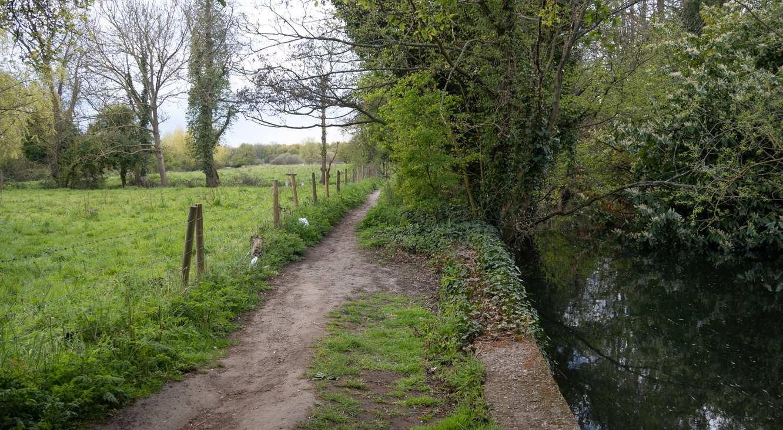

Site Details
Site | Boudicca Way
Description and purposes | This is a historical walk and is a signposted walk, it starts on White Horse Lane opposite the old May Gurney site and follows the path past the Watermill, and past the power station, it brings you out to a field where horses are grazed.

Checklist
Statutory designations - ie CWS, listed status, SSSI, SPA, NNR, SAC | Boudicca Way is a long-distance path, part of which runs through Trowse
Site allocations | None
Planning permissions | None

NPPF Criteria
Close to the community it serves. Add distance to centre of village | The walk starts in the centre of the village
Demonstrably special to the local community (beauty, historic significance, recreational, tranquillity, wildlife or other) Add as much here as possible to determine whether the green space is demonstrably special. | Recreational value. This walk is popular to the villagers, and is well used by dog walkers, families, and bird watchers, it also attracts some fishermen and once you reach the field on the other end, it attracts people canoeing, swimming and some picnickers. The walk is peaceful and offers a chance to reflect on the nature around you, it is prone to flooding.  Wildlife value. The river runs adjacent to the path and it is possible to see birds, swans, ducks and the odd heron.
Local in character and not extensive tract of land. Add site of green space | Approximately 1km of Boudicca Way goes through Trowse

Whitlingham Country Park
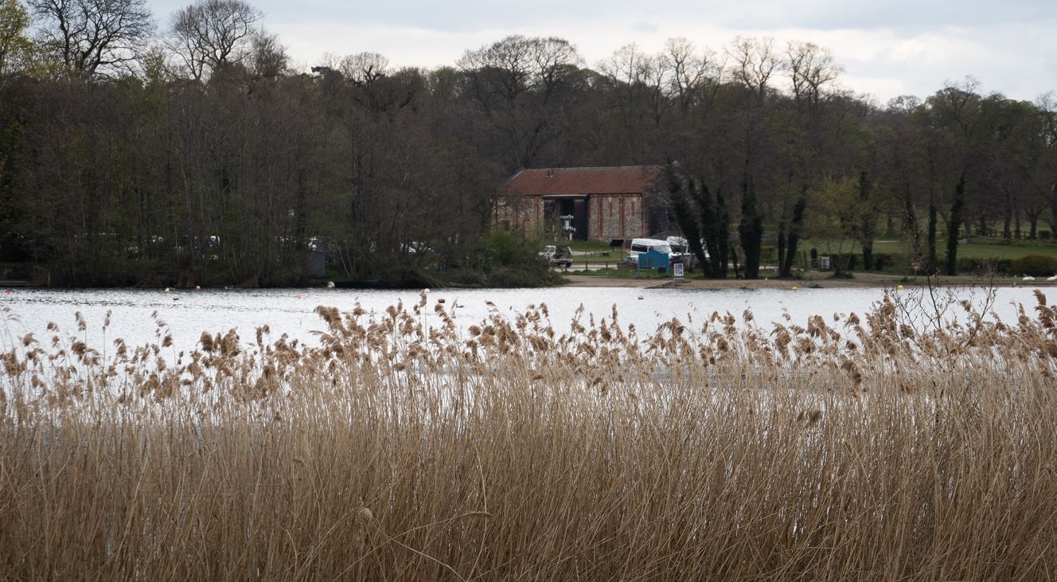

Site Details
Site | Whitlingham Country Park
Description and purposes | A large country park that is used extensively by people who live in the village and visitors. The park includes the Great and Little Broad. Whitlingham is looked after privately and attracts hundreds of visitors throughout the year. It also has historic remains of a Bishops Palace between the two broads.

Checklist
Statutory designations - ie CWS, listed status, SSSI, SPA, NNR, SAC | Part of the Country Park is designated a Historic Park and Garden by Historic England. The Broads designated a Local Nature Reserve and an area of woodland is a County Wildlife Site.
Site allocations | None
Planning permissions | None

NPPF Criteria
Close to the community it serves. Add distance to centre of village | Easily accessible to the village and leads to many other walks such as the start of the Wherryman’s Way
Demonstrably special to the local community (beauty, historic significance, recreational, tranquillity, wildlife or other) Add as much here as possible to determine whether the green space is demonstrably special. | Recreational value, popular with walkers, joggers, cyclists and water sports enthusiasts. It also attracts bird watchers to look at the many different birds that nest there.  The park is a stunning open space, very tranquil and hosts beautiful views across the lake, meadows, woodland and the River Yare.  The park has historical value, being derived mainly from Crown Point Park.
Local in character and not extensive tract of land. Add site of green space | 67ha

https://neighbourhoodplanning.org/toolkits-and-guidance/making-local-green-space-designations- neighbourhood-plan/

