Trowse Neighbourhood Plan

Important Views Assessment

Contents
1 Introduction 2
2 Assessment of Key Viewpoints 3
2.1 View 1: Across the Common towards Russell Terrace 4
2.2 View 2: Into Trowse from the village sign 5
2.3 View 3: Trowse Church Meadow up towards the Bypass 7
2.4 View 4: towards County Hall from the Dell Allotments 8
2.5 View 5: Down into the village from Crown Point 9
2.6 View 6: Down into the Valley from Whitlingham Hall 10
2.7 View 7: Across Trowse Meadow 11

Introduction
Trowse is one of a small family of model villages in Great Britain. As Bournville is to Birmingham, Port Sunlight to Liverpool, so Trowse is to Norwich.
Trowse was created (or more accurately expanded) by the Colman family during the 1800s for workers at Colman's mustard factory. The family still owns much of the surrounding land. It is also home to another great, old-established Norfolk family business – May Gurney – a major civil engineering and construction company which was acquired by Kier Group in 2013.
It is proposed that a few of these special views are afforded protection within the Neighbourhood Plan. During 2021 the community identified the most important views and the reasons why these are special. This document provides the evidence to support these views being included within the neighbourhood plan.
A set of criteria was used to identify such views:
- Accessible from a public space;
- A good reason for its inclusion within the Neighbourhood Plan which may relate to its recreational value, conservation interest, scenic quality, rarity or planning history; and
- Have a specific reason for being important to the community.

Assessment of Key Viewpoints
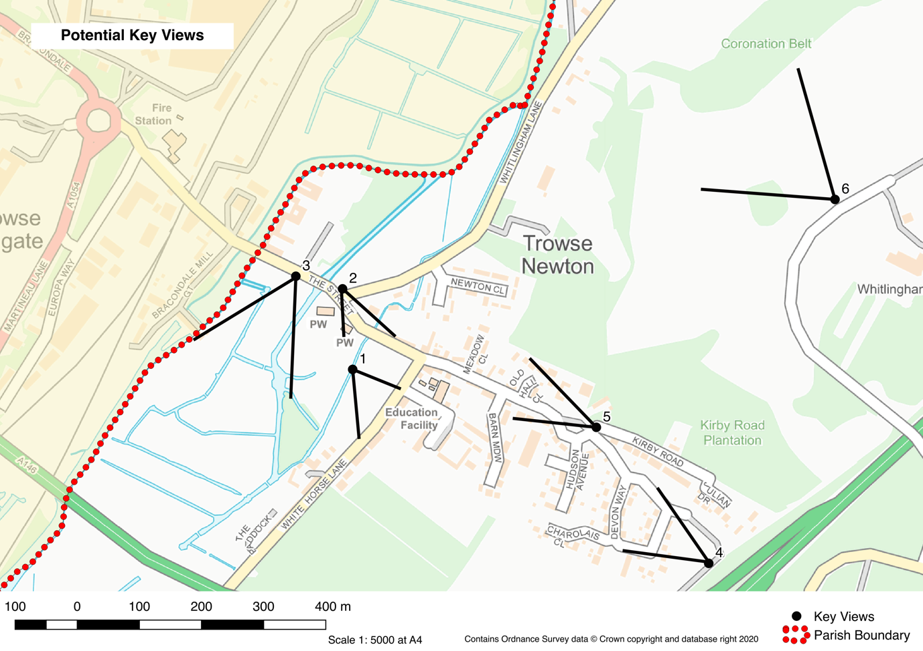
- View of Russel Terrace from across the Common
- View into the centre of Trowse from the village sign
- View of Trowse Church meadow up towards the bypass
- View from the Dell allotments towards County Hall
- View down into the village from Crown Point
- View down into the valley from Whitlingham Hall
- View across Trowse Meadow

View 1: Across the Common towards Russell Terrace
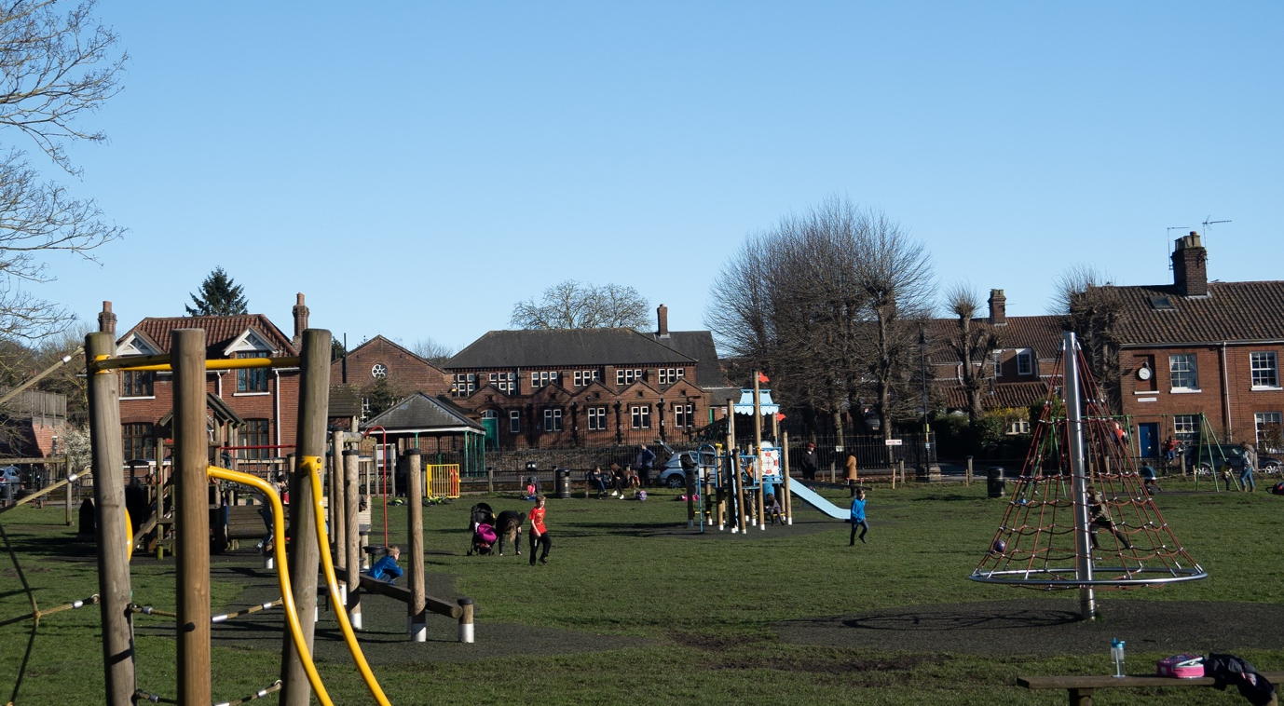
Description and purpose | A modern play area against a backdrop of our Colman’s model village.
Is the view publicly accessible? | Yes. Accessible from all sides and also provides walks across a bridge to the Church meadow. Clearly the natural centre of the village with a pub, restaurant and coffee shop bordering it.
Quality of the view – condition | Clear views through the Common making parental control across the play area easier
Planning history | In 1973 The Parish Council applied to the Commons Commissioner to register the Common on behalf of the Parishioners. This was refused and the Common has no owner and comes under the protectorate of the District Council.
Scenic quality of the view | The heart of the village. Surrounded by Colmans built houses and other iconic landmarks. To the west of the Common you can see the new Norfolk Homes development
Conservation interest | The area is common land and within the conservation area. It is possible to see the old school, which is a listed building. The school moved in October 2020, with the old building owned by Norfolk County Council.
Recreational value | The Common has a diverse array of recreational equipment.
Rarity | Picturesque centre of an historic model village.

View 2: Into Trowse from the village sign
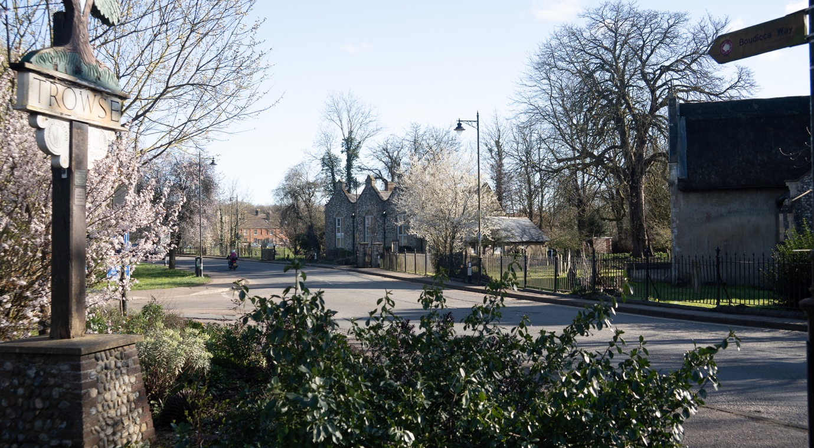
Description and purpose | The entrance to the village from Norwich with St Andrews Church on the right
Is the view publicly accessible? | Vehicle and pedestrian access to the village
Quality of the view – condition | A vista that has changed very little over the years.
Planning history | St Andrew's church has an important 13th century chancel, built between 1282-1283 under Master Nicholas. The west tower dates to the 14th century, the nave to the 15th century, and a north aisle was added in 1901 during restorations of 1899-1905 by Boardman. The building itself is of flint with ashlar dressings, and has a nave roof of lead and a thatched chancel.  Inside there is an octagonal carved font, and there are life-sized wooden figures of King David and angels around the pulpit, in a Baroque style, which were donated by the Colman family in 1902. On the south wall behind the altar are a number of 18th century paintings from St Michael Coslany, and there is a carved 19th century wooden reredos by Minnis, as well as a brass dated to 1585.
Scenic quality of the view | A clear access point to the village from the city. The graveyard at St Andrew’s Church is now closed, with the current cemetery a short walk away down Whitlingham Lane.
Conservation interest | There is a wildlife walk across the church meadow, behind the Church (with a ‘animals/flora of interest sign, as you enter the Church meadow across the bridge from the Common).
Recreational value | A range of activities are held at St Andrew’s Church. You can also see the common which is a key area for recreation in the village.
Rarity

View 3: Trowse Church Meadow up towards the Bypass
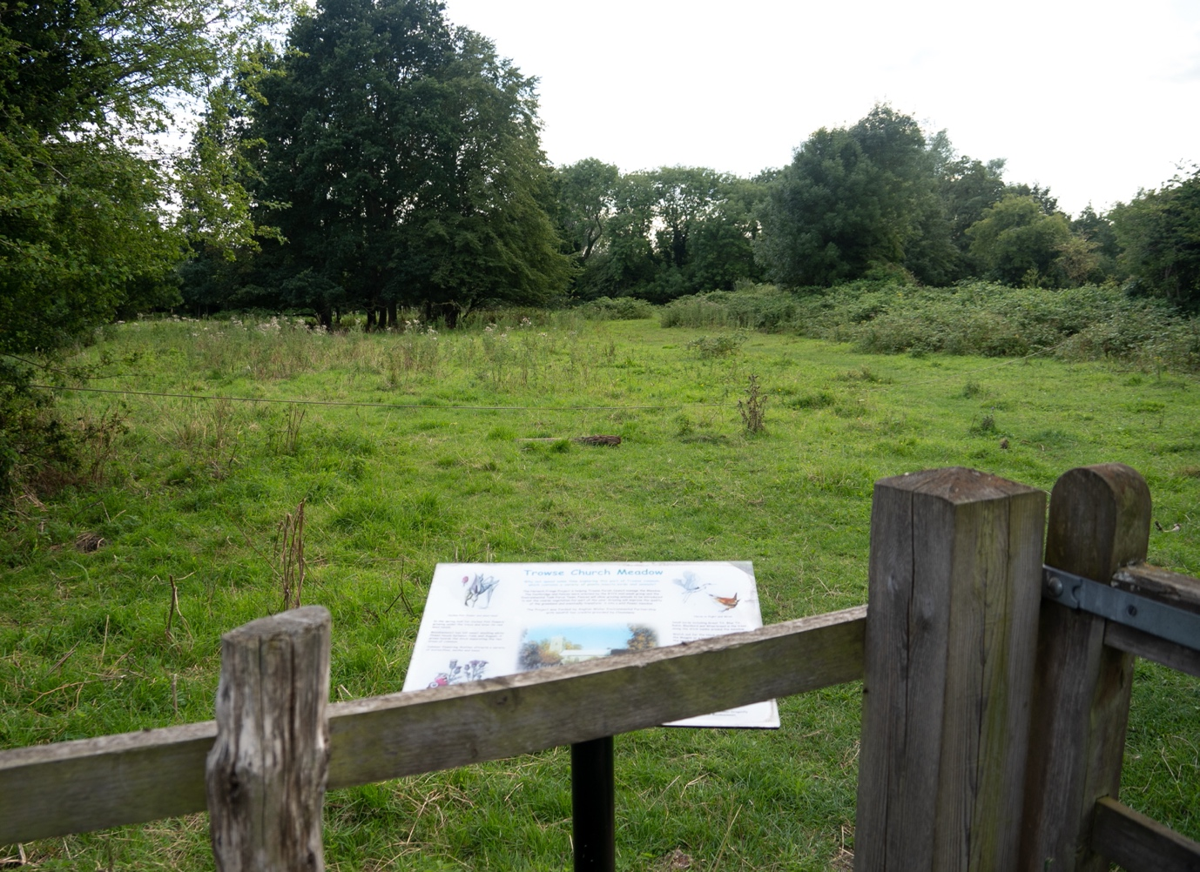
Description and purpose | This is the walk from the Common and across Church meadow towards Trowse bypass
Is the view publicly accessible? | Yes. Either from the Common or through the Church car park on the meadow
Quality of the view – condition | Excellent
Planning history | The Church was given planning permission to construct a car park in the first part of Church Meadow (as you access it from the Street).It is authorised for 14 spaces and can only be open from 30 minutes before until thirty minutes after a Church service.
Scenic quality of the view | Excellent view of the historic centre of the village.
Conservation interest | Interesting Flora and Fauna
Recreational value | Permitted Walk
Rarity | N/A

View 4: towards County Hall from the Dell Allotments
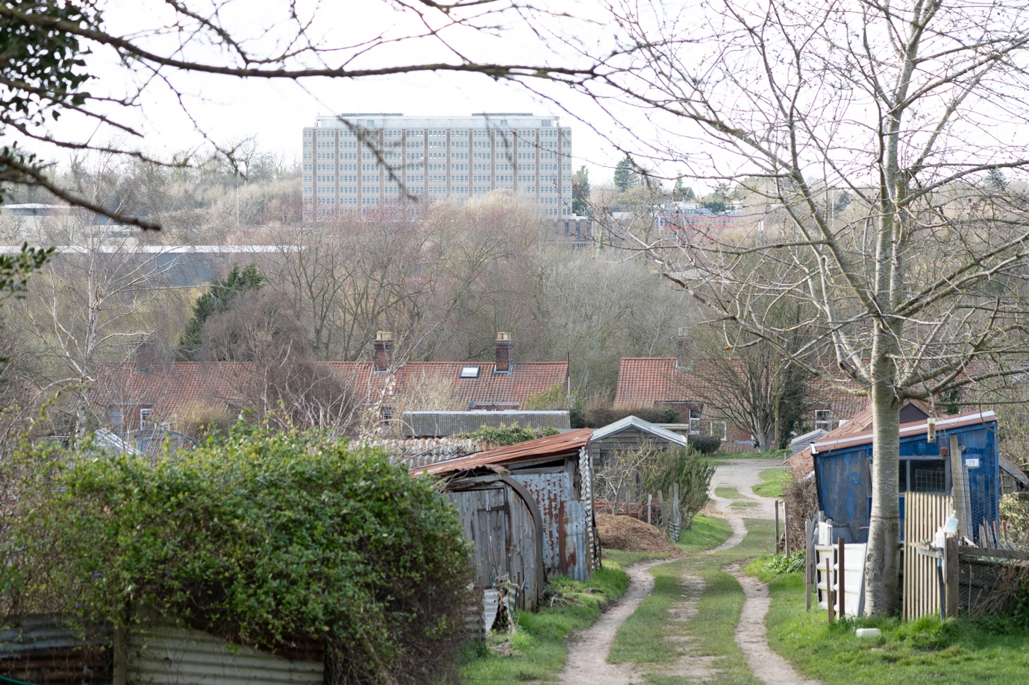
Description and purpose | This view shows the contrast between Trowse and nearby Norwich. The allotments have recently updated by the Parish Council with an improved layout. This area is regularly referred to as ‘the beating heart of the village’.
Is the view publicly accessible? | Yes
Quality of the view – condition | Excellent
Planning history | The land is owned by the Arminghall Trust and leased to the village via the Parish Council.
Scenic quality of the view | Excellent view from the top of the allotments to the southern end of the city.
Conservation interest | By its very nature it is a haven for wildlife
Recreational value | Massive with all plots allocated.
Rarity | N/A

View 5: Down into the village from Crown Point
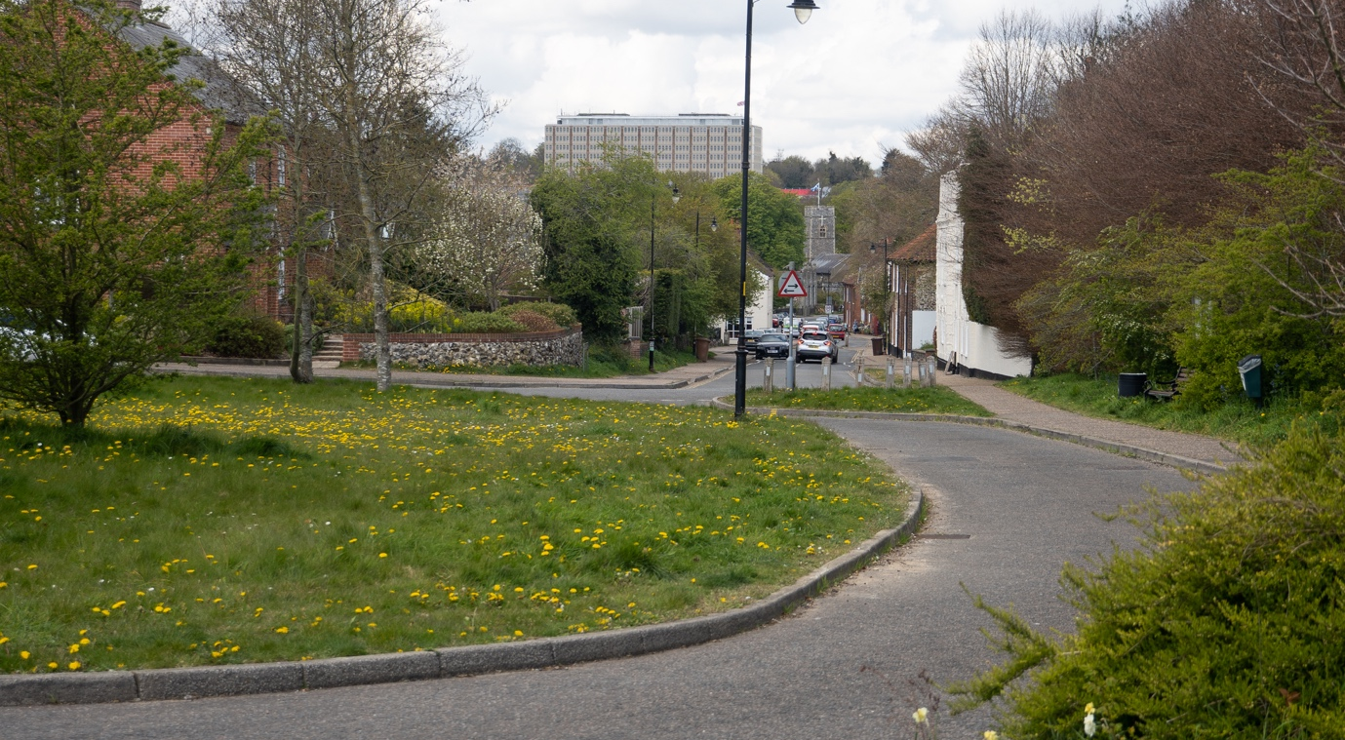
Description and purpose | The top end of the village showing St Andrews Church and County Hall in the background.
Is the view publicly accessible? | Yes
Quality of the view – condition | This is the view that people see as they come into the village from Trowse Woods and Whitlingham Hall, or if they’ve just been to the Crown Point Tavern. The view narrows down the road towards the church in the distance. You can see County Hall on the horizon.
Planning history | N/A
Scenic quality of the view | Very good particularly the walk as described above
Conservation interest | All within the Trowse conservation area and excellent wildlife opportunities
Recreational value | Excellent
Rarity | An opportunity to see and visit Whitlingham Broad with a panoramic view of the City.

View 6: Down into the Valley from Whitlingham Hall
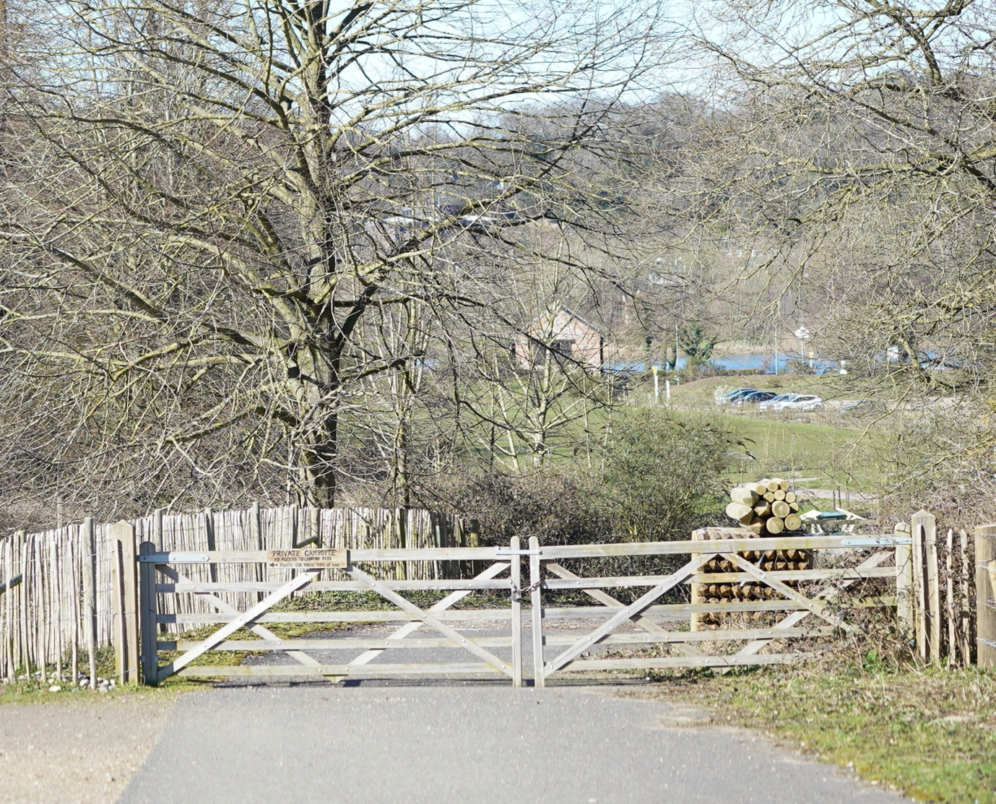
Description and purpose | Walking down the hill past Whitlingham Hall you start to see the campsite on your right and Whitlingham Broad straight in front of you.
Is the view publicly accessible? | Yes, Permissive Road and path all the way.
Quality of the view – condition | Gets better the nearer you get to the Broad. Opportunities to spot wildlife in the woods and surrounding fields and particularly on the Broad
Planning history | Conservation Area
Scenic quality of the view | Very good. To the left is a view of the city and to the right, Trowse Campsite with its glamping tents, Shepherd Huts and Tree House.
Conservation interest | Very high
Recreational value | Has always been a popular place to visit but is getting busier all the time.
Rarity | Rare opportunity to enjoy extensive space and wildlife on the edge of the city.

View 7: Across Trowse Meadow

Description and purpose | View across Trowse Meadow when walking across the permissive footpath
Is the view publicly accessible? | Yes
Quality of the view – condition | Lovely view across the water meadow
Planning history | None
Scenic quality of the view | Very good. A peaceful and tranquil setting across the water meadow.
Conservation interest | Very high, the meadow is a hive for wildlife, the river runs along both sides of the meadow and often you can see birds like Kingfisher.
Recreational value | A popular place for walkers and families particularly over the summer
Rarity | Rare opportunity to enjoy extensive space and wildlife on the edge of the city.

