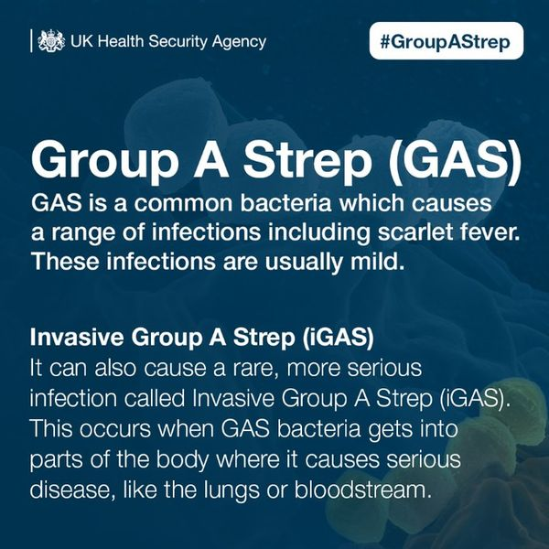
The government has a page of information for education providers and parents here Strep A and scarlet fever – what are they and what are the symptoms? Information for parents, schools, colleges and early years providers - The Education Hub (blog.gov.uk) and you might want to forward a link to it; it’s nice and clear and being updated on a daily basis.

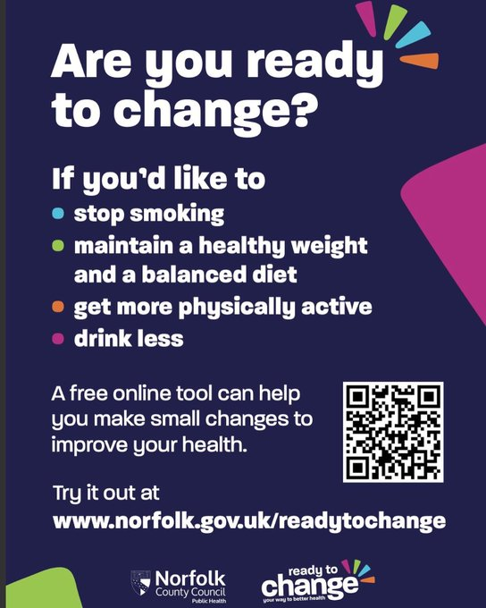
With so much information available, changing behaviours can be complicated and overwhelming when it comes to trying to be healthier. I’ve been working with
@NorfolkCC
on their #readytochange tool which provides support to people who wants to improve their health #ad

Strep A
The government has a page of information for education providers and parents here Strep A and scarlet fever – what are they and what are the symptoms? Information for parents, schools, colleges and early years providers - The Education Hub (blog.gov.uk) and you might want to forward a link to it; it’s nice and clear and being updated on a daily basis.

Drains and Gullies
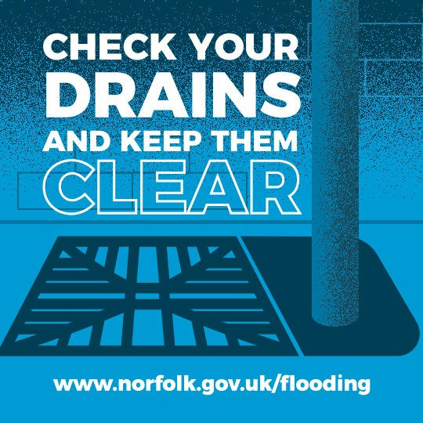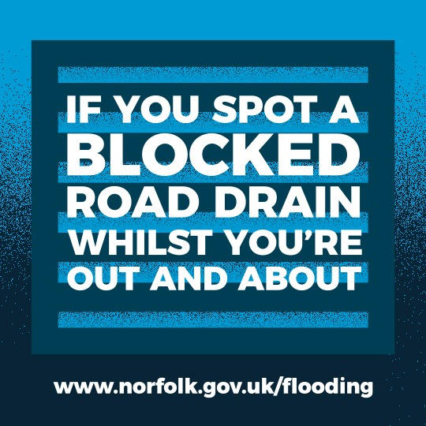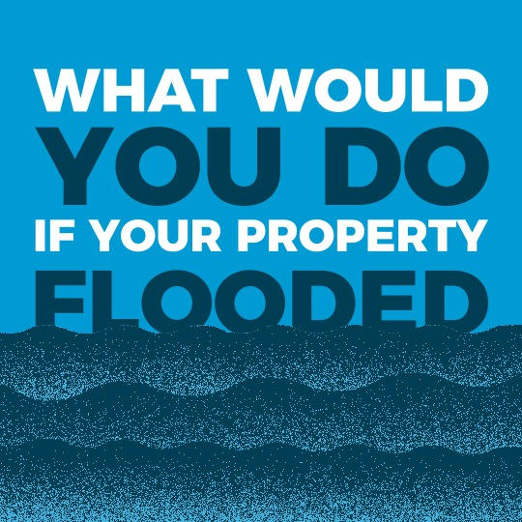
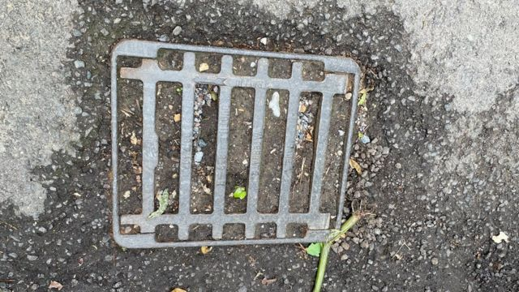
Now that we’re into the winter months, there’s bound to be more rain and surface water about.
Did you know it could be your responsibility to keep drains on your property clear? Check at the front and back of your house & unclog any blockages now to keep your drains clear this winter. And if you spot a blocked road drain when you’re out and about, please report it on the link below!
Live in a flood risk location? Make sure to click through to find out more & keep the Floodline number handy: 0344 810 8013
County Deal devolution agreement: an historic day for Norfolk

Today, the County Council and the Government have agreed, in principle, to transfer funding and powers to boost jobs, regeneration, housing and transport to Norfolk.

Known as a County Deal, it includes a guaranteed £20 million per year investment fund for the next 30 years.

Finalising a Deal would mean that, from 2024 onwards, we can do more to:

- Target funding and resources to Norfolk’s own growth and infrastructure priorities
- Attract and retain new and key businesses and sectors
- Invest in the skills we know we need
- Unlock housing and employment sites
- Raise our profile nationally, enabling our voice to be heard by Government and help shape future policies

As part of the deal, Norfolk County Council would have a Council Leader who is directly elected by the public, with the first election in May 2024.

County council leader, Councillor Andrew Proctor, said: “This is an historic day, one that opens the door to real opportunities for Norfolk.

“I’m delighted that Norfolk is well positioned to gain additional powers and money to improve people’s lives, thanks to the County Deal we have agreed in principle with the Government.

“The aim is for decisions and funding previously controlled in Westminster to be agreed in Norfolk, for Norfolk.

“Striking a deal will help us to boost our economy through jobs, training, housing and development, improve our transport network and support our environment.

“Getting to this point shows that the Government sees Norfolk as a can-do county. I’m confident that we will make a success of this and that more powers and funding would follow.”

Levelling Up Secretary Michael Gove said: “We are putting power into the hands of Norfolk because we know important decisions are best taken closer to home, by people who know what their challenges are, not by those sitting behind a desk in Whitehall.

“This landmark deal allows leaders in Norfolk to take forward local priorities over the longer term, and it will be for the people of Cromer, Norwich, and Great Yarmouth to elect someone who is best placed to represent their unique interests as a county.

“I look forward to working closely with whoever the new leader is to level up Norfolk and unleash the economic potential of the whole county.”

We’re interested in what you think. In line with Government guidance, we will stage a formal public consultation, in 2023.

You can find out more about the deal and next steps at www.norfolk.gov.uk/norfolkcountydeal . Please contact countydeal@norfolk.gov.uk if you have any questions or wish to register for updates.

Bus Services
I wanted to make you aware of an opportunity that has arisen for the County Council and First Bus to apply to central government for funding to secure additional zero emission buses in Greater Norwich through the Zero Emission Bus Regional Area (ZEBRA) fund. Through this fund, the County Council has already secured funding of £3.2m from the Department for Transport (DfT), and £3.6m from First Bus, for 15 zero emission buses, associated provision of electrical charging facilities at First’s bus depot, and an upgrade to the local power grid, to all be operational by March 2024. DfT has now invited cities that were successful with receiving ZEBRA funding to submit a request to change the scope of their existing ZEBRA schemes, which can include additional buses and electrical charging infrastructure.

In partnership with First Bus, we have developed a proposal for an additional 55 zero emission double deck buses to be operational by March 2024. No further upgrades are needed to the local power grid and bus routes that these additional zero emission buses would serve all operate in Greater Norwich and run through the city centre, which is currently declared an Air Quality Management Area. These bus routes are the Pink Line (services 11, 11A and 12), Red Line (services 23, 23A, 24 and 24A), Blue Line (services 25, 26 and 26A) and the Orange Line (service 21). This proposal is forecast to reduce 80,000 tonnes of carbon and 32 tonnes of local air quality related emissions of NO_{x} and PM_{2.5} over the 17-year life cycle of the new buses. This proposal would require additional funding of circa £8.6m from government and circa £16.4m from First Bus.

This proposal would enable the Roundtree Way bus depot in Norwich, operated by First Bus, to operate an entirely zero emission bus fleet. Full electrification of the bus fleet operating from this depot would present the opportunity to remove all diesel infrastructure and engineering equipment, demonstrating a permanent and complete commitment to zero emission buses going forwards. Diesel buses would continue to operate from the Vulcan Road bus depot and future opportunities will be considered for how these remaining buses can also be replaced by zero emission buses. We will also continue to engage with other bus operators in Norfolk on the transition of their fleets to zero emission, which is outlined as a clear aspiration in the Bus Service Improvement Plan.

There is no guarantee that funding will be available from government to meet this, or any further requests for the scope of ZEBRA projects to be expanded. However, this is an opportunity to send a clear message to government that we want to transition to zero emission public transport as soon as we can.

We will brief the media accordingly regarding this opportunity. In the meantime, I would ask that this information isn’t shared but please let me know if you have any questions on this.

Risk management plan
Every three years we are required to consult the public on our Community Risk Management Plan, known as a CRMP. The last time we did this was in Autumn 2019 (when it was known as an Integrated Risk Management Plan – IRMP). We have put together a series of proposals for changes within our approach which we believe will help to reduce risk and improve safety for residents and help to protect the infrastructure of Norfolk. We are now asking the public for their views on this and would like as many people as possible to take part in our consultation.
During the summer, our teams worked tirelessly around the clock to deal with wildfires caused by extreme heat. It is testament to their efforts that there was no loss of life in the county and we are very proud of all they achieved. One of our proposals is about having a ‘roaming crew’ to ensure we have the cover in the county exactly where it is most likely to be needed. The same goes for our technical rescue equipment, with one of our proposals being to relocate an important piece of kit from Thetford to Great Yarmouth, where our risk data shows it is more likely to be needed for water and animal rescues.
The draft proposals have been approved by cabinet and the public consultation launches today (Monday, 7th November) and will run for six weeks. As well as the online consultation, we will be discussing our proposals at a number of public events at Norfolk fire stations, designed to interact with local communities. This will also provide a much-welcome opportunity for our crews to offer advice and support around risk and fire safety to their local residents. The attached leaflet provides details of those events on page two.
The corrected link is: http://www.norfolk.gov.uk/crmp
We would be very grateful if you would take part and have your say to completing the online consultation which can be found at http://www.norfolk.gov.uk/crmp
We would also like to ask if you would be kind enough to share the information with colleagues and groups you are involved with in local communities. We want to gain responses from a wide range of people from across Norfolk so your support in achieving this is very much appreciated.
Norfolk’s gritting fleet are heading out for the first gritting run of the season tonight as icy weather is forecast. Gritters will be out in the west, inland north and inland south areas of the county. It's not currently expected for road surface temperatures to drop low enough for gritting to be needed in the coastal areas or in the city, however the team will continue to review the latest information and forecasts.
To coincide with the start of the icy conditions Norfolk County Council’s annual travel information and safety campaign #NorfolkWinter launches on social media with information and advice to keep people moving around safely this winter however they choose to travel.
Each full 3-hour gritting run in Norfolk sees 2,200 miles of road treated. All A and B-class roads and some C-class roads are treated with a focus on commuter and major bus routes and as far as is possible one route into all villages. The A11 and A47 are gritted by National Highways.
Cllr Martin Wilby, Cabinet Member for Highways, Infrastructure and Transport, said: It’s a sign winter is just around the corner as Norfolk’s gritting crews take to the roads for the first time this season. We are well prepared to help keep Norfolk moving over the coming months with all of Norfolk’s salt domes fully stocked.
“We can all help keep ourselves and others safe this winter by always driving to the conditions, especially when it’s icy, wet or snowy. It’s also vital to plan ahead and be prepared when travelling on foot or on two wheels and understanding that adverse weather can cause delays on public transport too. Our Norfolk Winter campaign will provide as much useful information and guidance as possible to keep residents travelling around the county safely over the next few months.
“I’d also like to express our thanks to the team that deliver Norfolk’s highway services, working day and night throughout the winter. They recently celebrated winning the Highways Winter Maintenance Award 2022. This national award recognises the hard work of the team and in particular their use of innovative technology. Well done!”
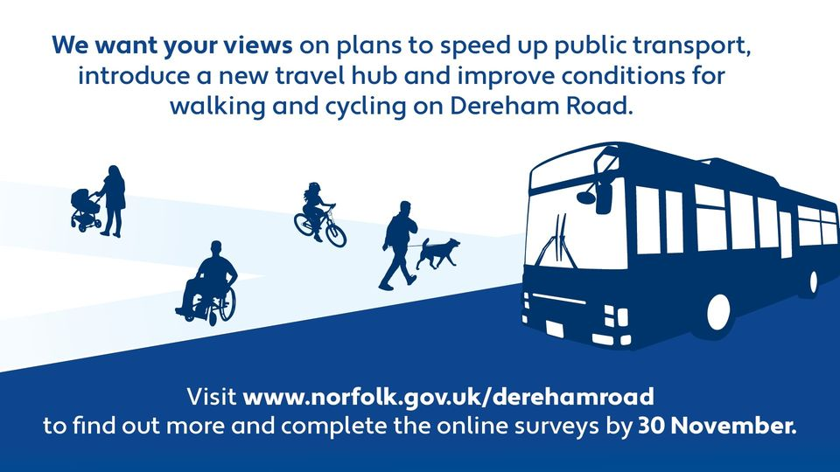
Gritting
The county council’s experienced highway team will be keeping a close eye on detailed specialist forecasts and weather sensors across the county that help inform when and where gritting will be taking place throughout the winter.
Updates will be posted to the county council’s social media channels to let people know when gritting will be taking place. As well as tips and advice for travelling safely through the winter. Look for the #NorfolkWinter hashtag on Twitter and Facebook.
People can check which roads are on the council’s gritting routes for the 2022/23 season on the map at www.norfolk.gov.uk/gritting. On the same map people can find the locations of around 1,900 grit bins in the county that are filled by the County Council and which people can use on public pavements, cycle paths and roads to help everyone get around safely.
Find more information on our website: www.norfolk.gov.uk/winter
Ready for winter driving
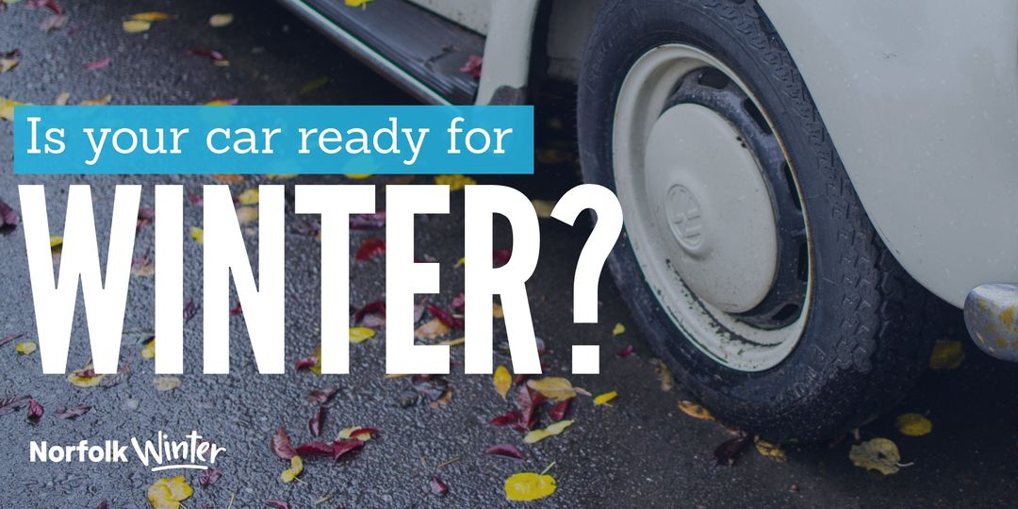
If you’re driving in wintry conditions make sure you give extra space to other road in case, you need to brake.
Keeping your car in as high a gear as possible will help you avoid wheel spin, and if you do need to reduce your speed, go into a lower gear and use the brake pedal very gently – all but the most gentle of braking will lock your wheels on packed snow.
If you’re driving in wintry conditions make sure you #DriveToArrive:
Motorists should check their lights to ensure that they are correctly aligned clean and working. Lights that are not adjusted properly can dazzle other road users, and in turn this may cause an accident. Fog lights must only be used when visibility is seriously reduced
Remember the POWDERY checklist:
Petrol: do you have enough?
Oil & Water: checked?
Damage & Electrics: is your car in working order?
Rubber: are your tyres, OK?
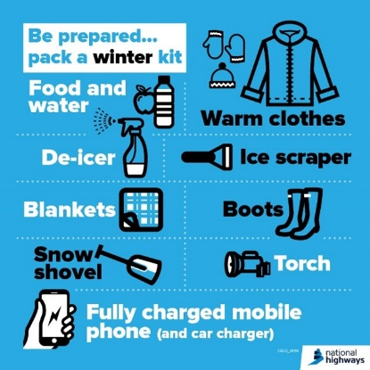
Yourself: are you ready to drive?

For more winter driving tips visit our website:
https://orlo.uk/EnvmM

Looking for a trader you can trust?
Norfolk Trusted Trader is the only assured scheme endorsed by Norfolk County Council. It’s the place to go if you’re searching for quality local businesses.
The scheme has a bright new look as we’ve recently changed provider. Here are the key changes you’ll notice:
• Fully accessible searchable directory so you can find your trusted trader more easily
• Directory optimised to work on all devices
• Easier to give online feedback
• Dedicated support line for consumers looking for a trader
• Free access to a dispute resolution scheme
Choose with confidence – visit our new look Norfolk Trusted Trader directory https://orlo.uk/trusted_trader_718Q4
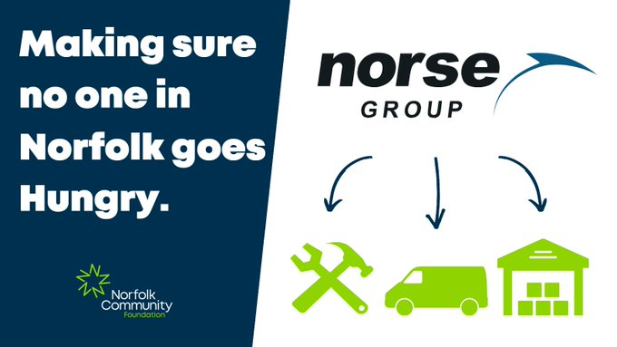
Norfolk Community Foundation
@NorfolkCF
Our Nourishing Norfolk Network is growing faster thanks to our partnership with
@NorseGroupLtd
, who support the food hubs through services like vehicle maintenance and refurbishment work. Hubs will soon also benefit from Norse’s expertise in logistics and warehousing.
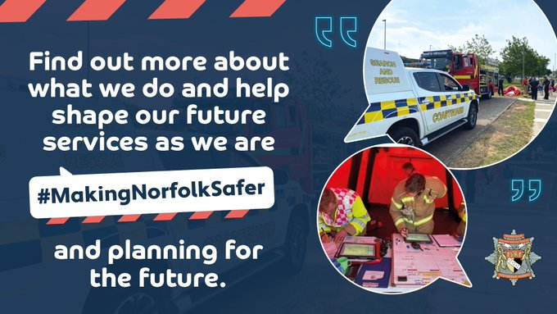
Norfolk Fire and Rescue Service
We hope you had a great weekend. As you ease into another week, please could you spare time to fill in our online consultation about our plans for a Safer Norfolk? We'd love your views on how we best protect our county. Thanks! https://orlo.uk/okSWA

Why is an NHS Health Check so important?
https://orlo.uk/ruXjp
https://orlo.uk/what_is_an_NHS_health_check_G0GId
As we get older, we have a higher risk of developing some health conditions like high blood pressure, heart disease or Type 2 diabetes. An NHS Health Check can help you reduce these risks and stay healthy.
Reed Wellbeing NHS Health Check Practitioners have appointments available at over 40 community venues across Norfolk. If you are 40–74-year-olds and meet the eligibility criteria you can have your health check done on the spot, for free. It’s quick and simple – and can help you to live a better life for longer.
NHS Health Check appointments are available now... to book in visit the Reed Wellbeing website, give them a call on 08081750413, or simply turn up on the day.

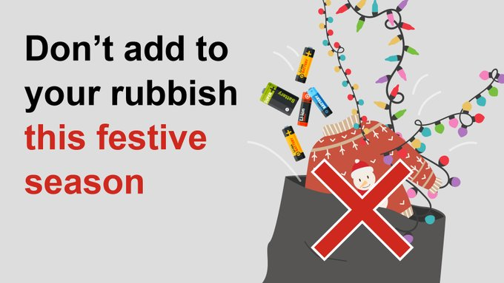
Did you know you can recycle Christmas lights? Don’t put them in your bin – take them to your nearest recycling centre. Find out more at: http://ow.ly/RZIt50LTwsT
Did you know a massive 54 million plates of food are wasted at Christmas alone? Check out our website for top tips to reduce your waste and save some money at http://ow.ly/EjFR50LTxlL
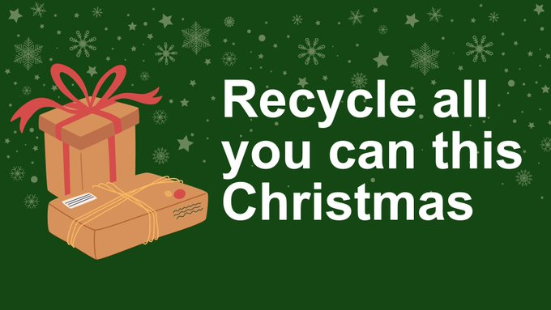
Don’t forget to clean and dry your recyclable containers – we all produce more waste over Christmas, so let’s recycle as much as possible! Find out more at http://ow.ly/5tIZ50LV8kW

- #NorfolkWinter Norfolk Fire & Rescue Service Scam
- Scam Alert –World Cup “Tickets to the Final” Lottery Email Scams – 23 November 2022
- Scam Alert – Romance Scam Emails – 23 November 2022
- Rogue Trader Alert – Doorstep Cold Callers - Roofers – 23 November 2022
- Information Alert – Avian Influenza confirmed, and controls put in place at a premises in Taverham, Norfolk – 23 November 2022
- Cold Calling Alert – Telephone calls claiming to help with Government money – 23 November 2022
- Information Alert - Avian Influenza confirmed, and controls put in place at further premises in Norfolk
- Scam Alert – Telephone cold calls claiming to be from ‘Openreach’
- Scam Alert – Telephone cold calls about ‘money transfers’
- Rogue Trader Alert – Doorstep cold callers selling ‘their’ artwork
- Scam Alert – Telephone cold calls offering ‘medical pain devices’
- Rogue Trader Alert – Doorstep Cold Caller offering tree work
- Information Alert - Avian Influenza confirmed, and controls put in place at further premises in Norfolk
- Scam Alert - Automated telephone calls claiming to be from HMRC
- Scam Alert - Emails claiming to be from 'IPS' about a parcel they were 'unable to deliver'
- Scam Alert - Accommodation rental scams
- Recall Alert - Coca-Cola is recalling a limited number of Coca-Cola Zero Sugar multipacks with Christmas cardboard as some may contain Coca-Cola original taste
- Food Alert - Hotel Chocolat is recalling two lot codes of their 'Hotel Chocolat Caramel Milk Batons' as they contain peanuts which are not mentioned on the label
- News Alert – Norfolk Trusted Trader launches new website
- Information Alert – Avian Influenza confirmed, and controls put in place at a premises near Mileham, Norfolk
- Scam Alert – ‘Family member’ scam messages
- Safety Alert – Office for Product Safety and Standards issues Urgent Safety Alert for baby self-feeding pillows
- Information Alert – Scamnesty 2022
- Food Alert - Nestle UK is recalling some Aero Hot Chocolate products as they may contain small pieces of food grade silica beads
- Food Alert – Lidl GB is recalling their ‘Simply Grated Cheddar 500g’ with the Best Before date of 23 December 2023 because it may contain small pieces of plastic
- Cold Calling Alert – Doorstep cold calling incidents
- Information Alert – Scamnesty 2022
- Scam Alert – Online account registrations and unknown charges on bank accounts
- Safety Alert - B&M are recalling 'My First Ball' as the product may present a choking hazard. Anyone who has purchased the item is asked to stop using it immediately and return it to store for a full refund
- Allergy Alert - Iceland Foods is recalling their 'Iceland Takeaway Pilau Rice 350g' with the Best Before date of 10 January 2024 as it has been incorrectly packed with egg fried rice making the product a possible health risk to anyone with an allergy or intolerance to egg and/or wheat (gluten) and/or sesame and/or soya

