Waste Review: update to come
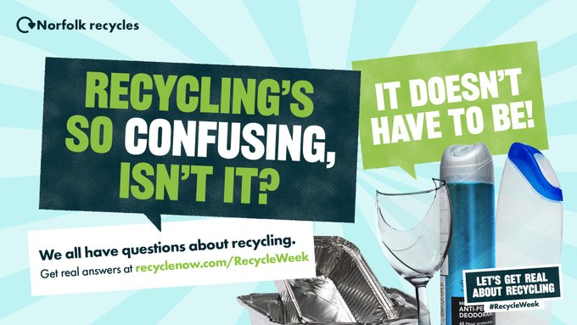
Recycling is so confusing , isn't it?.. It doesn’t have to be! Ask our bin genie. http://ow.ly/ytRq50KSXu3 Lets get real about recycling #RecycleWeek

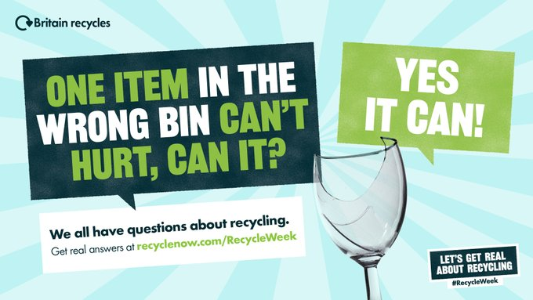
We all have questions about recycling. Get real answers at http://ow.ly/PliN50KZExV #RecycleWeek

SNDC now have their own app
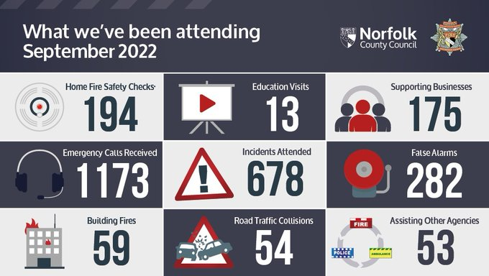
The fire and Rescue service are reviewing the problems with this summer’s heatwave
This will be in 2 parts.
An internal response review including any prevention measures that could have been taken. This is ongoing now.
The 2nd part will be in areas that were particularly affected, Poringland included within that group. This will happen shortly, notified through Clerk, and involve local residents.
Fire engine visit being arranged for Community Centre: fire safety at home
Lots of help still available
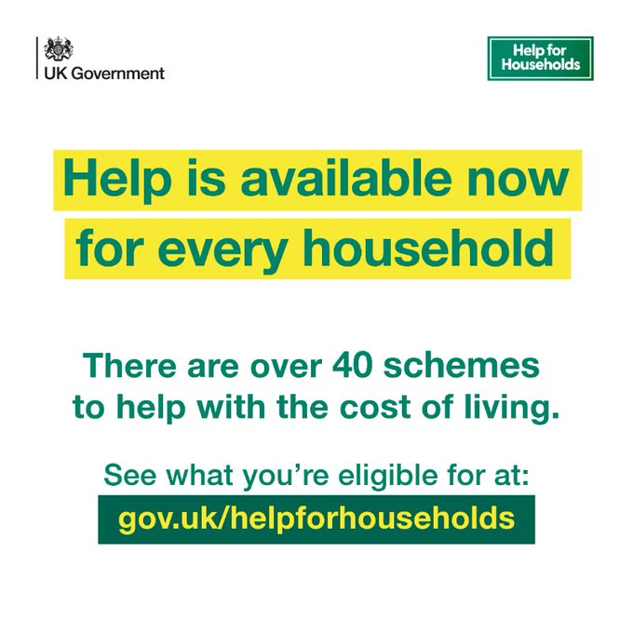
Warm Rooms
Norfolk Libraries Service will be making all 47 of its libraries available as part of the Warm Welcome campaign. The scheme supports free, warm, and welcoming spaces in communities across the UK.
Warm Welcome is a national campaign which will work with community spaces, including churches and faith groups, businesses, and local authorities, to ensure that nobody is left to suffer on their own this winter.
Libraries across Norfolk remain open for all and provide a space for people to sit in comfort and access a variety of services on offer. These include reading, doing a jigsaw, playing a board game, or joining in Just a Cuppa or activities.
“We are proud to be able to join the Warm Welcome campaign, alongside the other support which is on offer from our libraries.”
Other free services available at Norfolk libraries include:
· Tea, coffee, instant soup, and hot chocolate are available during staffed hours
· Library staff and volunteers can provide visitors with trusted information about other support which is available
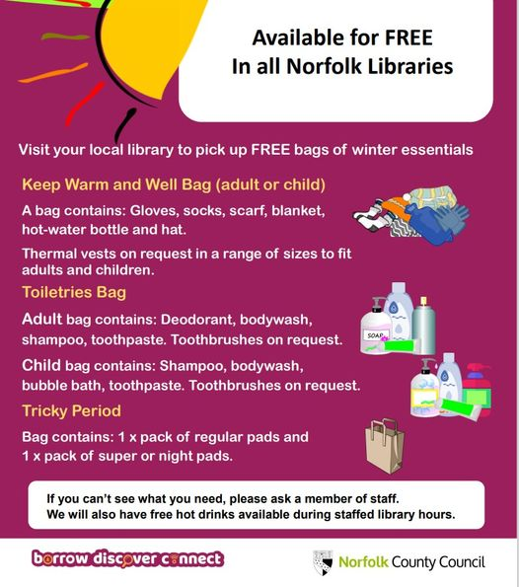
· A variety of bags are available for free, with no questions asked

Message from Lord Dannett at the Flood Alliance
Flooding is a real threat in Norfolk through the winter: keeping even the smallest watercourses clear and flowing freely will help protect homes and businesses safe.
A build-up of flood water with nowhere to drain to can quickly turn a minor incident into a disaster for the home. By checking the drains and ditches on their own property, residents can take action to mitigate the effects of flooding on their home.
To keep your property, and those around you, safe from flooding, property owners must check ditches and watercourses on or adjacent to their land and keep them clear. Even smaller watercourses which may be dry for most of the year, play a key drainage role in wet weather. Find out more about your responsibilities online.
Under UK law, landowners have a responsibility to keep watercourses on their property clear, even if only a few feet of the ditch pass through their property. Hedges or fences that are erected within the boundaries of a property can even prevent owners knowing they have a watercourse to maintain.
Lord Richard Dannatt, Chair of the Norfolk Strategic Flooding Alliance (NSFA), said:
“It’s easy to put flooding into the ‘out of sight, out of mind’ box, and not think about it until the waters start rising, but the most effective steps to protect your home and yourself are taken much earlier. A quick check of your drains and watercourses, making sure water flows freely, can take just minutes but can save you hundreds of thousands of pounds in damages by giving water somewhere to drain to other than into the home.
“There are of course other actions that can be taken to prepare for flooding: on a countywide level, we in the NSFA have put in place new practices, new channels and new ways of working to make sure we can respond to flooding and mitigate it’s impacts more effectively across Norfolk. But to make the country truly resilient, we need everyone to play their part and think about how they can protect themselves and their homes this winter.”
Making sure that water can flow smoothly and easily through existing ditches and watercourses will protect properties from flooding and keep the local community safe. Property owners must keep these ditches clear of fallen trees, branches, bushes, garden refuse or rubble and litter will help water flow: a simple test is to ask whether a fish could swim through the ditch or watercourse. If the answer is no, water flow could also be obstructed and lead to flooding of the property.
For drains in public places and along Norfolk’s highways, the County Council’s Highways Team work to clear them and keep roads open. You can report any blocked or broken drains on Norfolk’s highways via our Floods webpages.

Council Tax
People can have their say on the county council’s Council Tax and spending proposals, until December 16th.
Norfolk County Council wants to hear people’s views on the level of general Council Tax, plus the adult social care precept, for 2023-24.
You can have your say at www.norfolk.gov.uk/budget and paper copies of the consultation can be requested via email at haveyoursay@norfolk.gov.uk
Councillor Andrew Jamieson, cabinet member for finance, said: “We all know the cost of living is rising sharply and that has made our efforts to bridge the £60 million gap much more challenging.
“That’s why I’m so keen to hear people’s views on our Council Tax and key savings proposals.”
The council is consulting on:
- A proposed total increase of 2.99 per cent - 1.99 per cent for general Council Tax and one per cent for the adult social care precept – in line with the current budget planning and the expected level which will be set by the Government.
- People’s views on a rise of 4.10 per cent, as the council has set in previous years, and 10.1 per cent - in line with inflation - which would require a referendum.
The other savings proposals the council is consulting on include:
- Reducing the opening hours of the Norfolk Record Office (NRO) from 28 hours a week to 22.5 hours a week.
- Reducing weed spraying activities on the highway from twice a year to once a year.
- Reducing summer opening hours at Norfolk’s recycling centres and closing all recycling centres on Wednesdays.

The consultation will run from 21st October 2022 to 16th December. Findings will be considered by the cabinet on 30th January, before the full council finalises the budget on 21st February, 2023.

Other reviews

Speed Management strategy. Last version was 2014, new policy going to Cabinet this year including reference to the new Highway Code
Ofsted on Children’s Services

Scams
- Scam Alert – Text messages regarding ‘energy bills discount'
- Information Alert - Avian Influenza confirmed, and controls put in place at further premises in Norfolk
- Scam Alert – Emails claiming to be from PayPal
- Scam Alert – Telephone cold calls claiming to be ‘bank security’
- Cold Calling Alert - Doorstep Cold Callers in the King's Lynn area
- Recall Alert – Iceland recalls their ‘Iceland Ready Cooked Diced Chicken Breast 800g’ with the best before date of 17 June 2023 as some packs may contain uncooked chicken
- Food Alert - Charlie Bigham's is recalling their 'Vegetable Lasagne for 1 365g' and 'Vegetable Lasagne for 2 730g' with the use by date of 24 October 2022 as it may contain plastic making it unsafe to eat
- Scam Alert – Computer Repair Company Scams – 26 October 2022
- Cold Calling Alert – Telephone cold callers regarding solar panels – 27 October 2022
- Information Alert – Avian Influenza confirmed, and controls put in place at further premises in Norfolk – 27 October 2022
- Scam Alert – Postal Lottery Scams – 27 October 2022
- Information Alert - Avian Influenza confirmed, and controls put in place at further premises in Norfolk
- Rogue Trader Alert – Doorstep Cold Callers claiming issues with properties’ roof and chimneys
- Scam Alert – Be aware of Bogus doorstep cold callers
- Rogue Trader Alert – Doorstep Cold Caller selling trees and garden furniture
- Recall Alert – Poundland recalls their ‘Light Up Pumpkin & Ghost’ due to a safety risk
- Recall Alert - Aldi is recalling their 'Kirkton House Pumpkin Ceramic Tealight Wax Burner' as it poses a potential fire risk

