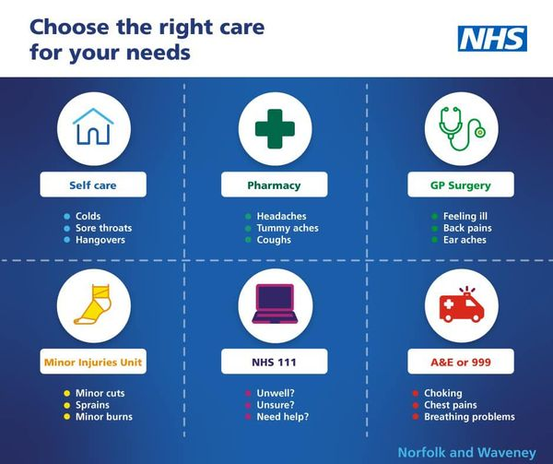

Help us to help you – Norfolk and Waveney’s health and care system under extreme pressure - Norfolk & Waveney Integrated Care System (ICS) (improvinglivesnw.org.uk)
Jubilee Trees for Norfolk – Planting a Lasting Tribute to Queen Elizabeth II
Norfolk residents are being invited to plant a tree in memoriam to honour Her Majesty, Queen Elizabeth II.
Jubilee Trees for Norfolk was launched earlier this year to encourage people to “Plant a tree for the Jubilee” supporting the Queen’s Green Canopy. Norfolk County Council is now relaunching the scheme and hopes that tree planting across Norfolk can offer a long lasting tribute to a monarch so special to our county and create a legacy to honour her dedicated service of more than 70 years,.
The County Council has made half-price tree packs available at seven tree collection points including Norwich (County Hall and Broadland Country Park), Acle, Long Stratton, Watton, Fakenham and King’s Lynn). Residents should apply online at www.norfolk.gov.uk/jubileetrees and the packs will be ready for collection in the planting season between December 2022-February 2023.
Cllr Eric Vardy, Cabinet Member for Environment and Waste, said: “Getting involved with Jubilee Trees for Norfolk and supporting the Queen’s Green Canopy initiative will be a lasting legacy across the county and a perfectly poignant tribute to Her Majesty The Queen, the work she did and the causes she championed during her 70 year reign. This will not only help create new habitats for wildlife in Norfolk but also provide a fantastic opportunity for residents and community groups to do something positive for their county.
“It is also a key part of the Norfolk County Council’s response to tackling the challenges of climate change and will help towards our net zero carbon goals as part of our Environmental Policy.”
The Jubilee Trees for Norfolk scheme is being funded by Norfolk County Council and the Government through the Trees Outside Woodland project.
It is part of the 1 Million Trees for Norfolk project, an ambitious initiative to work in partnership with communities, landowners, other agencies, businesses and individuals across the county to enable one million trees to be planted over five years.
In the 2021/22 planting season, the 1 Million Trees team enabled nearly 45,000 trees to be planted through a range of innovative projects.
Find out more about the 1 Million Trees for Norfolk project and how to apply for the Jubilee Trees for Norfolk here: www.norfolk.gov.uk/jubileetrees
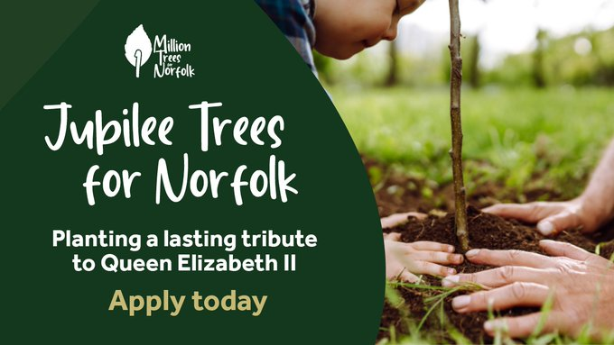

ENDS
Guidance pages are available for applicants on the Norfolk County Council website, which give more information and help make sure the right trees are planted in the right places.
Tree packs come in a range of bundle sizes and types including hedgerow, wildlife, small trees and taller trees. All saplings, which are between 40-60cm tall, are healthy and free of disease and sourced from carefully selected suppliers. There is a smaller discount on the heritage orchard packs, which are hand selected to pollinate and contain maturer trees.
About the 1 Million Trees for Norfolk project
1 Million Trees for Norfolk is an exciting and important initiative agreed at Cabinet in November 2019 as part of Norfolk County Council’s Environmental Policy. The Environmental Policy’s targets are wide-ranging, from committing to achieving ‘net zero’ carbon emissions on our estates by 2030, to creating a Pollinator Action Plan to help protect and recover our nature. The 1 Million Trees for Norfolk initiative is one very important part of the Policy and aims to significantly increase Norfolk’s tree cover.
The project is an ambitious initiative to work in partnership with communities, landowners, other agencies, businesses and individuals across the county to enable the one million trees to be planted over five years.
About Trees Outside Woodland
The Trees Outside Woodland programme is developing innovative and sustainable new ways to increase tree cover to address both climate and ecological emergencies. The £2.5M, three-year programme is funded by HM Government and delivered in partnership by The Tree Council, Natural England, the Department for Environment, Food & Rural Affairs with five local councils.
About the Queen’s Green Canopy
The Queen’s Green Canopy is a unique tree planting initiative created to mark Her Majesty’s Platinum Jubilee in 2022. It invites people from across the United Kingdom to “Plant a Tree for the Jubilee” to create a legacy in honour of The Queen’s leadership.
Once trees have been planted during the planting season they can be recorded on The Queen's Green Canopy map any time from 1st October.

Help for families, Norfolk assistance Schemes
Norfolk County Council has released details of the multi-million-pound support package that is available to communities through a wide range of initiatives. This is being boosted by the latest round of the Household Support Fund from the government, which is worth £6.7m, and is being bolstered by the county council with a further £1.2m, adding to the already significant investments planned for Norfolk communities.
The funding will enable the continuation of the excellent partnership work that has happened across the county date, including creation of 15 food hubs across the County through a pioneering collaboration with the community foundation. This has supported 12,000 people already, with other parts of the country seeking to learn from this best practice.
To date the cost-of-living support through the multi-million-pound package has helped over 128,000 households with £14.3m of funding. People can see which support they are eligible for and apply for help online at through the Norfolk Assistance Scheme (NAS).
We know that some of our residents face financial challenges this winter with the massive increase in the cost-of-living, particularly rising energy costs and food prices. This extended package of investment will help those most in need to access additional support over the winter months, including help with energy and water costs.
The County Council has invested heavily over the last 12 months and is committed to the continuation of vital support to Norfolk Households this Winter, including adding £1.2m to the latest round of Household Support Funds in addition to wider, longer-term investment into our communities
Building on the strong partnerships established across Norfolk, we are working alongside the district councils, the voluntary sector, and schools to make sure we can reach those who need this support the most. It will also provide some much-needed help over the Christmas period.
Recognising the need for local interventions and the role of voluntary and community organisations, the county council is providing Norfolk Community Foundation with £220,000 to provide grants of up to £2,000 towards the cost of running or establishing a Community Hot-Spot that gives a warm welcome to the whole community, in particular reaching those who are vulnerable or have been impacted by the cost-of-living crisis.
“Working with our vital frontline charities this funding will enable us to offer support in two key areas. It will help us to build a network of community hotspots providing warm places across the county for people to come together. In addition, it enables us to reopen the opportunity to help struggling households manage their increasing utilities costs. Last winter this programme saw nearly 20,000 households supported on food bills at what was a very challenging time.
“We are delighted to see our partnership continue and expand at a time when coming together has never been more important.”
Following the success of the current Household Support Fund, Age UK will be supporting this next release of funding focussed on utility payment support. We have recognised that minimum wage and zero-hour workers may have felt they were not entitled to support in previous rounds, therefore we would especially encourage those aged 50 plus with low incomes to reach out to the Norfolk Assistance Scheme.
If you would prefer to chat to us first, please call the Your Norfolk Advice line on 0333 996 8333 where our Triage team will be more than happy to discuss potential support
“We know this year is going to be incredibly challenging for many our customers. We’re incredibly proud of the support provided over the last year but the next 12 months are going be tougher, and we all need to act.
“We’re pleased to be working with Norfolk County Council, Norwich Age UK and Norfolk Community Foundation to highlight the support we can offer for anyone struggling to pay their bills. This year we’ve put forward £65 million of tailored affordability support – this is the biggest package of support we’ve ever provided, meaning we can help even more people in a way that’s tailored to their individual circumstances.
“This support includes discounted tariffs, meaning eligible customers can get up to 50 per cent off their water bill, as well as affordable payment plans, and payment holidays in certain circumstances. We also offer direct support through the Anglian Water Assistance Fund, which is specially designed to help to cover the cost of bills when people are going through the most challenging times. The support package will also signpost customers to potential government benefits they may be able to claim.
“Whatever the circumstances, our message to customers is simple: if you’re struggling, please get in touch. The sooner we talk, the sooner we can help.”
In summary Norfolk County Councils' investment in Norfolk communities includes:
- £7m of capital funding for Multi-Use Hubs which will re-develop town centres in King’s Lynn and Great Yarmouth, co-locating Adult Education and Libraries alongside wider community support
- £4.7m in multiply funding aimed at improving adult numeracy skills through free personal tutoring, digital training, and flexible courses
- £2.7m for the Holiday Activity and Food programme in conjunction with Active Norfolk, providing free holiday activities for eligible children and young people aged 5-16 in Norfolk
- £1.2m for Nourishing Norfolk, Warm Spaces, and to expand the capacity of the Advice Network
The continuation of the Household Support Fund will be spent in several areas:
- £3.6m for cost-of-living vouchers to families of free school meals eligible children with those eligible receiving a total of £120 in vouchers per child for the period
- £2.7m to continue the county council’s existing Norfolk Assistance Scheme (NAS) which provides emergency financial help, essential household goods, and advice and support for all Norfolk residents in need
- £0.9m for district councils to provide community support which targets those most in need, and focuses on providing initial emergency support, as well as providing onwards referral via the NAS
- £0.4m of support targeted to voluntary and community groups, via the Norfolk Community Foundation, enabling Norfolk’s voluntary, community, and social enterprise (VCSE) organisations, faith groups, and town and parish councils to enable direct support to some of our most vulnerable communities
- £0.22m to voluntary and community organisations to cover core costs for providing warm spaces for vulnerable people to access and provide signposting for additional help or support that they might need
- £0.084m to support libraries to continue their “Warm and Well” schemes, and “Grab and Go” bags, including free sanitary products
A vibrant new website, BeNorfolk.co.uk, has been launched today to inspire visitors and locals to try out more than 300 activities and experiences showcasing the best of Norfolk’s nature and culture.
It aims to encourage off-season visits with a variety of free and paid-for experiences, with many of them providing experiences for people with additional physical, sensory, and cognitive requirements.
This website offers inspiration for new walks, cycle routes, adventure and activities for nature lovers, no matter the weather!
BeNorfolk will showcase the county and encourage people to access the full breadth of arts, culture, nature, heritage, and local produce available.
Ranging from guided walks to new cycle paths, craft activities to Champing (camping in historical churches) or stargazing in the Broads, the website is part of the EXPERIENCE project managed by Norfolk County Council. The project is funded by the European Union through its European Regional Development Fund and Interreg VA France (Channel) England programme. The project spans six pilot regions in France and England.
Cllr Eric Vardy, Norfolk County Council’s Cabinet Member for Environment and Waste, said: “We are delighted that BeNorfolk will celebrate the natural and cultural assets of Norfolk, including new and exciting trails and cycling routes to try out. This website pulls together an array of diverse, accessible and sustainable experiences for residents and visitors to explore and enjoy what our county has to offer.”
The new website aims to help people choose the right experiences and activities for them, using filters such as accessibility, theme and season.
Visitors and residents can explore the BeNorfolk interactive website to find events tailored to their interests and location. Users can pick from an extensive menu of options to design their own itineraries to get out and about across the county, meet new people and try something different. People are encouraged to explore the website as new activities are added.

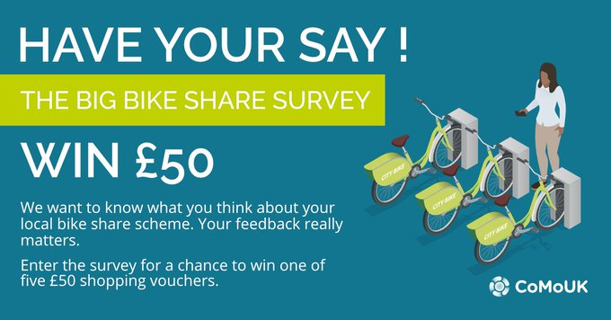
We want to know what you think about
@BerylBikes
share scheme for the Big Bike Share Survey 2022 Please visit this link to share your views https://orlo.uk/L8jQ4 and be in with a chance to win one of five £50 shopping vouchers.

Health and care organisations from across Norfolk and Suffolk have joined forces to promote a new mental health campaign to encourage people to focus on their wellbeing.
Launching on World Mental Health Day, the ‘Take 5’ campaign will encourage people to take 5 minutes to make their emotional wellbeing a priority.
We’re encouraged to eat at least ﬁve fruit and vegetables a day to take care of our physical health, but what about our mental health?
Evidence suggests there are 5 steps you can take to improve your mental health and wellbeing. Trying these things could help you feel more positive and able to get the most out of life.
1. Connect with other people
Good relationships are important for your mental wellbeing.
2. Be physically active
Being active is not only great for your physical health and fitness. Evidence also shows it can also improve your mental wellbeing.
3. Learn new skills
Research shows that learning new skills can also improve your mental wellbeing.
4. Give to others
Research suggests that acts of giving, and kindness can help improve your mental wellbeing
5. Pay attention to the present moment (mindfulness)
Paying more attention to the present moment can improve your mental wellbeing. This includes your thoughts and feelings, your body, and the world around you.
Cllr Bill Borrett, Norfolk County Council’s Cabinet Member for Public Health, said:
"It is vital we learn how to look after not only our mental health but also that of our family and friends,”
“As winter approaches and the days grow shorter, it’s important to find positive ways of looking after ourselves. We hope our ‘Take 5’ campaign will encourage people to eat well, spend time in nature, take up a new hobby and get enough sleep which can all help to nurture our wellbeing.”
A dedicated webpage has been created to bring together suggestions of how people can ‘Take 5’ to improve their emotional wellbeing.
Visit the Take 5 webpage.

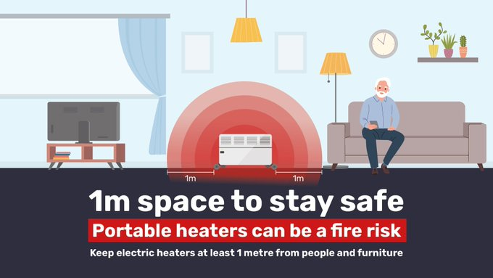
When it’s chilly many of us will use a portable electric heater to stay warm. These heaters can be a fire risk. Keep yours at least 1 metre from people, furniture and items like blankets, cushions and newspapers. Get more info: https://orlo.uk/QSv3E
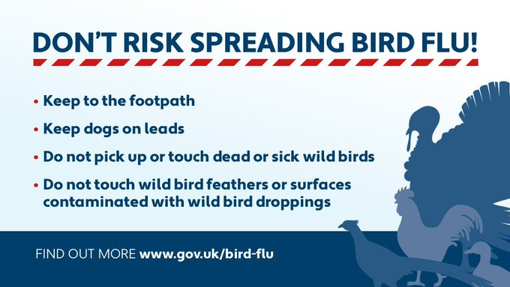
DO YOU KNOW ABOUT THE ‘ANYWHERE, ANYTIME’ TICKET? If you travel between our #Konectbus and #ParkandRide networks and are NOT using our Anywhere, Anytime ticket, you could be losing out. To enquire about these great value-for-money tickets, visit http://konectbus.co.uk/anywhere

- Scam Alert – Emails claiming to be from your email contacts
- Scam Alert – Emails claiming to be from PayPal
- Scam Alert – Telephone cold calls claiming to be from Citizens Advice
- Information Alert – Avian Influenza confirmed, and controls put in place at two further premises near Lowestoft, East Suffolk
- Information Alert – Avian Influenza confirmed, and controls put in place at two further premises near Attleborough, Norfolk
- Rogue Trader Alert – Doorstep Cold Caller claiming issues with properties’ roof – 07 October 2022
- Scam Alert – Energy saving texts received claiming to be from “gov.uk” – 12 October 2022
- Scam Alert – WhatsApp ‘family member’ scam messages - 12 October - 2022
- Scam Alert –Fake SMS messages in Facebook – 11 October 2022
- Rogue Trader Alert – Doorstep Cold Callers – 13 October 2022
- Information Alert – Avian Influenza Housing Order – 13 October 2022

