District Councillor Report – February 2023

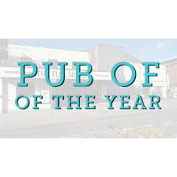
Pub of the Year

I had the pleasure of visiting three pubs in South Norfolk recently.
These were the three that had received the highest number of votes from the public to win the Pub of the Year award for 2023, and it’s worth knowing we received over 1000 nominations for this Award, so the three finalists are all winners.
Myself and two others had the job of judging out of these three who should be the winner and this will be announced at our Business Awards in March.

Domain Migration

It has been 19 months since our joint website went live and we are now approaching the final stages of the migration project to switch off the old domains. So, this means:

• All emails that go to our old email name @s-norfolk.gov.uk, will stop forwarding and will not be received and senders will get a generic email to say they have not been delivered.

• The old websites will also stop re-directing.

Community Resilience Plan
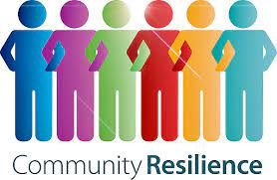
With Christmas a distant memory it's tempting to think that the worst Winter weather is behind us. However, some of our coldest weather and heaviest snow often occurs in February and early March.

It’s worth planning for severe weather and in particular how your community might be affected by loss of power, gas or water during a severe cold snap.
One of the best ways to do this is to produce a Community Emergency Response Plan, which details the resources, networks and contacts your community can use to respond to all kinds of emergencies.
Your community has lots of useful resources available, such as:

• People willing to check on vulnerable neighbours, pick up shopping and medicine or offer lifts.
• Equipment such as generators, portable lights and other tools.
• A convenient meeting place such as a village hall where people can come and get support and a hot drink.
• Detailed knowledge of local risks.

Having a plan in place makes it easier to tap into these resources

Modern slavery

Modern slavery and human trafficking are crimes in which people are exploited for other people’s personal gain. It takes place all over the world, including Norfolk.

The types of exploitation can include, but are not limited to:

- Sexual exploitation: sex work, escort work, pornography, massage parlours, brothels.
- Organ harvesting: removal of organs for black market sale, transplantation.
- Domestic servitude: nannies, cleaners, housemaids.
- Forced begging: forced labour, street begging, pickpocketing/stealing.
- Labour exploitation: construction, farming, textiles, car washes, nail bars, cannabis production

In Norfolk in 2021:
143 National Referral Mechanisms (NRM) were completed. The NRM is a framework for identifying and referring potential victims of modern slavery and ensuring they receive the appropriate support.
71% of reported modern slavery cases involved women and girls. Female victims made up most sexual exploitation cases with more than 50% being minors.
55% of confirmed victims of forced labour exploitation, were children.
The signs of exploitation are visible in plain sight, providing you know what to look for, and once you notice something, there is often anxiety about what to do next.

If you would like to know more please explore the Norfolk Anti-Slavery Network website: www.norfolkantislaverynetwork.

Active NoW
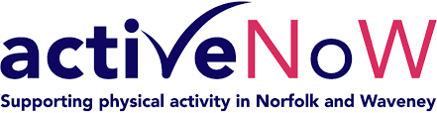
Active Norfolk and Waveney (NoW) is a co-ordination centre for physical activity referrals from the NHS. Commissioned by Norfolk and Waveney Integrated Care System, Active NoW will be a single point of triage for all physical activity opportunities across the county.

Clinicians can refer patients who would benefit from increased levels of activity who will then be contacted by Active NoW staff who will discuss the patient’s goals, capabilities and wider support needs before directing then to the most appropriate form of activity. This could be formal exercise referral programmes such as Broadly Active, or independent, general exercise options such as health walks, parkrun or community-based exercise classes, etc.

The Active NoW team will maintain contact with the patients to judge their progress over 12 weeks and plan a suitable exit route before reporting back to the referring clinician. Residents living in Broadland or South Norfolk and in need of wider support will be assisted by the appropriate service through the Help Hub.

South Norfolk and Broadland Councils have successfully been contracted to deliver this service across the county on a 12-month recurrent contract. The coordination centre started formally receiving referrals from 23/1/23. Both councils will continue to deliver the Broadly Active exercise referral programme to eligible residents within both districts, alongside a small amount of commissioned delivery in Norwich.

The Councils have also received funding through the Better Care Fund to test referrals to the programme from non-traditional sources such as Adult Social Care and Social prescribers.

Yours Creatively

Starting this month, we are running a project named Yours Creatively, which is included in residents’ Yours Sincerely newsletters. Yours Sincerely is posted to community groups and individual residents throughout South Norfolk who have registered to receive the free newsletter. It contains information regarding the Help Hub services available, engaging chat, recipes, wellbeing advice and information about other community events taking place. The aim of the newsletter is to reach out to those more socially isolated in communities so they can feel engaged and are aware of what help is available from the council.

Yours Creatively is an addition to this newsletter with the aim of promoting good mental health and wellbeing through a creative outlet. Working with local artists, five different art projects have been created that can be done at home/in a community group and recipients will also receive a small pack of art materials to enable them to take part. Each project has a theme to explore and includes different written exercises as well as a wide variety of different art techniques to learn and put into practice.
Residents have the option of sending back their work to us in a freepost envelope with a view to creating a public exhibition in the community this Summer.

If you’re aware of any community groups that would benefit from receiving the Yours Sincerely/Yours Creatively newsletter, please let them know about it, they can email communities@southnorfolkandbroadland.gov.uk with their group name and address to be added to the mailing list. If you’re aware of any individuals, please get their consent before sending these details over to us.

Mindful Towns and Villages

We want to make South Norfolk a 'Mindful District' by offering community groups and small businesses two types of free mental health training and support from our Help Hub, we will support towns and villages to achieve 'Mindful Town' or 'Mindful Village' status, with the tools to develop a community-led network of Wellbeing Champions.

To be recognised as a 'Mindful Town or Village', several representatives from the local community need to commit to becoming Wellbeing Champions. These could be members from sports clubs, pubs, small local businesses, community organisations, the Town/Parish Council, or any other local community pillars.

These representatives will be offered free training, which will enable them to recognise mental health issues and provide low-level support to individuals in the community. Wellbeing Champions will also be given knowledge on the Councils’ Help Hub, local services and how to refer people to a specialist mental health support worker should a resident need further assistance.
When the required number of individuals have completed the training in the area, the Town/ Village will receive window stickers to make residents aware where they can seek support. These can be displayed to show that the place is a safe place to talk and has a Wellbeing Champion for support.

Town and Parish Council Forum

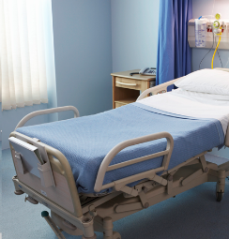
We recently held this month’s Town and Parish Council Forum this covered a number of topics one is District Direct where we are helping with patients getting discharged from hospital.
Delays in hospital discharges is creating a crisis due to a shortage of admission beds but South Norfolk and Broadland Councils now have a service in the NNUH working to ensure that discharges take place as soon as they can, this is called District Direct. Because the District Direct team can purchase goods and services immediately they can work quickly to remove impediments to discharge.
The hospital believes that referring a case to District Direct saves, on average, eight bed days.
The team work across the whole catchment area of the hospital, irrespective of the district in which the patient lives.
In the financial year to December District Direct have received 1000 referrals thus saving 8,000 bed days.

New Member of staff

I’m pleased that we have hired a new Flood & Water Management Officer.
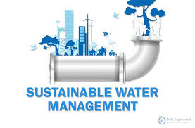
Nathan Harris - Flood & Water Management Officer
01508 505254
07401 191197
nathan.harris@southnorfolkandbroadland.gov.uk

District members were keen for Officers to look after the needs of our local communities and felt the Council is perfectly placed to deliver a strong programme supporting local resilience and identifying actions to reduce flooding likelihood and impacts and they will actively encourage others to do the same.
Another role that I’m really pleased about is a Surface Water Drainage Officer ‘Ditch walker’.
New 12 months post
Practical role focussing on ‘walking ditches’ to inspect, investigate and resolve issues of land drainage, including advising landowners on their responsibilities to maintain water courses.
Emergency incident scheme which means a council representative can be on site in a flooding event, providing support as required

What they will be looking at:
- Riparian issues
- Blocked/Overgrown water courses
- Fly tipping within water courses
- External flooding to property
- Provide general flood prevention advice
- Provide advice on planning

What is the best way to get this information out to your residents and businesses?
If you have parish magazines or well used social media groups please let us know and we can make sure we reach as many people as possible.

Public Sector Decarbonisation Bid

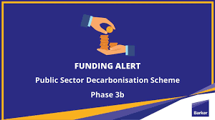
We received some good news last week that we were successful with a bid both Councils put in for the Public Sector Decarbonisation Grant and we were awarded just over £2M. South Norfolk’s portion of the grant will be spent on:
Horizon Centre – replacement of boilers with air source heat pumps.
Diss Leisure Centre – replacement of boilers with air source heat pumps, insulation of external walls and roof and solar panels on the roof.
Kestral House (one of our temporary accommodation houses) – replacement of boilers with ground source heat pumps and solar panels on the roof.

East Anglia Green Energy Enablement (GREEN) Project

National Grid is proposing to reinforce the transmission network between the existing substations at Norwich Main in Norfolk, Bramford in Suffolk, Tilbury in Essex as well as connect new offshore wind generation. This would be achieved by the construction and operation of a new electricity transmission line over approximately 180km and a new connection substation.
The reinforcement would comprise of mostly overhead line (including pylons and conductors) and some of this will go through South Norfolk. It goes along the Mulbarton side of the A140 so although it doesn’t immediately affect you it will change the skyline with new pylons so I have attached a link to the website where you can read more about it if you want to.

https://www.nationalgrid.com/electricity-transmission/network-and-infrastructure/infrastructure-projects/east-anglia-green-our-proposals-south-norfolk

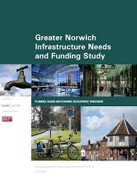
Greater Norwich Infrastructure Plan

Norwich City Council, Broadland District Council and South Norfolk Council are the three authorities who make up the Greater Norwich area, and they pool a significant proportion of their CIL income to form a joint Infrastructure Investment Fund.

Each Council bids for funding for projects in the next five years and SNC were successful with a number of projects:

- £153,000 – access and car park improvements at the Caistor Roman Camp
- £133,000 – Queens Hill Community Park
- £468,000 – Cringleford Country Park
- £500,000 – Easton Community Centre
- £5M – Hethel Technology Park – roundabout and access road

