We opened the old school buildings for Peter to take some photos of the school interior before the building was redeveloped. Joined by Chair and Clerk.
Amazing how different a building looks when not being used. There are still some items I think could be re-used and have contacted officers.
Extra government funding for electric buses in Norfolk
Norfolk County Council has received confirmation of an extra £11.4 million funding from the Department for Transport to electrify bus services in Norwich. This means a total of 70 zero-emission buses will be arriving in Norwich next year, along with Roundtree Way bus depot becoming one of the first two fully electric bus depots outside of London.
An additional 57 fast chargers will also be installed at the Roundtree Way First Bus depot and all diesel infrastructure removed, making it a fully electric depot.
This funding is in addition to the £3.3 million confirmed in March 2022, bringing the total funding to more than £14.7 million for Norfolk. First Bus are funding the additional £21 million needed to make the scheme happen.
The bus routes that these buses will serve are in Greater Norwich and will run through the city centre, currently declared an Air Quality Management Area.
Funding for highways and transport in Norfolk over the next year
Carbon-cutting transport schemes are set for a £29 million boost in Norfolk, despite the tough financial climate.
Cabinet considered a forward looking and carbon-cutting transport budget for the new financial year at a meeting on 6 March.
At £133m the 2023/24 highways and transport budget represents a £29m increase on the previous year’s budget. Despite inflation being expected to dent the authority’s spending power the highway and transport team have been focusing on maintaining and improving the network and continuing strong investment in carbon cutting transport strategies as the council moves towards net zero carbon by 2030.
The report summarises the funding and proposed allocations for 2023/24/25/26. It also includes the successful progression of the 3rd River Crossing in Great Yarmouth, the Transforming Cities Fund in the Greater Norwich area, and Long Stratton Bypass.
Cabinet also received an update on the improvements being made possible through the additional £10m investment in highway maintenance which will see £2.4m spent in 2023/4 on a number of key routes in the county, including the A149 at King’s Lynn and Wells and the A1065 at Swaffham and Hilborough.
Details of the location and cost of 120 walking, cycling, and road improvements across the county, and how £45.6m will be spent on maintenance of bridges, roads, drains and paths, are also available in the papers.

Norfolk Investment Framework – proposed new projects.
Developed by the county council and key stakeholders, the Norfolk Investment Framework (NIF) is used to inform and identify long-term investment priorities for the county to boost the economy and improve public services.
On 15 March Norfolk County Council's Infrastructure and Development Select Committee recommended to Cabinet a draft climate change strategy that that outlines how the Council will hit its net zero estate target by 2030, support clean growth across the county, and boost resilience to the changing climate.
Members heard that the authority’s own emissions from its buildings, streetlights and vehicles have halved in five years, and that the strategy sets a commitment to maintain this momentum and reduce these emissions by 90% from 2016/17 levels by 2030, with remaining emissions being offset.
The draft strategy aims to reduce emissions from the Council's own operations and services, as well as support wider emissions reductions and clean growth across the county. It includes measures to promote low-carbon transport options, develop the skills needed for the green economy, and encourage sustainable tourism. The Council will also work with local businesses and communities to support nature recovery, such as the nationally-significant Wendling Beck Project, being delivered by partners including Norfolk County Council.
“A collective effort will be needed to address climate change, and we’ll need to work with our partners and stakeholders to achieve our ambitious targets, including our District Councils and the private sector,”
“There are also huge opportunities for Norfolk. Our offshore energy industry will create skilled, year-round jobs while reducing emissions and making the whole country’s energy supply more secure. Norfolk also has the potential to really position itself as the UK’s most sustainable tourism destination with the investment opportunities and job creation which will follow.”
Trowse PC carbon footprint.
Are you interested in working out your Carbon Footprint and when you can become Carbon Neutral?
New Projects
At their meeting on 6 March, Cabinet agreed funding for 12 new pilot projects to shape Norfolk’s economic future, using £1.5 million from the local business rates fund. The proposed projects are the first phase of NIF. The projects include:
- Exploring development of a seaweed industry to support food, fertilisers, animal feed, biofuels and bioplastics. Stop the use of Soy.
- Investigating water storage and desalination and the efficient movement of water supplies around Norfolk.
- A digital and creative media centre in Watton, to improve skills and encourage start-up businesses.
- Working with colleges to support recruitment and retention of skills tutors, including the development of a bursary to support graduates in taking up tutoring jobs.
- Investigating the development of a rooftop solar panel network across greater Norwich.
- Carrying out a feasibility study on retrofitting homes to maximise energy efficiency.

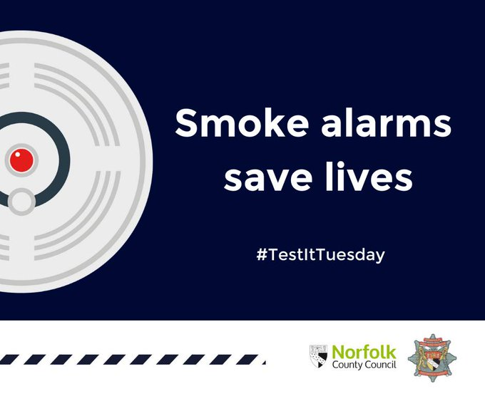

It takes just one press to test, so this #TestItTuesday let's all tests our alarms and ensure they make a noise. If they do, they work, if not replace the battery immediately.

