District Councillor Report – April 2023

Planning:

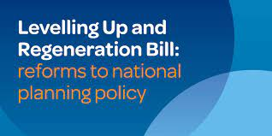
We have received two more consultations from the DLUHC (Department for Levelling Up, Housing and Communities) covering Stronger Performance of Local Planning Authorities supported through an increase in Planning Fees and Permitted development rights.

This shows they are looking at a total overhaul of the Planning system.

Nutrient Neutrality:
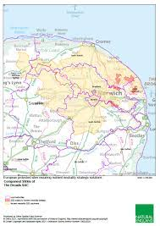
In line with the ambition to support both the environment and development, the Spring Budget 2023 announced funding to deliver local nutrient mitigation schemes which will boost the supply of mitigation available to support sustainable development.
This call for evidence and expression of interest seeks to help unlock stalled housing by deepening our understanding of the issues facing local planning authorities and supporting the creation of locally led nutrient mitigation schemes to allow development to move forward whilst ensuring these habitats are protected.
Where high quality proposals are identified in line with the relevant criteria, the government will provide funding. We are in the process of providing details of the JV we are part of with all the District Councils in Norfolk, apart from Norwich City Council. We remain in a very strong position to secure a significant sum of grant money via this mechanism. The first tranche allows each area to bid for up to £10m.

