Extra government funding for electric buses in Norfolk
Norfolk County Council has received confirmation of an extra £11.4 million funding from the Department for Transport to electrify bus services in Norwich. This means a total of 70 zero-emission buses will be arriving in Norwich next year, along with Roundtree Way bus depot becoming one of the first two fully electric bus depots outside of London.
An additional 57 fast chargers will also be installed at the Roundtree Way First Bus depot and all diesel infrastructure removed, making it a fully electric depot.
This funding is in addition to the £3.3 million confirmed in March 2022, bringing the total funding to more than £14.7 million for Norfolk. First Bus are funding the additional £21 million needed to make the scheme happen.
The bus routes that these buses will serve are in Greater Norwich and will run through the city centre, currently declared an Air Quality Management Area.
Funding for highways and transport in Norfolk over the next year
Carbon-cutting transport schemes are set for a £29 million boost in Norfolk, despite the tough financial climate.
Cabinet will be considering a forward looking and carbon-cutting transport budget for the new financial year at a meeting on 6 March.
At £133m the 2023/24 highways and transport budget represent a £29m increase on the previous year’s budget. Despite inflation being expected to dent the authority’s spending power the highway and transport team have been focusing on maintaining and improving the network and continuing strong investment in carbon cutting transport strategies as the council moves towards net zero carbon by 2030.
The report summarises the funding and proposed allocations for 2023/24/25/26. It also includes the successful progression of the 3rd River Crossing in Great Yarmouth, the Transforming Cities Fund in the Greater Norwich area, and Long Stratton Bypass.
Cabinet will also receive an update on the improvements being made possible through the additional £10m investment in highway maintenance which will see £2.4m spent in 2023/4 on a number of key routes in the county, including the A149 at King’s Lynn and Wells and the A1065 at Swaffham and Hilborough.
Details of the location and cost of 120 walking, cycling, and road improvements across the county, and how £45.6m will be spent on maintenance of bridges, roads, drains and paths, are also available in the papers.
Cabinet will consider the report on 6 March. You can find out more about the proposals and read the report here.
Norfolk Investment Framework – proposed new projects.
Developed by the county council and key stakeholders, the Norfolk Investment Framework (NIF) is used to inform and identify long-term investment priorities for the county to boost the economy and improve public services.
On 15 March Norfolk County Council's Infrastructure and Development Select Committee will review a draft climate change strategy that that outlines how the Council will hit its net zero estate target by 2030, support clean growth across the county, and boost resilience to the changing climate.
Members will hear that the authority’s own emissions from its buildings, streetlights and vehicles have halved in five years, and that the strategy sets a commitment to maintain this momentum and reduce these emissions by 90% from 2016/17 levels by 2030, with remaining emissions being offset.
Councillor James Bensley, who chairs the committee, said: “I am pleased that we will be reviewing a strategy that outlines firm, ambitious targets to reduce emissions and a coherent approach to adapting to changing weather patterns. The threat of climate change is real, and we must take action now to safeguard Norfolk's future.”
The draft strategy aims to reduce emissions from the Council's own operations and services, as well as support wider emissions reductions and clean growth across the county. It includes measures to promote low-carbon transport options, develop the skills needed for the green economy, and encourage sustainable tourism. The Council will also work with local businesses and communities to support nature recovery, such as the nationally-significant Wendling Beck Project, being delivered by partners including Norfolk County Council.
“There are also huge opportunities for Norfolk. Our offshore energy industry will create skilled, year-round jobs while reducing emissions and making the whole country’s energy supply more secure. Norfolk also has the potential to really position itself as the UK’s most sustainable tourism destination with the investment opportunities and job creation which will follow.”
At their meeting on 6 March, Cabinet will consider funding 12 new pilot projects to shape Norfolk’s economic future, using £1.5 million from the local business rates fund. The proposed projects are the first phase of NIF. The projects include:
Exploring development of a seaweed industry to support food, fertilisers, animal feed, biofuels and bioplastics.
Investigating water storage and desalination and the efficient movement of water supplies around Norfolk.
A digital and creative media centre in Watton, to improve skills and encourage start-up businesses.
Working with colleges to support recruitment and retention of skills tutors, including the development of a bursary to support graduates in taking up tutoring jobs.
Investigating the development of a rooftop solar panel network across greater Norwich.
Carrying out a feasibility study on retrofitting homes to maximise energy efficiency.

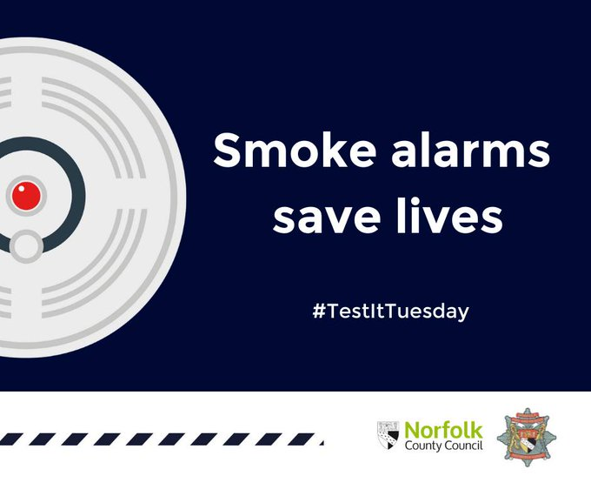
It takes just one press to test, so this #TestItTuesday let's all tests our alarms and ensure they make a noise. If they do, they work, if not replace the battery immediately.

21 March 2023
1 Million Trees Initiative Passes 200,000 Trees Milestone
As the 1 million Trees for Norfolk initiative approaches the end of its third planting season, Norfolk County Council is excited to announce a significant milestone in the journey to a greener, healthier county. of the aim of hitting 200,000 trees by the end of this season has been exceeded with the total now standing at nearly 210,000 trees and hedgerows planted. The efforts of the community and our partner organisations have been vital in us achieving this and in securing a sustainable future for Norfolk.
The Jubilee Trees for Norfolk scheme has played a big part of this with residents and organisations coming together to leave a legacy for the late Queen. This scheme alone has been responsible for the planting of nearly 33,000 trees to benefit future generations and help combat the effects of climate change. The County Farms Hedge Restoration Fund has also added more than 50,000 hedge plants to the total, which stood at 68,000 at the beginning of this planting season.
"This initiative is about much more than just planting trees. It's about addressing the environmental challenges we face and creating a greener, more sustainable future for Norfolk. The success of the Jubilee Trees scheme shows what can be achieved when we work together, and I'm excited to see what the future holds for this initiative".
With funding secured for the next planting season in November, Norfolk County Council will continue to work towards the goal of planting 1 million trees by 2025. Exciting new projects are planned, including a woodland planting scheme and a new partnership with Norfolk Farming and Wildlife Advisory Group (FWAG) to encourage woodland creation across Norfolk. Building on the success of ‘Jubilee Trees for Norfolk’ there will also be a new tree scheme supplying trees for the public to plant across the county.
Norfolk County Council would like to extend a special thank you to all those who have participated in the initiative by planting trees in their community. If you have planted trees as part of the 1 Million Trees for Norfolk initiative, please fill in the "Tell Us About Your Trees" form. Your contributions will be counted towards our total and will help us reach our goal.
To stay updated on the progress of the initiative and to receive information on future planting opportunities, sign up for our 1 Million Trees newsletter.
For more information on the 1 Million Trees for Norfolk initiative, visit www.norfolk.gov.uk/milliontrees

Norfolk County Council and Net Zero
Norfolk County Council has committed to working with our partners to achieve ‘net zero’ carbon emissions on our estates by 2030, but within our wider areas, work towards ‘carbon neutrality’. This also supports the government’s ambition for a net zero country by 2050.
We will achieve this by implementing carbon conscious ways of working across our buildings and supply chain; putting in place the right infrastructure across the county to support the move towards net-zero; and by working together with partners to lead and inspire our colleagues, citizens, communities, and businesses to take action and play their part in protecting Norfolk for future generations.

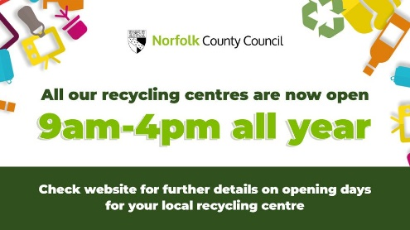
All our recycling centres are now open from 9am-4pm all year.
Check here https://orlo.uk/recycling_centres_xMiST for further details.
- Rogue Trader Alert – Doorstep cold callers offering gardening and tree work
- Safety Alert – Office for Product Safety and Standards identify unsafe toothed saw blade attachments
- Rogue Trader Alert – Doorstep cold callers attempting to sign consumers up to contracts
- Safety Alert – Morrisons recall their 'Valentine's Latte/Chocolate Glass due to the risk of the glass cracking
- Safety Alert - Smyths Toys recalls their own brand 'Jumping Ball' due to a chemical risk
- Cold Calling Alert - Telephone cold calls regarding 'loft insulation'
- Scam Alert – WhatsApp account take over scam
- Scam Alert – Automated telephone cold calls about 'unauthorised transactions'
- Scam Alert – International FIFA World Cup Online Lottery Letters
- Safety Alert - IKEA recalls their 'BLAVINGAD fishing game, multicolour' due to a possible choking hazard
- Safety Alert - Giro is voluntarily recalling their 'Giro Merit Helmet' manufactured prior to February 2023 due to potential safety risk

