Norfolk County Council and Suffolk County Council have been formally appointed by Government as responsible authorities for preparing a Local Nature Recovery Strategy for their respective counties.
This means that they will be working together to help improve wildlife habitats and reverse the decline of biodiversity across the region, working with local communities to develop a tailored nature recovery strategy for their areas.
They will also work with other local planning authorities, the Broads Authority, Natural England, and a wide range of stakeholders and partners, including farming and landowner groups.
This is all part of Government’s ambition to further drive nature recovery, with 48 individual local authorities across the country receiving allocations from a £14 million funding pot. Norfolk and Suffolk County Councils will receive £333,000 and £282,000 respectively over two years to fund this work. With the best ways to support nature recovery depending on local character and geography, Local Nature Recovery Strategies will help communities map out the action needed in their area to restore nature.
The Norfolk and Suffolk councils have already been working closely with each other, jointly hosting the Norfolk and Suffolk Nature Recovery Partnership, and a host of other stakeholders and interested parties to prepare for this moment. The two authorities have pooled resources and expertise and to ensure that strategies effectively join up across the two counties to the wider benefit of nature and people.
The Strategies will focus on how to improve habitats and protect the natural environment across the region, with local approaches tailored to the specific circumstances of each area. Norfolk and Suffolk are home to a variety of beautiful and unique landscapes, from the chalk streams of the Norfolk Coast to the Stour estuary at the south east of Suffolk and across many habitats in between, and specific policies will be drawn up to best protect and nurture each location.
Future plans will include working closely with other neighbouring counties, to identify and support opportunities for nature recovery at sufficient scale to really benefit wildlife.”
Our countryside and natural environment is a key part of our identity here in Norfolk, and we’re absolutely committed to nurturing it. Our work with Suffolk County Council will help protect nature throughout our counties and give it a chance to recover, to grow and to flourish for many generations to come.
Food waste
Households across Norfolk and Suffolk are being urged to sign up for a mission to do their bit to protect the planet and help get the best out of salad and vegetables.
Mission Food Savvy is targeting these items in the war on waste as they are some of the most thrown away foods in the two counties.
The summer campaign promotes savvy ways to store salad and vegetables to keep them fresher to be savoured another day; or send them undercover in delicious dishes to make sure nothing goes to waste.
Using a fun, hero agent theme, the campaign reveals how everything from tomatoes to cucumbers, carrots to broccoli, can escape the waste bin through better planning, storing and cooking.
Mission Food Savvy is the latest in the well-established Food Savvy campaign, run jointly by Norfolk County Council and Suffolk Waste Partnership. The campaign inspires households to reduce food waste by:
- Planning meals before shopping to ensure nothing goes to waste
- Keeping vegetables and salads in optimal condition by storing them correctly
- Getting creative with leftovers and send spare veg undercover into other dishes.
Suffolk Waste Partnership and Norfolk County Council work together on the Food Savvy campaign.
Rob Cole of the Suffolk Waste Partnership said: “Households in Norfolk and Suffolk throw away enough food in a year to fill Norwich Castle almost 25 times over, or 155 Bury St Edmunds cathedrals. What we are challenging people to do is to make it their mission to plan what they need and not waste food or money.”
Councillor Eric Vardy, Norfolk County Council cabinet member for Environment and Waste said:
"The average household wastes over two months’ worth of food each year - that's more than £700. Reducing food waste is good for the planet and our pockets, especially as many of us are working hard to make our budgets stretch further. We hope residents embrace our FoodSavvy mission and are inspired to use up their leftovers."
As well as financial savings there are environmental savings too. If everyone in the UK stopped throwing away food for just one day it would be the same as taking 14,000 cars off the road for a whole year.
Volume of food waste calculations based on 737,883 households in Norfolk and Suffolk (Census 2021). It assumes each household has a waste bin with a capacity of 240 litres, so the total volume of waste bins in Norfolk and Suffolk is about 177.1 million litres. Our research shows that 35% of this volume contains food waste, therefore the volume of food waste in the waste bins is about 62 million litres. There are no official stats to the volume of local landmarks, but we can make some rough estimates for illustrative purposes. For instance, the volume of food waste in the waste bins is roughly equivalent to:
- 24.8 Norwich Castles (the castle has a volume of about 2.5 million litres – estimated by multiplying height of 27m by area of 93,000m2)
- 155 Bury St Edmunds Cathedrals (the cathedral has a volume of about 400,000 litres – estimated by multiplying height of 40m by area of 10,000m2)
The average household wastes £700 of food each year. The latest ONS survey shows our region, ‘East’, spends £66.40 a week on food and non-alcoholic beverages (ONS Family Spending Workbook 3 – 31 May 2023). Annual wastage figure divided by weekly spend makes an equivalent of 10.54 weeks, and 4 weeks per month makes 2.5 months.
The greenhouse gas emissions associated with the 9.5 million tonnes of food waste in the UK in 2018 have been estimated to be around 36 million tonnes of carbon dioxide equivalent (CO2e), according to the latest report from Waste and Resources Action Programme (WRAP). [ONS]
Norfolk County Council has committed to working with our partners to achieve ‘net zero’ carbon emissions on our estates by 2030, but within our wider areas, work towards ‘carbon neutrality’. This also supports the government’s ambition for a net zero country by 2050.
We will achieve this by implementing carbon conscious ways of working across our buildings and supply chain; putting in place the right infrastructure across the county to support the move towards net-zero; and by working together with partners to lead and inspire our colleagues, citizens, communities and businesses to take action and play their part in protecting Norfolk for future generations.
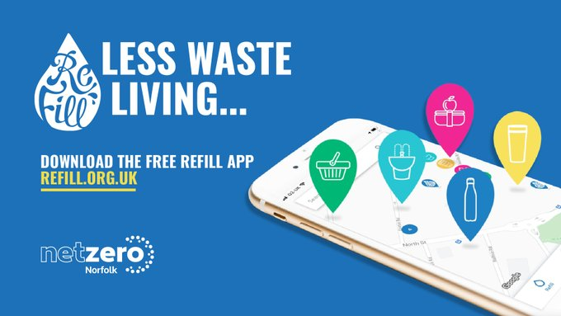
Did you know that around 75% of all litter consists of items used for drinks? Join the #RefillRevolution and top up your reusable cups or bottles at hundreds of locations in Norfolk which you can find on the free
@Refill
app. Find out more here: https://orlo.uk/refill_AcEYS
Heading for a day out this summer? Take your reusable bottles, coffee cups and lunch containers with you.
Look out for the Refill HQ window sticker to find hundreds of places to top up in Norfolk and save on the pointless packaging.
Find out more here: https://orlo.uk/refill_norfolk_z7gVy

Batteries
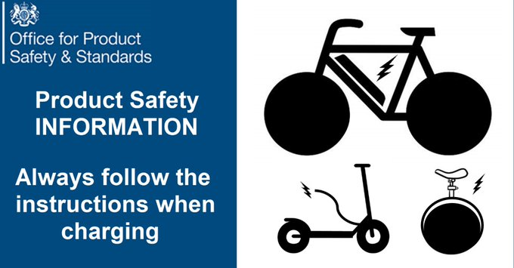
DON’T cover chargers or battery packs when charging overcharge battery overload sockets or use inappropriate extension leads
follow manufacturer’s instructions unplug charger when finished charge batteries while you are awake use the manufacturer approved charger
Cheaper batteries purchased from online sources which don’t necessarily adhere to UK safety regulations are more likely to fail and present an increased fire risk Always buy from a reputable seller and #ChargeSafe
Enjoy a family day out in Norwich! Groups of 5 can travel for just £6 on weekends or week days after 10am. http://konectbus.co.uk/norwich-park-ride

Fares on all Norwich park & ride services will be even cheaper from this September, making it easier and more affordable to travel car-free into the city centre by bus.
The new fares will be introduced, thanks to money that Norfolk County Council has secured from the Department for Transport (DfT) to help improve bus services across the county.
From Monday 4 September, passengers will be able to travel for one price at any time of day. The new fares have been designed to provide more flexible fare options for those choosing to travel independently, as a couple, as a family or with friends.
- Adults - £3
- Concessions £2
- 17-19 year olds - £2
- Child (5-16) - £1.50
- Extra passengers will cost just £1 when travelling with a full paying passenger.
- Under 5s still travel for free
The new fares coincide with the re-opening of Postwick park & ride, which further enhances the service, providing five out of town sites for those wishing to visit Norwich, from all major routes into the city .
The park & ride is a vital service for Norwich and with the re-opening of Postwick it’s important that we get passenger numbers back up across all our sites. These new prices make the park & ride a really affordable option for a trip into the city and is great for people wanting to avoid parking in the city centre. With buses running every 20 minutes throughout the day it’s also a great flexible option for those wanting to get to work in a cheaper and greener way.
This is the first fares promotion to be announced as part of the County Council’s Bus Service improvement Plan (BSIP).
Approximately £5.3 million of the BSIP funding has been allocated to fares promotions to make bus travel more affordable in Norfolk over the next three years.

Norfolk Bus Service Improvement Plan
Norfolk received the sixth highest allocation in the country and the funding consists of £30.9m of capital funding and £18.6m of revenue funding.
The plans outline 17 new measures across the county which give buses priority on the roads. These include new bus lanes in Norwich, King’s Lynn and Great Yarmouth and redesigned junctions across the county.
New or improved travel hubs are proposed for Sheringham, Cromer, Diss and Hunstanton which will provide better waiting areas with real-time information to help to give passengers a better experience as well as being integrated with walking and cycling facilities.
There will also be a county-wide review of bus stops with upgrades to improve access for people with disabilities, to provide more real-time information and a programme of works to reduce delays to buses.
Improved services announced as part of the BSIP:
Lynx 35 and 36 service
Sanders – X55 and 210 service
Konectbus – 5b and 11a service
Konectbus - 512 service
Konectbus – Fab4 service
Sanders – X40 service
Konectbus – 35 Canary Konect service
Lynx 35/38/48/49 services
First – Pink line extension
Coach services - 88/89 service
First – multiple service enhancements

Regular bus users and people travelling in groups are set to benefit from cheaper bus fares from next month thanks to money that Norfolk County Council secured from the Department for Transport (DfT) to improve bus services across the County.
The new fares discount, which will start on 3 September will mean that group day tickets for up to five people, weekly tickets and monthly tickets on all services across Norfolk will be discounted by 25%*.
This is the third in a series of fares discounts recently announced, with cheaper tickets on all Norwich park & ride services from September and the King’s Lynn Town Zone flat fare of £1.50 which starts next week.
Approximately £5.3 million of the funding received from the DfT has been allocated to fares promotions to make bus travel more affordable in Norfolk over the next three years.
Norfolk County Council Net Zero
Encouraging more people to use the bus travel and other sustainable options is key to our ambitious aims of achieving net-zero in Norfolk by 2030.
Norfolk County Council has committed to achieve ‘net zero’ carbon emissions on its estates by 2030, but within its wider area, to work with partners towards ‘carbon neutrality’. This also supports the government’s ambition for a net zero country by 2050.
We will achieve this by implementing carbon conscious ways of working across our buildings and supply chain; putting in place the right infrastructure across the county to support the move towards net-zero; and by working together with partners to lead and inspire our colleagues, citizens, communities, and businesses to take action and play their part in protecting Norfolk for future generations.

The school and council want to understand what the biggest challenges are in supporting your children to attend school regularly and how we can support your family to overcome them. Take the five-minute survey to share your thoughts at: https://orlo.uk/attendance_bSEBq

No big deal, we've only gone and signed up 7000 children already to the
#SummerReadingChallenge. (Okay, it IS a big deal). Find out more about the challenge here: http://tinyurl.com/NorfolkLibsSRC2023… and find out about our events for children here: http://tinyurl.com/SRC2023Events

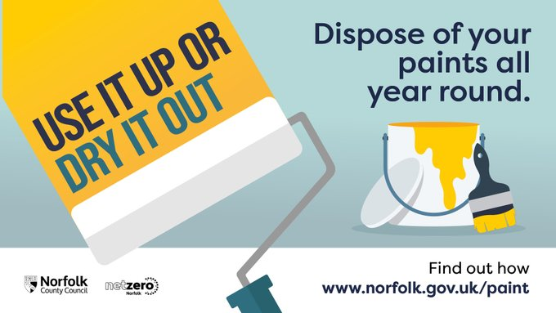
Do you need to dispose of unused paint? Find out how to at https://orlo.uk/disposing_of_paint_7W2Wy
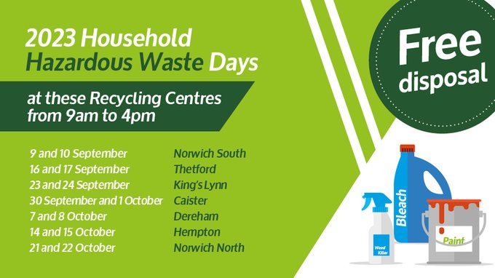
Summer garden plans? Leftover fence and decking stain and garden chemicals? We've got you covered! Norfolk County Council's Hazardous Waste Events are back in 2023 during September and October! Find out more here, https://norfolkrecycles.com/hazardous-waste-events-announced-for-2023/
- Rogue Trader Alert - Doorstep cold caller claiming issues with properties' roof
- Scam Alert - Automated telephone cold calls claiming to be from HMRC
- Scam Alert - Automated telephone cold calls claiming to be from 'Visa'
- Scam Alert - Telephone cold calls offering to stop telephone cold calls
- Scam Alert - Investment scams and fake cryptocurrency exchanges
- Safety Alert - Bosch has issued an 'Important Safety Notice' for their 'Bosch Styline Toaster' with the model numbers TAT8611GB & TAT8613GB' due to a potential risk of fire
- Recall Alert - Iceland is recalling 'Cathedral City Cheese & Ham Gratin 400g pack' with the best before date of 02 May 2024 due to the possible presence of Listeria monocytogenes

