District Councillor Report – August 2023

Town & Parish Summit:

We are holding our first in person Town & Parish Council summit on Thursday November 9th from 9:30am – 12:30pm. This invite is open to Parish Clerks and Chairperson and/or Councillors. More details to follow.

Vehicle Related PSPO:

The formal consultation for the Public Spaces Protection Order (PSPO) - vehicle-related ASB is now going live. Letters have been sent to all the formal consultees:

Police
Police & Crime Commissioner
Norfolk County Council Highways
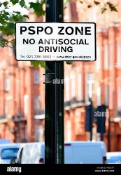
Parish and Town Councils – which you should have received
The consultation closes at 11:59pm on 29 September 2023.
I have attached the draft PSPO.
Some of our market towns and Villages are blighted by a few local drivers who routinely congregate in areas causing nuisance, littering and disturbance and/or drive circuits around these areas.
Pro-active enforcement work has been and continues to take place against the minority, however, it is costly and takes significant resource, which is difficult to maintain. Long term, we must enable the Police to intervene earlier and dispatch the minority from the area before their behaviour impacts - a PSPO allows this opportunity.

Parish & Town Council Forum:

The Council Forum for you to attend will be on the 7th September, you will receive your invite and agenda nearer the time.

Policing update:

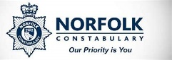
We had Superintendent Kris Barnard South Norfolk and Broadland District Policing Commander attend the Council to give Members an update on policing in the District.

It was good to see that South Norfolk is one of the safest Districts, not just in the County but in England.
It was amazing to see how many calls they receive in Norfolk in just one month:
May 2023
999 – 12388 101 – 7586
Officers are still encouraged to “Park, Walk and Talk” in their areas to get to know their communities, but they are now looking at a new strategy “Right Care Right Person”.

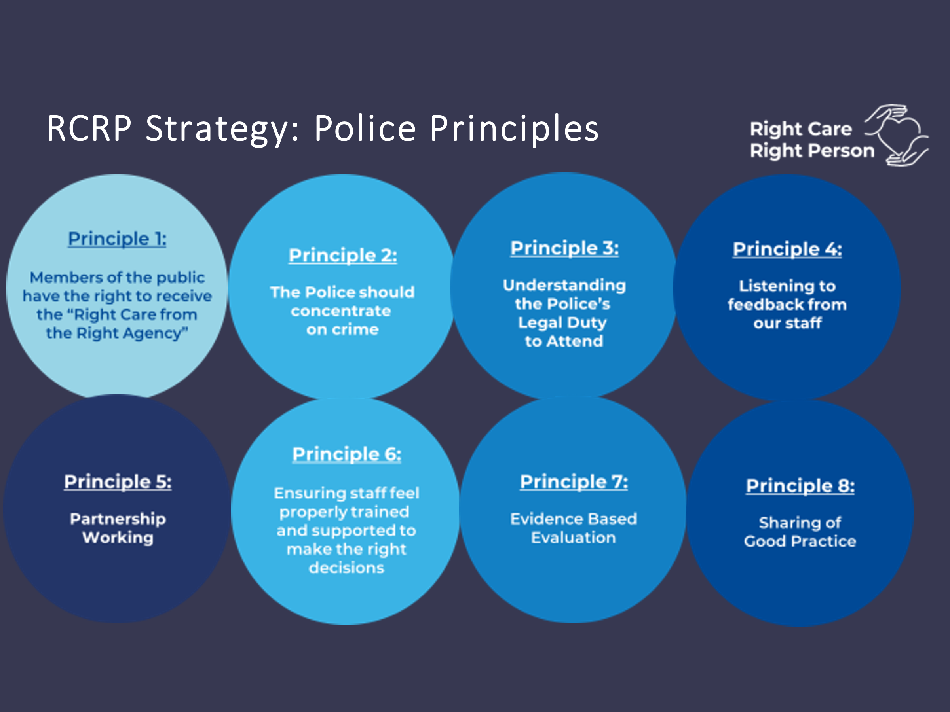

The Right Care, Right Person model seeks to ensures the right agency deals with the matter.
Currently, in a number of situations, the police are attending incidents but are not the right agency to deal with the issues facing them.
The Home Office are finalising a National Agreement between the police, NHS England and the Department of Health & Social Care to incorporate the Right Care, Right Person operating model.
This agreement is planned to be finalised shortly.
Norfolk Constabulary, working together with partners, aims to start implementation of Right Care, Right Person in the Winter of 2023.

Grants:

I have attached leaflets regarding two grants that are available for Community Groups which I hope you would be able to advertise.

Local Plan:

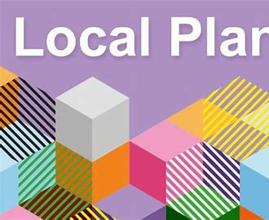
The Greater Norwich Development Partnership, which includes Broadland District Council, Norwich City Council and South Norfolk Council, submitted the Greater Norwich Local Plan to the Secretary of State for Housing, Communities and Local Government for independent examination.

The Plan has now be examined by the Government’s Planning Inspectorate and the inspectors have reported that they are supportive of the great majority of the sites we submitted for inclusion in the plan.

The inspectors have shared some modifications to the plan that they would like to see the partnership make. This is normal for a plan of this complexity and the amount of changes requested are comparatively minor. It is still on course to be adopted by the three Councils in January 2024.

NN:

We have written to the development sector in Norfolk to confirm that we are preparing to sell credits in the Yare catchment in the next few weeks.

Trowse Parking Scheme:

I am waiting for Officers at NCC who are going through all the responses they received from the last consultation.
They are looking to see if there are any small changes that could be made to help with any concerns, I will then have a meeting with them where they will present this to me before it comes back to the PC.
Hopefully this shouldn’t be too much longer.

Hornsea 3 windfarm:

