NCC cabinet considered the council’s top priorities for the next year, known as the corporate delivery plan.
These highlights how the County Council plays a leading role for Norfolk – providing key services, campaigning for more opportunities and speaking up for the county.
The plan highlights how the council provides, for a population of 914,039 in an area of 2,079 square miles:
- £1.3 million per day on adult social care for 19,000 people
- Support for 1,150 children in care
- 13 special schools
- 6,200 miles of road, 2,800 miles of footway and cycleway and 2,400 miles of trails and footpaths
- 47 libraries and 10 museums
- 42 fire stations
- 20 recycling and waste centres and 15 re-use shops
The council’s priorities for the next year are:
- A vibrant, sustainable economy, including £1.5 million of pilot projects through the Norfolk Investment Framework, overseeing completion of the Great Yarmouth operations and maintenance campus and delivering fibre broadband to 8,821 premises by next year.
- Better opportunities for children and young people, including plans for two more special schools, creation of a new learning strategy and working with the NHS on multi-agency, community-based support for children, young people and families.
- Healthy, fulfilling, and independent lives, including 12 more independent living units for people with complex needs, using digital technology to identify people who could benefit from earlier help and completion of the Great Yarmouth multi-user hub by spring next year.
- Stronger, engaged, and inclusive communities, including work with the voluntary sector on a new volunteering strategy, delivering, with partners, the hardship support programme and running public health campaigns through libraries.
- A greener, more resilient future, including starting to implement the council’s climate change strategy, supporting electric buses and electric vehicle charging points and consideration of new recycling centres in the Sheringham, Wymondham, Long Stratton and North Walsham areas.
Beryl Bikes
Beryl's Norwich scheme has achieved a major double milestone!
Riders have now completed one million journeys, covering three million kilometres since the scheme began in March 2020. This remarkable achievement has resulted in a reduction of over 156 tonnes of CO2 emissions, equivalent to 10,000 litres of petrol or 12 airline flights around the world!
Read more: https://orlo.uk/FOAtT
Water Safety
If you find yourself in trouble in water, follow the Water Way Code: Stop & Think, Stay Together, Call 999, Float to Live.
Summer Water Safety | Royal Life Saving Society UK ( RLSS UK )

Help prevent wildfires in Norfolk this summer.
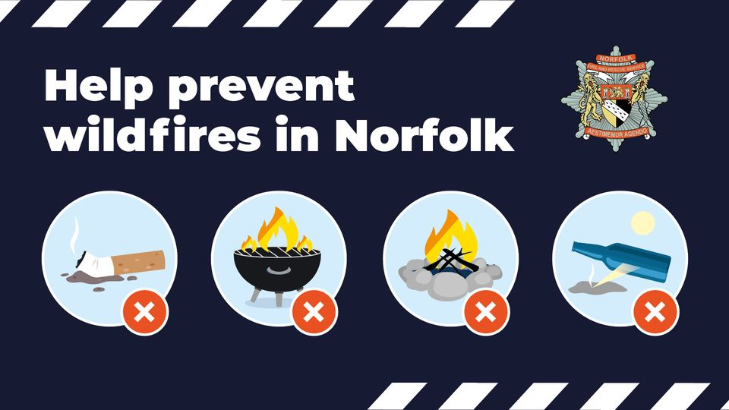
Householders are being advised how to protect their homes from wildfires this summer as Norfolk Fire and Rescue Service (NFRS) demonstrates new specialist equipment it will be using to respond to the seasonal threat.
Following the devastating fires that destroyed 22 homes across the county in July last year, NFRS has secured over half a million pound for new equipment and training for firefighters as increasing our efforts to work closely with communities to make sure they are more fire wise.
The farming community and landowners have received help to reduce fire risks on their land and plan how they can help stop the spread of wildfires using their skills and equipment in the event of an incident. They have also helped us mapped out how to access their water supplies in the event of an emergency.
NFRS staff have benefitted from new training and are currently trailing brand-new Wildland Firefighting suits which is both lightweight and more breathable, making it easier to work in extreme heat for long periods. Plus, new misting adaptors have been added to all fire appliances so that they can maximise water supplies as effectively as possible.
Terry Pinto, Group Manager - Prevention Lead for Norfolk Fire and Rescue Service, said: “Last year our communities suffered significant fire damage during the devastating wildfires during July when the temperatures hit 40°C. This year we are determined to do everything we can to prevent this happening again.
“Preventing wildfires is the responsibility of everyone in Norfolk and by following a few simple steps we can all help keep Norfolk safe this summer.”
Residents and visitors can help prevent wildfires in Norfolk by following five simple steps:
Dispose of cigarette butts responsibly rather than throwing them on the ground
Do not have BBQs in parks and public spaces other than designated areas. Portable BBQs pose the greatest risk, especially when they are placed directly on the ground - avoid using them altogether.
Do not have campfires or bonfires except in carefully managed and designated areas. You must never leave them unattended and always have the ability to extinguish them if you need to
Do not drop glass bottles because they can magnify the sun's rays and cause fires.
Report any signs of smoke or wildfire immediately to 999.
All residents should take steps to protect their home from wildfire.
Trim back shrubs or trees that are close to / touching your home and dispose of cuttings responsibly. Piles of cuttings are fuel for fire.
Clear away any build-up of flammable material in and around your garden such as leaves, compost heaps, log piles, dry grass etc.
Check for spaces between roof tiles or within your home where burning embers could become lodged such as rain gutters.
Position sheds and outbuilding away from your home and make sure that flammable substances (including fertilisers and pesticides) are stored safely.
Ensure your home is adequately insured and protected with smoke detection.
If you see wildfires approaching your home call 999 immediately.
Parish partnerships
Delivering local highway improvements in partnership with Town and Parish Councils.
I am delighted to inform you that due to the success of working in partnership with Parish/Town Councils for the last ten years the Parish Partnership Scheme Initiative will again be repeated in the financial year 2024/25. Further supporting information, including possible funding sources for your share of the bid, is available on our website.
The County Council has provisionally allocated £300,000 on a 50/50 basis (There is an upper limit on Norfolk County Council funding support of £25,000 per bid) to fund schemes put forward by Town and Parish Councils to deliver projects that are priorities for local communities.
We are particularly keen to encourage and support first-time bids. This letter invites you to submit bids and explains how the County Council can support you in developing your ideas. The closing date will be the 8th of December 2023. Please contact your County Councillor or local Highway Engineer based at the local Area Office for agreement and any advice in developing your ideas, especially around the practicalities and cost estimates.
Once all bids have been received, we will assess them and inform you of our decision in March 2024 following approval by the Norfolk County Council Cabinet.
Reuse shops
Norfolk’s popular chain of reuse shops at 15 recycling centres help stop unwanted goods being thrown away, and sell the good quality items at bargain car boot prices. A cut of the proceeds is donated to a chosen charity, which since April 2022 is Big C.
We’re proud that satisfaction with our sites is up to 85% with people particularly pleased with how clean and easy to use our recycling centres are.
Reuse is even better than recycling as it gives items a new home, cutting waste and transport impacts by preventing the need for production of new products. We showcased the fantastic work of the reuse shops as part the launch of our climate strategy yesterday. If you’ve not visited one of our reuse shops do drop by as you never know what you may find!
In the 12 months between April 2022 and March 2023 the reuse shops raised £22,177 for the Big C cancer charity, prevented 1333 tonnes from materials of being thrown away and saved an estimated 1270 tonnes of CO2. This is because materials are reused again instead of being transported away for processing or disposal. It also means that fewer new natural materials are required to make new products, as reused products are given a second life.
Refill your water.
Norfolk residents and visitors can now top up their reusable water bottles for free at more than 500 locations across the county. Many locations also refill reusable coffee cups, lunch containers and groceries too.
Refill Revolution - Norfolk Recycles

