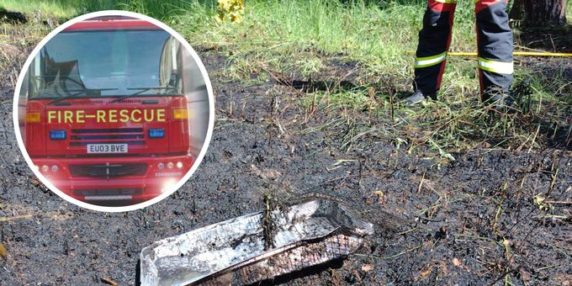
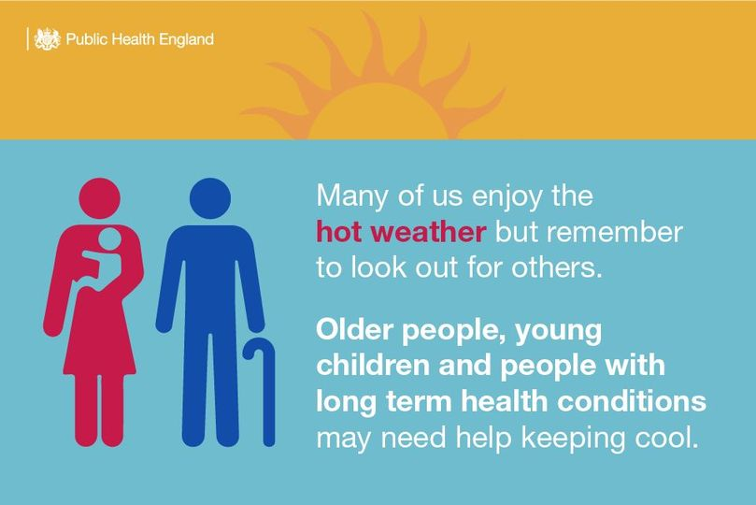

Beryl bike
To celebrate Better Transport Week Beryl who provide bike, e-bikes and e-scooters across the Greater Norwich area are offering 10% off the purchase of any minute bundles between 12-18 June, valid for one redemption per rider.
Beryl vehicles are fun, easy to use and can be hired simply and efficiently via the Beryl app, which is available for free download on the App Store for iOS, and the Google Play Store for Android users.
Use this code when purchasing your bundle in the app: BTW2023.#
Trowse will shortly have a base

We’re working hard to deliver our Bus Service Improvement Plan here in Norfolk to help more people to #ChooseTheBus.
In the last 6 months we have enhanced 15 services across the county with more frequent and later buses. We’re also improving bus stops across the county and developing Travel Hubs to integrate bus travel with walking and cycling better.
We’re also thrilled that the £2 fare cap from the Government has now been extended to the end of October this year which most operators in Norfolk are signed up to. So it really is a great time to leave the car at home and try the bus.
https://orlo.uk/2edAU #BetterTransportWeek

Do you look after a family member or friend? Help is available to you. You can speak to
@CarersMatterNfk
to ensure that you get the support you need. Call 0800 083 1148, email info@carersmatternorfolk.org.uk or see https://orlo.uk/carers_matter_XNOeg
Norfolk County Council and Net Zero
Norfolk County Council has committed to working with our partners to achieve ‘net zero’ carbon emissions on our estates by 2030, but within our wider areas, work towards ‘carbon neutrality’. This also supports the government’s ambition for a net zero country by 2050.
We will achieve this by implementing carbon conscious ways of working across our buildings and supply chain; putting in place the right infrastructure across the county to support the move towards net-zero; and by working together with partners to lead and inspire our colleagues, citizens, communities, and businesses to take action and play their part in protecting Norfolk for future generations.
Plan to retrofit our buildings
Composting
Would you like to start composting at home but don’t know how?
We're teaming up with Garden Organic to offer free workshops around Norfolk between now and September to show you how easy it is to start composting at home.
The 2-hour workshops will be delivered by our Master Composters and will cover the basics of home composting, how get the best out of your composting and what to do if you have problems with your compost.
Everyone who comes to a workshop will be given a voucher which will allow them to purchase a black 220L compost bin for £9!
To book one of the workshops visit: https://orlo.uk/syvH6

- Rogue Trader Alert – Doorstep Cold Caller offering to clean gutters
- Cold Calling Alert – Telephone cold calls regarding solar panels
- Cold Calling Alert – Flyers offering ‘Tree Surgery, landscaping and gardening’ work
- Cold Calling Alert – Telephone cold calls claiming domestic warranties have ‘expired’
- Cold Calling Alert – Telephone cold calls regarding ‘loft insulation’
- Food Alert – Gosh! Food Ltd are recalling various Sweet Potato and Falafel products as they may contain gluten which is not declared on the label
- Recall Alert – Lily’s Kitchen is recalling a batch of their ‘Fishy Fish Pie’ and ‘Chicken and Turkey Casserole’ dog foods as they main contain pieces of plastic
- Recall Alert – Sainsbury’s is recalling their ‘by Sainsbury’s Mexican Style Chilli Cheddar, 200g’ with the best before dates of 12 June 2023, 22 June 2023, and 30 June 2023 as it may contain Salmonella
- Scam Alert – Emails claiming to be from 'TV Licensing'
- Cold Calling Alert – Telephone cold calls regarding 'loft insulation'
- Cold Calling Alert – Telephone cold calls asking about life insurance
- Scam Alert – Telephone cold calls stating 'there is a tax fraud court case against you'
- Scam Alert – Telephone cold calls claiming to be ‘bank security’
- Recall Alert - Fox International are recalling a number of their life jackets and a life jacket refill kit as the safety certificates for the products are not valid
- Recall Alert - Johnson's Veterinary Products Ltd is recalling all batches of their 'Johnson's Small Animal Insecticidal Shampoo 125ml' and 'Johnson's Dog Flea Shampoo 200ml' due to a potential quality issue

Take your home composting to a new level with a Bokashi bin. This nifty container lets you compost ALL your food waste - including cooked food, meat, fish, dairy and all sorts of other organic material.
We’ve teamed up with GetComposting to offer you a twin pack for just £15.
Buy your Bokashi bin and check out our other compost bin offers https://orlo.uk/compost_sEgRd
Norfolk County Council are looking for new hosts to join the hundreds of other Norfolk residents who have opened their homes and provided accommodation for a family or individuals from Ukraine.
The Homes for Ukraine scheme was launched in March 2022 to provide support to Ukraine following the Russian invasion in February 2022. The war in Ukraine has now entered its second year, and the need for support and compassion for those displaced by the conflict has not changed. We are still in need of people to host Ukrainian families; especially for guests who have been in Norfolk for a while now and are needing to move for employment, education or other reasons.
Cllr Margaret Dewsbury, cabinet member for communities and partnerships, said: “I’m really proud of our county and how quickly our residents responded to the call for help. Over 800 households have so far welcomed a guest, but we still need more hosts to come forward. In particular, we are looking for people who can help house families, so if you’ve got space, please get in touch with the team to find out more.”
A range of ongoing support is on offer for hosts, including a monthly thank you payment of £500. Hosts also get support with all safeguarding and accommodation checks from Norfolk County Council, alongside our district, borough, city councils and voluntary sector partners. Information packs are available to help hosts with the settling-in period and provide information on the practical steps that guests will need help with, like setting up a bank account and finding work.
Throughout the time guests live with hosts, we also conduct welfare visits to support everyone to help make the hosting arrangement successful and rewarding. Once guests are ready to move on, either into their own accommodation or to return to Ukraine, we have a range of practical support and services available to help this go smoothly.
Mary, who lives in Wretham, hosts a family from Ukraine. Alya who has 2 children came to the UK in April 2022. Mary supported Alya and her family to get their children into school and is hoping to host the family until the children have finished their schooling. The oldest child will then go onto college to study.
"The experience has been really rewarding," Mary said. "There is so much support on offer when you become a host, and I'd encourage anyone who is considering offering accommodation to get in touch with Norfolk County Council to see what's involved. The thank you payment is nice, but the whole process is worth far more to me than that. You get to help people in real need and see that you are making a difference to their lives - I'm so glad that I signed up!"
Maureen, who lives in Watton, responded to the call for hosts straight away, offering her spare room to Nadia, a 22-year-old from Ukraine, where she had an apartment and a good job. Her family are still in Ukraine, west of the capital. Using her background in vocational education, Maureen helped Nadia successfully apply for a job, and after being hosted for a number of months, Nadia now lives independently.
“The whole process has been so rewarding,” Maureen said. “I’d encourage anyone to register their interest if they have space to become a host. You get a real feel-good factor that you’re helping someone in need; it can be a mutually satisfying experience.”
Do you have a spare room or rooms and can offer a safe place to stay to those fleeing the war in Ukraine? Join hundreds of other hosts across the county and register your interest now at www.norfolk.gov.uk/ukrainehost

