District Councillor Report – September 2023

Solar Together:

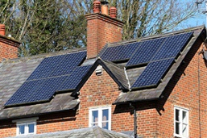
Broadland and South Norfolk Councils are offering residents the chance to be part of a scheme to help make it easier for homeowners and small businesses to buy solar panels for generating energy.
The councils, along with other councils in Norfolk, have once again partnered with bulk buying specialist iChoosr to set up Solar Together Norfolk, which is a group-buying scheme where the more people and businesses who join, the better the price should be of the installation.
Register by 27 October, 2023, and then pre-vetted UK solar PV installers will participate in an auction. They are able to offer competitive pricing as the volume and geographic concentration makes it possible for them to realise greater efficiencies, which they pass on with lower prices for installations.
Pride in Place Grants:

We have just opened up round two of the above grant scheme.

Following a successful round one scheme we still have some funding left for feasibility and revenue which is what is available in this second round.

Nutrient Neutrality:

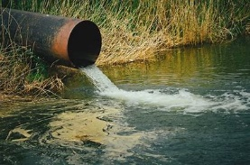
After receiving an announcement that the Government had finally decided to try and deal with NN so that LPA’s could finally release planning decisions and get house building back up and running, it was disappointing that the House of Lords blocked it.

NPPF:
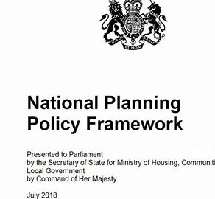
We received a welcome letter from The Secretary of State advising of their proposal to remove the 5yr land supply, as long as LPA’s have an up to date Local Plan.
SNC have this so we will benefit from this, as we don’t currently have a 5yr land supply due to NN we have been receiving speculative applications from developers in areas outside the NN catchment area, which are more difficult to refuse as we don’t have our 5yr land supply.

Riparian owner:

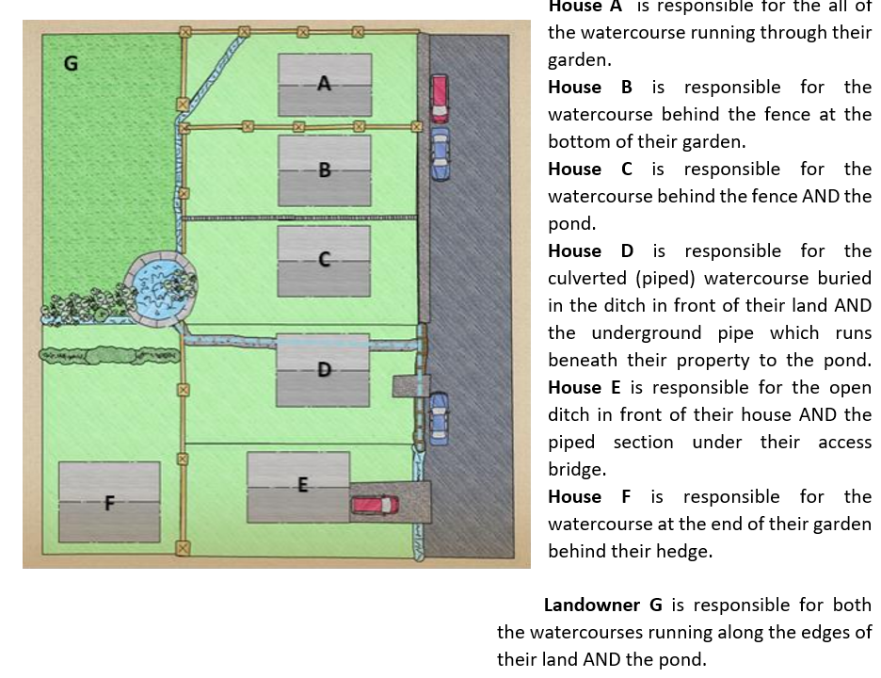

I have also attached a leaflet below and a link to the Norfolk Strategic Flooding Alliance.

Norfolk Strategic Flooding Alliance - Norfolk County Council

To report flooding:
Flooding Hotline call 0344 800 8013 to report flooding anywhere in Norfolk or email: water.management@norfolk.gov.uk
New South Norfolk MP:

Yesterday I sat on a panel of 13 who interviewed six shortlisted candidates to stand as the next South Norfolk MP.
Three were then selected to attend the evening session where Members of the SNCA could ask them any questions they wanted.

After a secret vote Poppy Simister-Thomas was selected to stand.

