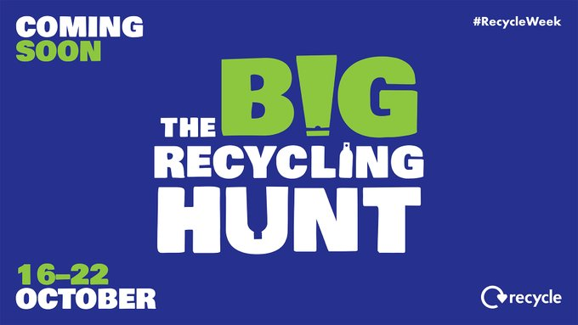
Join the hunt next week for #RecycleWeek. This Recycle Week, we’ll be on a hunt for some day-to-day items that you didn’t know you could recycle. Keep an eye on our socials as we’ll be sharing lots of information about things you can recycle rather than throw away!

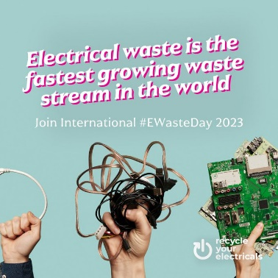
It’s International #EWasteDay. Get involved by bagging up your old cables, broken kettles or anything else with a plug, battery or cable and find your local drop-off point https://bit.ly/45W8s9d #RecycleYourElectricals #InternationalEWasteDay

Western Link
The Norwich Western Link is a step closer to becoming a reality today as we now have a crucial funding commitment from central government for the project.
You’ll probably be aware that we’ve been waiting, and pushing, for this news for some time, so it’s great that ministers have listened and understood the importance of this new road link for Norfolk, and the wide range benefits it will bring to residents and businesses. It will, I’m sure, be a huge relief to the people worst affected by the traffic congestion on small roads and in communities to the west of Norwich, which is causing knock-on impacts and concerns about air quality, road safety and quality of life.

Now we have this funding commitment we can move the project forward. So what happens next? First of all, we need to finalise the planning application documents – these are already well-developed but we previously couldn’t finalise them given we didn’t know when we would be in a position to submit them. So we do need to do a final review and make any updates as appropriate.

A report will also be brought to the council’s cabinet containing an update on the project and details about the planning application, and I and my fellow cabinet members will be asked to approve submission of the planning application.

As ever, we still have some way to go on the Norwich Western Link and a lot of hard work ahead, but it’s fair to say we have achieved a major milestone with today’s news. It’s important that we continue to invest in transport infrastructure in Norfolk to support all kinds of journeys and accommodate planned growth. The Norwich Western Link, and the significant benefits it will bring to local residents, businesses and the Norfolk economy, is a key part of making sure Norfolk has the transport networks it needs.

Today’s announcement gives us a commitment from central government to fund the majority of the cost of the project and will bring an anticipated £213m of national investment into the county, with the potential for the government contribution to be uplifted to cover even more of the costs.
Have your say on our walking, wheeling and cycling strategy for Norfolk
Norfolk County Council has today opened a public consultation on a draft walking, wheeling and cycling strategy for the county.
The strategy is an updated version of the previous walking and cycling strategy which was published in 2017. Since then, there has been a step change in national and local policy which has placed walking, wheeling and cycling at the heart of decision making.
The proposed new strategy brings together Norfolk’s local transport, environmental and public health ambitions and aims to make walking, wheeling or cycling the natural choice for both travelling from A to B and for leisure.
The draft strategy has been created following policy reviews, evidence collation and engagement with district councils and Active Norfolk. Now the county council wants to hear from residents, stakeholders and organisations to get their thoughts on the proposed strategy.
Graham Plant, cabinet member for highways, infrastructure and transport said: “Our draft strategy supports the Government’s ambition for walking, wheeling and cycling to be the natural first choice for many journeys. We want to support the growing population in Norfolk to choose sustainable transport whenever possible. This will help create and support healthy communities, enable our transport network to run effectively, emit fewer harmful emissions, and help protect our environment as much as we can.”
The scale and pace of delivering the strategy will be dependent on the level of funding the County Council can secure. Having this strategy alongside our already approved local cycling and walking infrastructure plans for Norfolk helps us to present our ambition to central Government and give us more likelihood of securing funding in the future.
The consultation is available online at www.norfolk.gov.uk/walking-wheeling-cycling and will be open until Friday 24 November. For anybody unable to complete the consultation online paper copies can be requested by contacting haveyoursay@norfolk.gov.uk or customer services on 0344 800 8020.

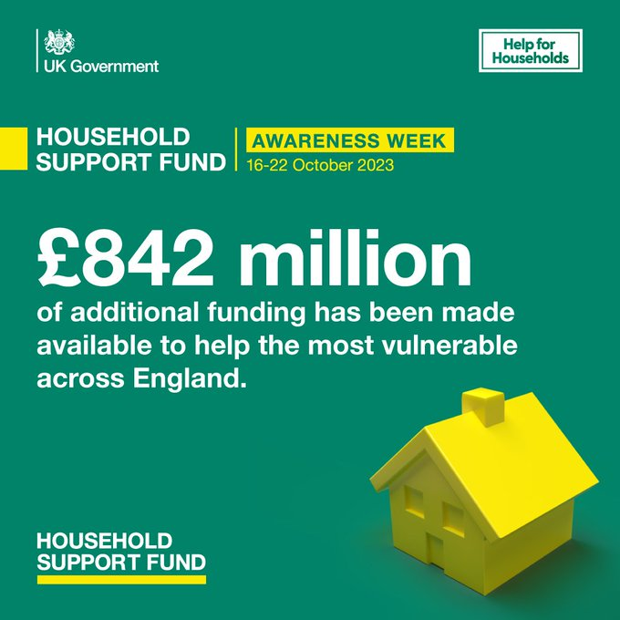
Are you struggling to pay the bills? This week celebrates Household Support Fund Awareness week, find out what support is available for you at https://orlo.uk/cost_of_living_jt3c8… #HouseholdSupportFundAwarenessWeek

We're starting to get excited... it's not long now till you will start to see the first of our 70 electric buses driving on key routes into Norwich. Look out for more details coming soon.

£2,500 grants available for community tree projects
Norfolk County Council in partnership with Busseys has today launched a grant scheme to help local communities plant new trees and create greener and cleaner areas to live. The scheme is part of the council’s one million trees initiative and aims to support tree planting projects across the county and contribute to ambitious net-zero targets.
The Busseys Community Tree Grant has made £10,000 (maximum of £2,500 per application) available to community organisations in Norfolk who are passionate about tree planting. Applications must be for planting trees that provide a tangible community benefit.
Cllr Eric Vardy, Cabinet Member for Environment and Waste, said: " This collaboration represents a significant step towards enhancing the county’s green spaces, nature recovery, and ecosystem. I am thrilled that we are working with the Busseys family and that together we can promote and support tree planting across our picturesque county through this initiative. We all know that money doesn’t grow on trees – but this scheme will provide local communities with the money they need to make trees grow! I encourage local communities to develop their plans and apply for this fantastic scheme.”
Busseys managing director, Paul Bussey, said: "We have a longstanding commitment to environmental sustainability. Our Tree Planting Initiative, which began in 2007, has allowed us to plant trees for every customer who purchases a vehicle from us or donating to Foodcycle for meals. We are excited to expand this initiative in partnership with Norfolk County Council to further promote greenery, cleaner air, and overall community well-being in Norfolk."
To ensure the success of this project, an application process has been put in place to guarantee that all trees are planted in suitable locations to maximise their survival and provide a meaningful community benefit. More information on how to apply, the application process, and deadlines visit: How to apply - Norfolk County Council.
This grant initiative is open to anyone in Norfolk who possesses the necessary land permissions and space to undertake tree planting projects. For more details about who can apply and the grant requirements, please read www.norfolk.gov.uk/busseyscommunitygrant.
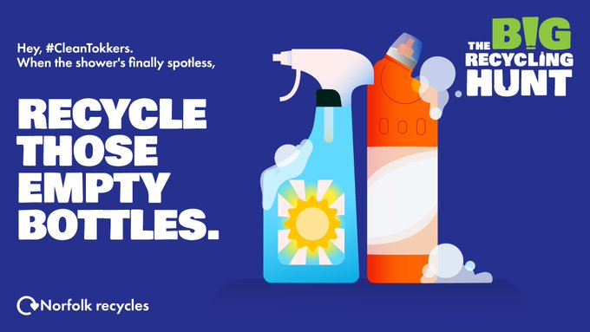
People needing help when they leave hospital are set to benefit from a new community service, to help them recover at home.
The Norfolk and Waveney Community Support Service (NWCSS), will be led by Voluntary Norfolk, the British Red Cross and Age UK Norwich and is funded by Norfolk County Council, NHS Norfolk and Waveney Integrated Care Board and Suffolk County Council.
The service is aimed at helping people with everyday tasks, like shopping, walking the dog or making phone calls and supports people to live independently whilst they recover. It supports people leaving hospital and those with short-term needs in the community.
The service has evolved from six separate services into one consistent joined up service for the whole of Norfolk and Waveney. The support provided through the original services will continue but with a combined wealth of experience and skills to support the whole of Norfolk and Waveney. Funding for the service has also increased by 30%, from £471,000 to £621,000 per year.
Cllr Alison Thomas, Cabinet Member for Adult Social Care at Norfolk County Council, said: “We know that people recover better from illness and injury when they are in their own homes and sometimes, they need a bit of help to get back on their feet. This isn’t just help with social care but with the smaller tasks that we sometimes take for granted.
“The evidence tells us that if people can keep their home in a habitable condition, eat well and maintain their relationships, there is a much lower chance of them needing long-term care, so this service has the potential to make a huge difference to people’s lives.
"I am delighted that such well-known and respected organisations have joined forces to deliver this newly enhanced service for those recovering at home following hospital discharge."
The service has been developed in partnership with partners across health and social care and is one of several approaches to support hospital discharges this winter.
Alan Hopley, CEO, Voluntary Norfolk, Gary Morgan, Director for Central England, Health & Local Crisis Response, British Red Cross and Jamie Price, Head of Operations, Age UK Norwich, said:
“The operating model offers an opportunity to minimise duplication, ensure a more joined up experience for the service user, and provide a single point of access for referring organisations across Norfolk and Waveney.
“We know that individuals have better outcomes and readmission is reduced when such support is in place, and the partnership model will utilise the experience and local networks of the three providers to support people and link them into community groups to encourage them to be confident, resilient and engaged with their community.
“We’d like to thank all those who have engaged with the design and set-up of the service and look forward to engaging with stakeholders across Norfolk and Waveney as it rolls out to different referrers. We’re also excited to continue the development of the service to grow and enhance the offer and work with local organisations.”
Executive Director of Nursing for NHS Norfolk and Waveney Integrated Care Board, Tricia D’Orsi, said: “This service will give people greater choice and more control over their own recovery and independence, as they transition towards life living with, or after an injury or illness.
“It is a great example of voluntary organisations, local authorities and the NHS working together to improve outcomes for local people and communities.
“We believe the service will bring benefits to the wider health and care system so that people can leave hospital when they ready, creating capacity for others requiring hospital care.”
The service is made up of a mixed pool of paid staff and volunteers. Anyone interesting in a voluntary role can contact volunteering@voluntarynorfolk.org.uk
Council budget proposals published
People can have their say on the county council’s proposed council tax levels and budget proposals for next year.
Norfolk County Council is consulting the public, until 1 December 2023, on a 4.99 per cent overall rise to its share of council tax, plus savings of £26.5 million.
Councillor Andrew Jamieson, the council’s deputy leader and cabinet member for finance, said: “We are keen to hear people’s views on our proposals to balance our budget while ensuring that vital services are protected.
“We are operating in increasingly challenging circumstances, having faced a period of reductions to funding we are now grappling with rising demand and increasing costs to deliver services.”
The proposals out to consultation are:
- A general council tax rise of 2.99 per cent, plus a further two per cent of adult social care precept
- Savings proposals of £26.5 million
The £26.5 million of savings proposals make a “significant contribution” towards the council’s £46.2 million savings target:
- Adult social services, £14.2 million
- Children’s services, £4.8 million
- Community and environmental services, £5.5 million
- Strategy and transformation, £0.9 million
- Finance, £1.0 million
The remainder of savings proposals will be developed over the next few months once further information has been released from government. The council is waiting to hear whether more funding will be provided in the autumn statement in November, or the provisional local government finance settlement in December.
Cabinet will consider consultation findings in January 2024 and make its final recommendations to council. The full county council meeting will decide the budget and council tax level on 20 February 2024.
To take part in the consultation, see www.norfolk.gov.uk/budget

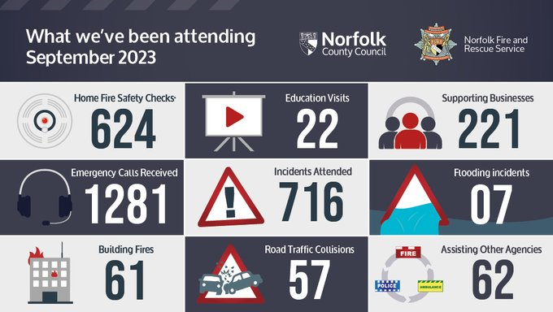

Have you got a ditch on the other side of your hedge or fence? Are you responsible for its upkeep? If you are – make sure it’s clear! Find out more about how you can prevent flooding here https://orlo.uk/floods_2EDiQ
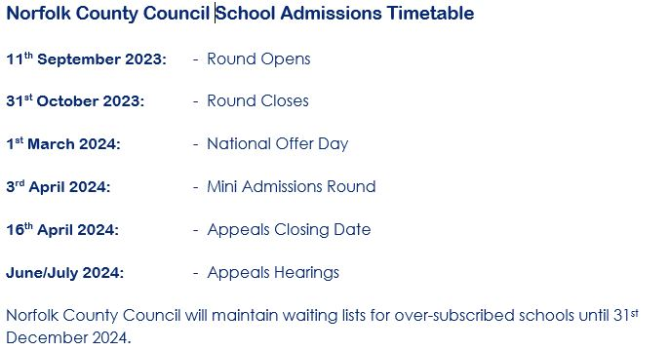
Winter campaign launches to support residents in Norfolk and Waveney to stay Warm and Well.
Supported by local health and care organisations in Norfolk and Waveney the latest Warm and Well Campaign is being launched to help us all stay as well as possible during the cold months ahead.
The campaign encourages Norfolk and Waveney residents to “winter proof” their health and wellbeing by preparing for winter illnesses and reminding people what to do if they do fall ill.
Additionally, the campaign aims to support people to who may be struggling to pay bills or heat their home this winter by raising awareness of the wide range of winter hardship support that is available locally.
The Warm and Well campaign promotes some of the essential ways that residents can stay healthy, warm, and well this winter, including:
- Getting their flu and COVID-19 vaccinations as soon as they’re offered them
- Keeping themselves well this winter by staying warm, keeping active, and keeping a well-stocked medicine cabinet so they are prepared for common winter illnesses
- Advice for people who look after someone at home and how to set up an emergency carer plan
- Signposting people to the hardship support that is available and providing tips on how to make homes more energy efficient.
- Encouraging use of the NHS 111 service, community pharmacies, Minor Injuries Units, and GP practice services instead of going to A&E
- Supporting people to look after their mental health
People can find all the information they need by visiting the online portal here www.winterwellnorfolkwaveney.co.uk.
Health and care leaders are encouraging all residents to make use of these resources to support their health during the coming months and help reduce pressure on local health services.
Tricia D’Orsi, Executive Director of Nursing at NHS Norfolk and Waveney, is urging people who are eligible for free flu and Covid-19 vaccines to take up the offer. She said: “Vaccination against seasonal illness is a really important way to help keep you and your loved ones safe and healthy this winter. Last year, we saw some people becoming very unwell with flu and Covid-19. Vaccination is a safe and effective way to help protect people who are at risk of getting seriously ill from flu and Covid-19 and to help keep people out of hospital over winter.”
Diane Steiner Deputy Director of Public Health at Norfolk County Council, said “Our winter wellness health portal has lots of useful health information to help you prepare for the onset of Winter. You can help reduce your risk of catching and spreading winter bugs such as the common cold or tummy bugs as well as serious illnesses like flu and COVID-19 by adopting simple measures such as washing hands regularly in soapy water for at least 20 seconds, covering your mouth and nose with a tissue when you cough or sneeze and putting the tissues straight in the bin. If you do fall ill and don’t feel well enough to do your normal activities staying at home and avoiding contact with other people until you feel better is also a sensible precaution to take.”
Bill Borrett, Chair of Norfolk and Waveney Integrated Care Partnership, said “People can feel more isolated during Winter months as they stay indoors and this can impact their mental health. We can all help by checking in regularly on friends, family and neighbours particularly during cold snaps. Connecting with your local community can make a difference for those living by themselves plus it can help lift your own mood as well”.
“Last year our winter wellness portal received thousands of visitors seeking information like how their local pharmacist can support their health. This year the portal includes even more information to help people get the support they need over the cold Winter months. Visit www.winterwellnorfolkwaveney.co.uk “.

Gritting
Twenty-seven brand new gritters will be taking to the roads for the first time later this winter in a £3,238,000 boost to the annual push to help keep Norfolk moving safely during the winter months.
The news comes as crews completed their first gritting runs of the season at the weekend, treating routes in the west, inland north and south and east coast areas of the county.
Norfolk’s fleet of 58 winter vehicles treat 2,200 miles of roads on each full 3-hour gritting run. All A and B-class roads and some C-class roads are treated with a focus on commuter and major bus routes and as far as is possible one route into all villages. The A11 and A47 are gritted by National Highways.
Cllr Graham Plant, Cabinet Member for Highways, Infrastructure and Transport, said: “Our salt domes are fully stocked, crews are ready to go, and our experienced highway team are keeping a close eye on weather sensors and detailed specialist forecasts that that help inform where and when gritting will be taking place.
“To help keep people moving around safely this winter, however they choose to travel, we’ll again be providing information and advice on social media with the hashtag #NorfolkWinter.”
In addition to the 49 gritting routes, a number of pedestrian areas and main pavements are treated in the centre of Norwich, Great Yarmouth and King's Lynn, and more than 2000 grit bins are available around the county for people to use on roads, pavements and cycle paths.
Find more information via www.norfolk.gov.uk/winter

- Scam Alert - Fake emails offering 'free spins' at online casinos
- Information Alert - Safestyle UK cease trading
- Scam Alert - Text messages claiming to be from Royal Mail
- Scam Alert - Scams targeting users of Careline Community Service
- Allergen Alert - Asda is recalling all use by date codes of their Asda Chocolate Caramel Mini Crisp Bites 200g up to and including Use By 14 December 23 as packs contain egg which is not mentioned on the label. This means the product is a possible health risk for anyone with an allergy or intolerance to egg
- Allergen Alert - Morrisons is recalling all best before date codes of their Morrisons 18 Caramel Crispy Bites as packs may contain egg which is not stated on the label. This means the product presents a risk for anyone with an allergy or intolerance to egg
- Recall Alert - Candy Dynamics is recalling several varieties of their 'Toxic Waste Slime Licker Sour Rolling Licking Candy' due to the possibility that the rolling ball may detach which could cause a choking hazard
Rogue Trader Alert - Doorstep cold calling incidents
- Scam Alert - Letters claiming to be from the Chartered Trading Standards Institute
- Scam Alert - Automated telephone cold calls claiming to be from Visa
- Recall Alert - Sainsbury's is recalling their 'Taste the Difference Spanish Chorizo Iberico Ring 200g' with all date codes from Use By 23/11/23 onwards due to the possible presence of Listeria monocytogenes
- Recall Alert - TK Maxx are recalling 'Biscotti Darlings' which were on sale in TK Maxx and Homesense stores between 01/05/23 & 30/06/23 due to mould being found in the product
- Recall Alert - Poundland are recalling their 'Creepy Town Hanging Ghost' with the Poundland Product Code 814437 which has been sold in stores since 21/08/23 due to a serious safety risk and potential injury hazard

