Non-Designated Heritage Assessment
December 2021
Trowse with Newton
Neighbourhood Plan 2022-2038
Table of Contents
Introduction 1
Assessment 2
NDHA A- Flint Barn, Whitlingham Country Park 2
NDHA B- Kingsley Farrington Boat Yard 3
NDHA C- Estate Cottages on Whitlingham Lane 5
NDHA D- Old Police House, Newton Close 6
NDHA E- Former May Gurney Offices along The Street 8
Appendix: Non- Designated Heritage Assets Map 12

Introduction
Non-designated heritage assets are buildings, monuments, sites, places, areas, or landscapes identified as having a degree of significance meriting consideration in planning decisions, but which are not formally designated. They are valued as distinctive elements of the local historic environment.
Historic England provide guidance on the listing of local heritage assets to assist community groups, for example in preparing a Neighbourhood Plan. Local lists complement national designations and intends to highlight heritage assets which are of local interest, to ensure they are given due consideration when change is being proposed.
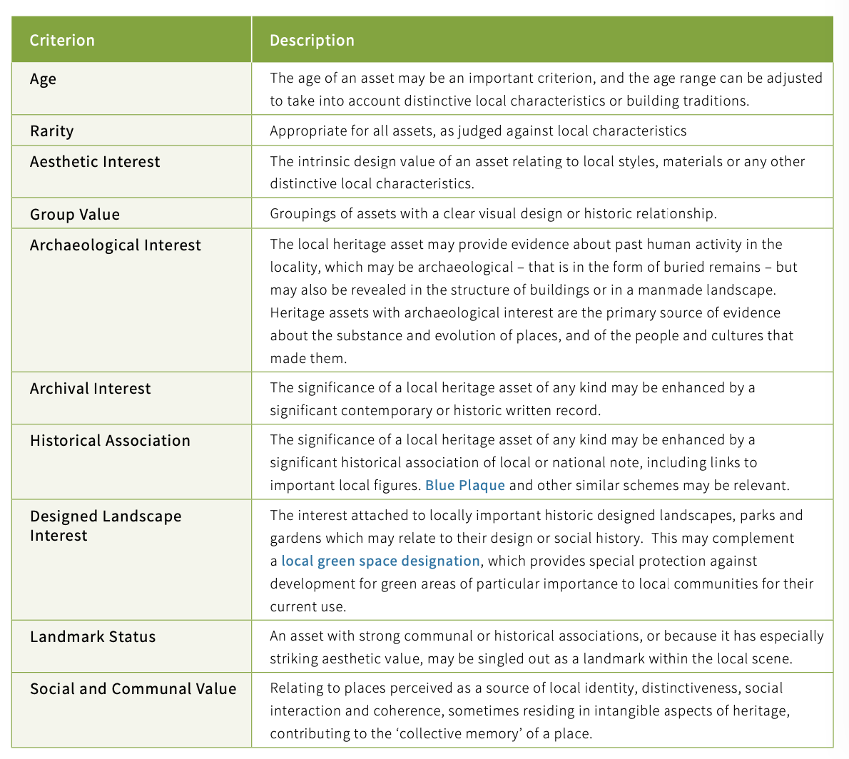
Figure 1: Table criteria taken from Local Heritage Listing: Historic England Advice Note 7

Assessment

NDHA A- Flint Barn, Whitlingham Country Park
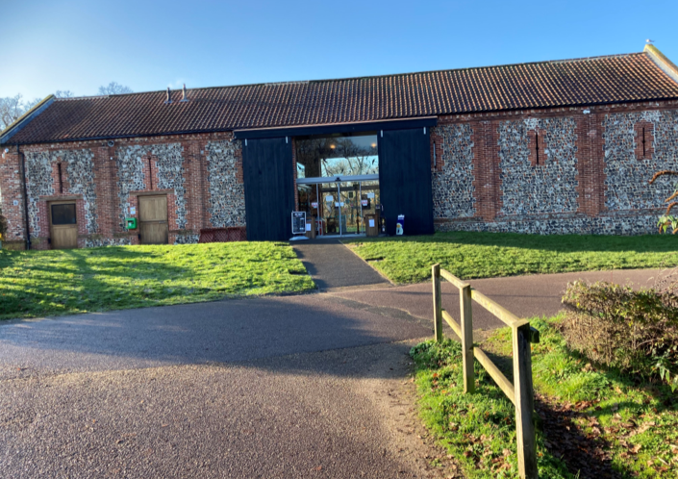
Description | Flint Barn
Age | Unknown – pre 19th century
Rarity | Average
Aesthetic Interest | A good example of a well-restored flint barn which is now used as a café for the Whitlingham Country Park. It is well-proportioned with flint and brick walls and pantiled roof, restored barn doors and windows
Group Value | As part of the character of the Broads Country Park and of Trowse as a surviving model village, the barn is a valuable asset
Archaeological interest | None
Archival Interest | There are references to the Flint Barn in accounts of activities on the river and around Whitlingham for example the Whitlingham Regatta and rowing races in the 19th and 20th centuries  https://joemasonspage.wordpress.com/2018/08/04/historic-whitlingham/
Historical Association | None found in terms of individual figures although Colman and other Norwich School artists frequently painted in the area and there is a strong historical association with the model village movement and provision of high quality leisure for factory workers.
Designated Landscape Interest | Important to the character of the country park
Landmark Status | None
Social and Community Value | Important to have a social and leisure space near to the village centre

NDHA B- Kingsley Farrington Boat Yard
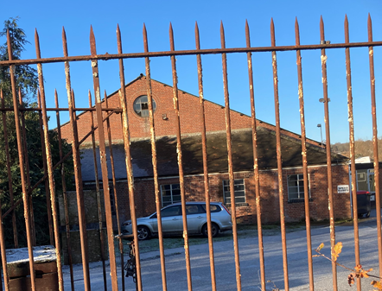
Description | Boatyard
Age | Approx 1950s
Rarity | One of very few remaining working boatyards
Aesthetic Interest | Part of the industrial heritage of the area
Group Value | Linked to the Broads network, the thriving water sports/canoe/kayak activities
Archaeological interest | None
Archival Interest | Listed on the Norfolk Historic Environment Record
Historical Association | The boatyard is part of the character of Whitlingham Country Park and the history of rowing, sailing and other water-based sports are an important legacy of the drive to provide leisure for the city dwellers and factory workers
Designated Landscape Interest | The landscape interest is part of the natural development of the area rather than a conscious design, but adds to the character and mix of industrial, residential and leisure
Landmark Status | None
Social and Community Value | Contributing to a working heritage and maintaining rare industrial skills that are distinctive  The rowing club is a well-used and important local offer which uses the country park and broads

NDHA C- Estate Cottages on Whitlingham Lane

Description | Cottages
Age | Late 19th century/early 20th century
Rarity | Not necessarily extremely rare but of a distinctive style which is not common
Aesthetic Interest | Following the aesthetic style of the estate cottages and characteristic of the area
Group Value | Part of the Whitlingham/Crown Point Estate and the model village status of Trowse
Archaeological interest | None
Archival Interest | Part of the Crown Point Estate, linked to the Colman Family
Historical Association | None
Designated Landscape Interest | As above. Important to the character of the estate and model village features that
Landmark Status | None
Social and Community Value | None

NDHA D- Old Police House, Newton Close
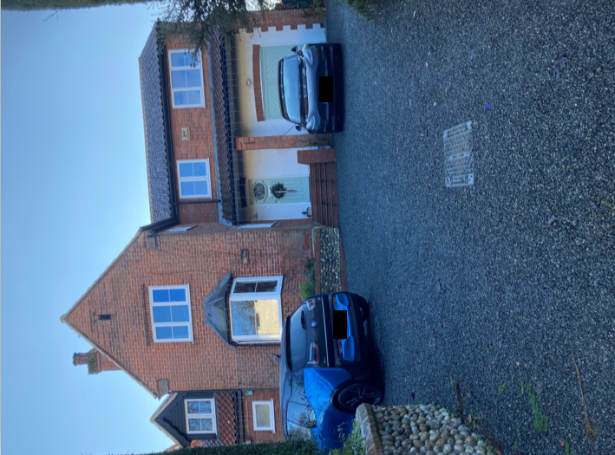
Description | Old Police House which has now somewhat extended and called the Copper Penny.
Age | Built 1968
Rarity | These are the only police houses in Trowse on land given to the force by the Colman family
Architectural and artistic interest | They are “of their time” and in that respect are unlike many other houses in the village. As Trowse was a working village for the Colman factory almost all of the village housing was from the late 1800’s/early 1900’s. So, the Police House’s design is very modern by comparison. They are also large detached houses compared to the rest of the village.
Group Value | The Police Houses are another part of the Model Village aspect of Trowse. They may not have been built by Colman family but the land was given to the Police to build residents for serving police officers at the time.
Archaeological interest | Built on the site of a former quarry. Originally No.5 collapsed due to this. No. 5 has since been rebuilt on piles.
Archival Interest
Historic Interest | Forms part of the Colman family history of Trowse
Landmark Status

NDHA E- Former May Gurney Offices along The Street
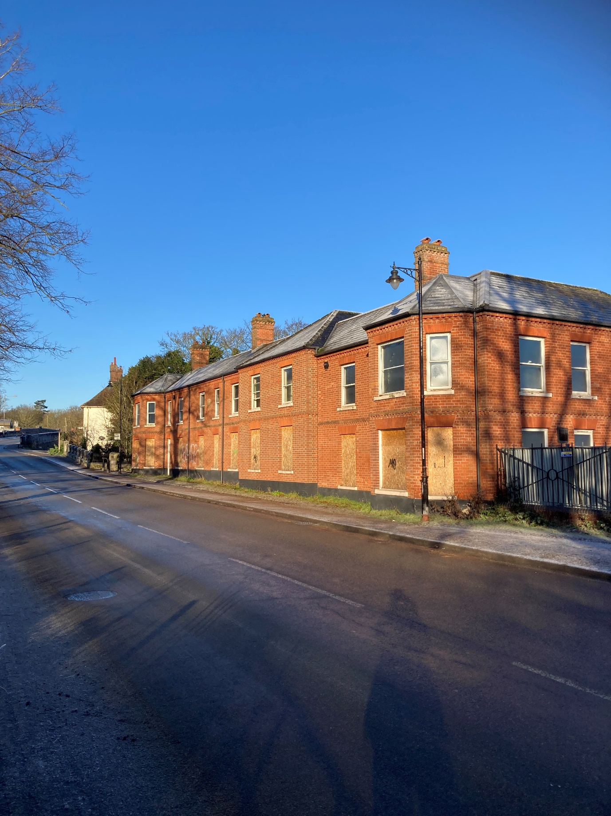
Description | May Gurney offices
Age | 1880s
Rarity | Not rare
Aesthetic Interest | Well proportioned Victorian buildings that line the roadway of The Street, redbrick and slate construction although original windows have been removed.
Group Value | Part of the approach to the village of Trowse and the transition from the city of Norwich to the countryside park. Important to the streetscape
Archaeological interest | None
Archival Interest | The buildings are on the site of the former pub, post office, houses and shops that lined the original highway from Bracondale to Trowse (The Street) many of which were demolished when the Bracondale railway bridge was built in the 1880s to enable cattle to cross the railway without stopping the trains, or for the train traffic to hold up the droving of cattle to the market.  The site appears in historic records in the Archive Centre and in the history of Trowse and Colmans.
Historical Association | Part of the character of Trowse with its links to the cattle trading and rearing as well as mustard production
Designated Landscape Interest | Important to the streetscape
Landmark Status | None
Social and Community Value | None

Suggestions of NDHAs from the consultation:
- Manor Rooms and adjoining house
- Railway buildings
- Building next to the church (former parish rooms)
- White Horse Pub
- The River Green café
- Kirby Road terraces
- Terraces on the common
- Church ruins in the woods
- Pumping station building
- The old village school
- Crown Point Villas
- Blockhill Cottages
- The Flint Barn at Whitlingham
- Newton Cottage
- Vulcan Cottages
- Archaeological sites at Woodhenge and on White Horse Lane
- Remains of St Andrew’s Church near Tower Cottage
- Terrace housing along the Street and White Horse Lane
- The Henge on White Horse Lane
- Trowse village sign
- The white Gothic cottage and stone cottages
- Bridge over the Tas near the church
- Railings around the common and church
- Flint wall going up the street along Kirby Road and Devon Way
- Former May Gurney / Kier buildings that line the Street
- Old disused pumping station and ancillary building
- The horse trough on the corner of the road opposite the White Horse pub
- Old telephone box near the White Horse pub
- The plaque that mentions the site of the chapel
- The plaque on the path beside Easter Cottage
- All the terrace houses built for the Colman’s employees, to acknowledge what the Colman family did for the village
- The White House
- YMCA sports hall

A number of these may already be identified as buildings of townscape significance in the Trowse Conservation Area Appraisal.
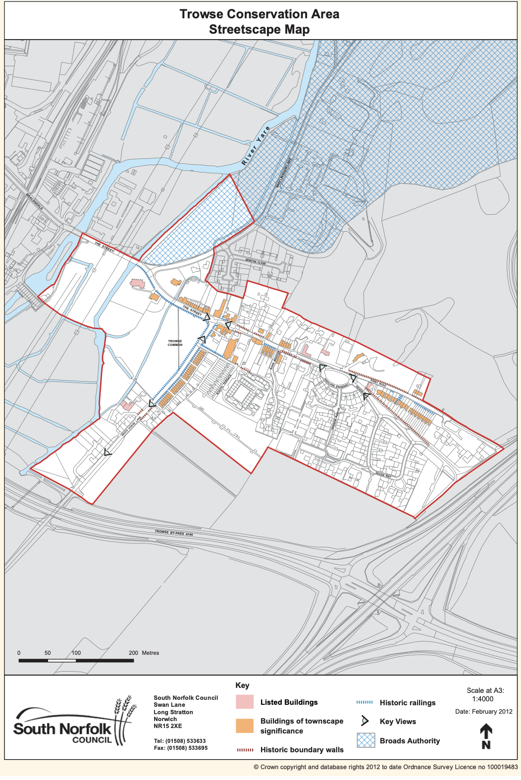
Figure: South Norfolk Trowse Conservation Area Streetscape Map

Appendix: Non- Designated Heritage Assets Map

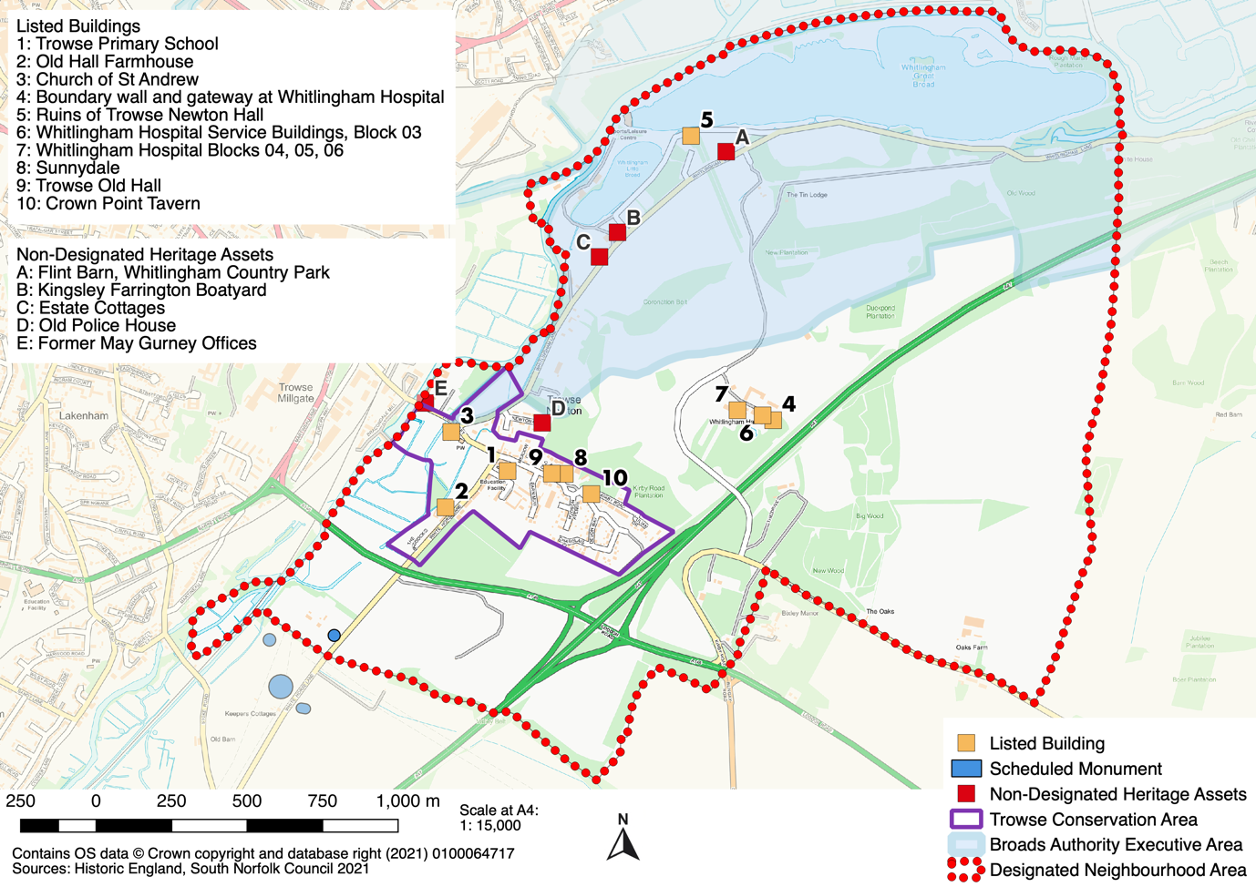
Trowse with Newton Neighbourhood Plan 2022-2038

Taken from Local Heritage Listing: Historic England Advice Note 7 - https://historicengland.org.uk/images-books/publications/local-heritage-listing-advice-note-7/heag018-local-heritage-listing/
https://www.south-norfolk.gov.uk/sites/default/files/Trowse_with_Newton_Character_Appraisal_2012.pdf

