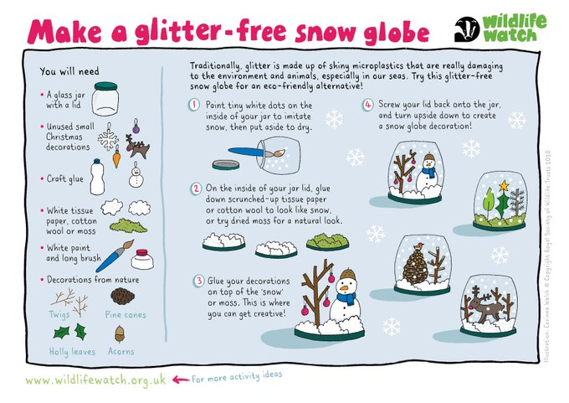
Our local hospitals are extremely busy right now caring for very sick patients. Please read our guidance for the festive period around the health services available to you https://improvinglivesnw.org.uk/help-us-help-you-over-the-festive-period/
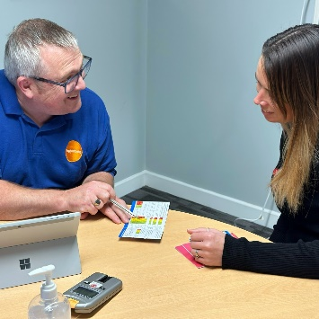
Become a healthier you in 2023! If you are between the ages of 40-74, you could be eligible for a free check-up. Book in at over 40 community venues across Norfolk this January Check your eligibility & book here: https://orlo.uk/health_checks_vpdFS… or call 08081750413

Finding help
Norfolk Community Directory contains activities, services and groups to help all Norfolk residents live healthy, active and fulfilling lives.
You should find something to help you, whether you want to: keep healthy, be sociable, physically active, mentally active, raise your aspirations for educational achievement, help your community, stay independent, feel included, get involved, improve your well-being, stay safe, find suitable care and support, find help to look after your children, or get family support. We also provide information which supports the Local Offer, Care Act and Childcare Act.
Home | Norfolk Community Directory
Help with living costs - Norfolk County Council
Help for Households - Get government cost of living support
Buses
Nine bus operators in Norfolk have today announced that they will be taking part in the Bus Fare Cap Grant scheme.
This means that a single journey on all services run by these operators between 1 January – 31 March 2023 will cost no more than £2 thanks to funding from HM Government.
The scheme is part of the Government's Help for Households campaign designed to support families through cost-of-living pressures.
Operators taking part are:
- BorderBus
- First
- Konectbus
- Our Bus
- Sanders
- Simonds
- Coach Services
- Stagecoach
- Semmence
At a time when many are struggling with the rising cost of living, this is a welcome investment to help bring down travel costs for many. All local operators already offer really good value fares, particularly for multiple trips or group tickets - but this offer will benefit those residents who may only use the bus occasionally or for those who want to try using the bus for the first time. Schemes like this complement our own work in improving bus services across Norfolk well and support us in our ambitions to get more people using public transport more often.
The Department for Transport announced in September plans to invest up to £60 million to introduce the £2 bus fare cap on a single bus ticket on most services in England outside London.
Since then operators have received details of the funding that would be available to them and have decided whether or not to take part.
Bus travel remains the most popular form of public transport in England, making up around half of all journeys. That’s why we’re investing £60 million to cap single bus fares at £2 to support every passenger and help get people back on the bus.
With the scheme set to take two million car journeys off the road, it’s fantastic to see so many bus operators signing up to the fare cap, helping people to ‘Get Around for £2’ between the 1st January and 31st March.
Winter
Power cuts
Are you ready for an unexpected power cut? Parts of the country lost power for up to a week during Storm Arwen last winter, so it’s worth taking sensible precautions now:
- Have a stock of non-perishable, easily prepared food that doesn’t need cooking
- Have some bottled water – in some places, mains water will stop working if there’s no power
- Have enough warm clothes – lots of thinner layers are best - and bedding
- Have LED torches or LED camping lanterns and spare batteries – much safer than candles
- Have an old-fashioned plug-in, landline phone and a list of family members’ landline numbers if they still have them – mobile networks soon fail in a power outage
If it happens:
- You can go to the live power cut map via the UK Power Networks website for information and updates. If the Internet is down, dial 105 for updates from UK Power Networks
- Listen to Radio Norfolk on a battery or car radio, for initial updates (95.1 FM in east Norfolk, 95.6 FM in north Norfolk and 104.4 FM in west Norfolk)
- If Radio Norfolk is not working, Radio 2 (88-91 FM) or Radio 4 (92-95FM or 103-105 FM) should still be running
- Look after frail relatives and neighbours
- Beware of carbon monoxide – never bring a barbecue indoors, don’t use gas cookers for heating, open a window if you are using a gas camping stove and don’t leave it unattended
Driving
- Gritting
- Check your car
- Have emergency items in car
Recycle/Reuse
- Recycled your Christmas
- Any reuse items

Bus
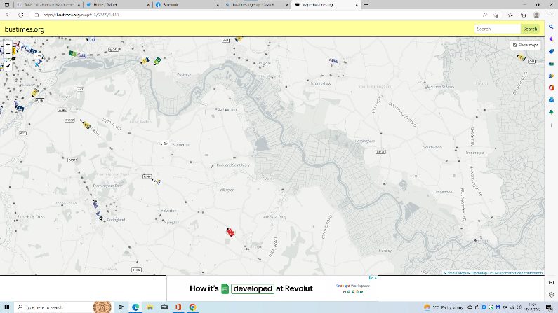
- Ever wondered when your bus was going to arrive? Now you can.
- Go to bustimes.org select the map and you can see the bus.
- Square with number is a bus


Never miss a bin

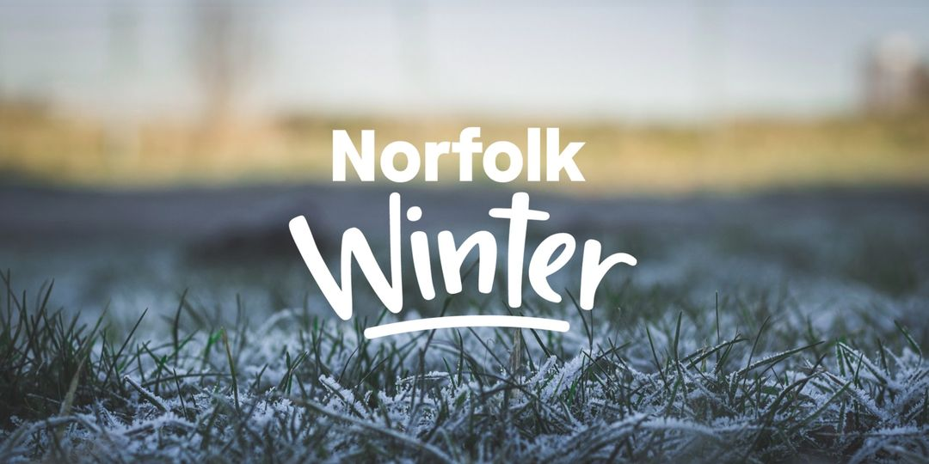
Highway teams are starting the big grit bin refill this week, following the cold snap late last year. There’s no need for you to let us know about an empty grit bin near you – all public highway grit bins will be checked and refilled by the team over the coming weeks. You can check where your nearest grit bin is here: https://orlo.uk/fYsss
Did you know that a little grit goes a long way – you only need a tablespoon of grit for a square metre of ground! And do remember the grit is just for use on the public highway – not private paths or driveways.
If you think a location would benefit from a grit bin in the future, contact your local town or parish council.
County Hall Update
