District Councillor Report – March 2023

Levelling-up and Regeneration Bill: reforms to national planning policy consultation

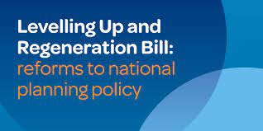
We had our first joint SN and Broadland Council Policy Committee recently to look at the proposed response to the Levelling-up and Regeneration Bill: reforms to national planning policy consultation.

On 22 December 2022, the Department for Levelling Up, Housing and Communities published this consultation which seeks views on Government’s proposed approach to updating to the National Planning Policy Framework (NPPF).

This was a forty two page document which asked about a number of proposals but the main ones I hope will be agreed with are:

- No longer having to demonstrate a five-year land supply (as long as you have an up to date local plan).
- Getting rid of the 10% buffer that you have to have on top of the five-year land supply.
- Increasing the protection given to Neighbourhood Plans.
- Taking into account applications which have not been built out by developers.
- Encourage the delivery of more homes for the elderly.
- Taking applicant’s past behaviour into account when decision making.

Police

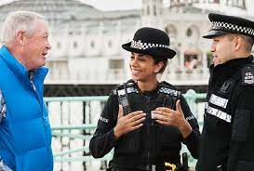
We had Paul Sanford, Chief Constable come and give us a presentation which was very interesting.
He told us how policing has had to change so much in recent years, he understands that the public like to see Police more visually and he encourages Officers to “Park, Walk and Talk” but most crime now has Officers working behind closed doors as they are dealing with more fraud, which is often online from individuals who operate from abroad and the other crime which is still unfortunately the highest in the County is domestic abuse.
Speeding which he knows is what most people think is very high is actually not as bad as people think, it’s the usual thing that the minority spoil it for the majority who are safe drivers.
Norfolk is still one of the safest County’s in Britain and he is determined to keep it that way,

King’s Coronation
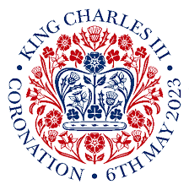
South Norfolk Council has established a new grant to support Town and Parish Council’s across the district to organise a celebratory event during the King’s Coronation Bank Holiday weekend of 6th to 8th May 2023.

The grant will be available to help towards the costs that may occur when organising King’s Coronation events for the community. Town and Parish Council’s are eligible to apply for the grant and must demonstrate the funds are to support the provision of an event for residents.

Parish Council’s/Meeting’s will be able to apply for a £200 grant.

Planning:

The links below will take you to two “You Tube” videos of Phil Courtier, Director of Place explaining about Nutrient Neutrality and how the Planning system works in an easy to understand presentation.

Planning: https://youtu.be/ih_bMKX65AE
Nutrient Neutrality: https://youtu.be/zfu2Pz9frwY

Voter ID:


I have attached a document which lists Q&A from a LGA Webinar on voter ID.

Trowse Parking Scheme:

I’m pleased we have finally got a date for when the Trowse Parking Scheme is going out to advert.

Friday 21st April until Tuesday 16th May

Business Awards:


South Norfolk and Broadland Councils held the 2023 Business Awards last week at “Top of the Terrace” Carrow Road.
This was an excellent event with over 300 people in attendance celebrating our independent businesses in the two Districts.

Long Stratton by-pass:

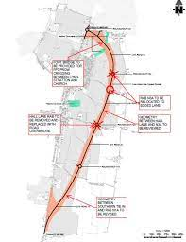
On Wednesday last week the Planning Committee approved the Long Stratton housing scheme and finally the long awaited by-pass!

The by-pass is planned to start being constructed in April 2024 and should be finished in the Autumn of 2025.

Help Hub:


I have attached another link to a video which tells you a little bit more about what services the Help Hub at the Council offers.

https://www.youtube.com/watch?v=SR1Nh5IKb7A

Mindful Towns/Villages:

I mentioned at the last meeting how villages can become a “Mindful Village”.
I have attached a flow diagram in my written report which shows how this can be achieved once again with the support of our Help Hub.

