District Councillor Report – November 2023

Training:

Training on Homelessness and the Housing Register.

Business Awards:


Nominations are now open for our Business Awards for 2023, there are a number of categories that businesses can self-nominate for as below:
Business Growth; Business Innovation; Employer of the Year; Environmental Impact; Excellence in Advanced Manufacturing; Excellence in Insurance, Financial and Professional Services; Food and Drink Producer of the Year; New Business; Small Business of the Year and Tourism Business of the Year.

Residents are also invited to vote for their favourite Retailer of the Year and Pub of the Year.
The awards ceremony will take place at Norwich City Football Club in March 2024.
To nominate your business, or to vote for your favourite retailer and pub, visit the Councils’ website
www.southnorfolkandbroadland.gov.uk/businessawards.
Closing date for entries is 15 December 2023.

Nutrient Neutrality:

The Joint Venture Company we are involved in regarding dealing with NN has been finalised, with all stakeholders involved approving how it will operate which means we should be able to start selling credits and releasing approved planning applications by the end of the month!

You may have seen in the EDP the first scheme has been to pay a farmer to stop farming pigs on land on both sides of the A47 for eighty years. This will enable credits to be bought for 5,000 homes.

Polling Stations:


We are currently carrying out a review of polling districts and polling places (stations) in the district. Every Council is required to carry out such a review every five years, so we need to complete our next one by January, 2025. The aim of the review is to ensure that, where practical, electors have reasonable facilities for voting and polling stations are accessible. The review cannot make changes to parish/town boundaries which are, in the main, designated as polling districts. If you’d like to make any comments on this review please follow the link below:
https://www.southnorfolkandbroadland.gov.uk/elections/review-polling-districts-places-2023-24
Cabinet Meeting:

Customer Experience Business Case
Public Spaces Protection Order - Vehicle-related anti-social behaviour
Business Breakfast:

Our next Business Breakfast is being held on Wednesday 13th December at Park Farm Hotel, Hethersett from 7.30am to 9.30am.

Our keynote speakers will be:
• Neil Foley, founder of the Business Growth Club - Why are businesses so bad at looking after their existing customers?
• Laura Yaxley, from LY Copywriting Ltd - Nail your newsletter - Drive repeat business and show your customers you care about keeping in touch.
Followed by:
• South Norfolk Council will be giving businesses a Business Support update.
• Jessica Barnard will be presenting from Park Farm Hotel on their offer.

National Award:
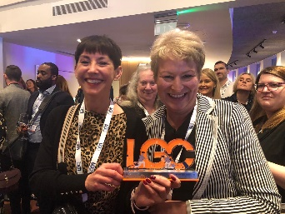
Broadland and South Norfolk Councils’ Director of Resource, Debbie Lorimer, has been recognised with a national award.
Debbie won the award for Workforce Innovator at the inaugural Local Government Chronical Workforce Awards.
The Awards took place on 8 November with 45 live presentations from 36 shortlisted councils outlining their innovative solutions to workforce challenges.
Debbie won the award for her work in bringing the One Team together under one roof.
Grant:

South Norfolk and Broadland Councils have launched a Winter Pressures Grant that enables communities to support their residents through the winter period. The funding is for a maximum of £1,500 per group and can be used for projects that clearly outline how they will support individuals and families during the colder months.

Examples include;
- Support to operate Warm Spaces that offer free food and/or drinks, social engagement and wider support
- Provision of Christmas hampers and gifts for the most vulnerable households in a community
- Purchase of warmth providing equipment such as blankets, hats, oil-filled radiators etc. to donate or loan to those in need

For further information and an application form, please see here; Winter Pressures Grant – Broadland and South Norfolk (southnorfolkandbroadland.gov.uk)

Business Builder:
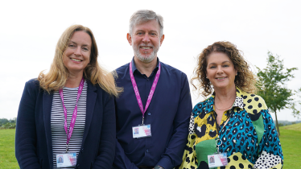
South Norfolk Council and Broadland District Council have helped over 200 businesses secure grants totalling almost £700,000, through the Business Builder programme.
This investment has accelerated growth and supported start-up companies, creating jobs and boosting the local economy.
Alongside investment, business owners have also been able to access advice and training, tailored around each business and its specific needs.

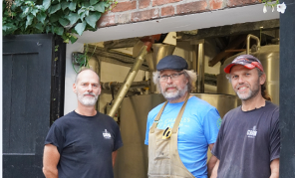
Phil Halls, founder of Grain Brewery said: “Last year we were looking for ideas to improve our turnover, as the business was under pressure. I had always wanted to convert the barn alongside the brewery and create a taproom where people could stop by, however I wasn’t financially in a position to invest in the work on my own.
“So, when the opportunity came up to apply for a Development Grant I jumped at it. The whole application was very straightforward and fast, with Jo guiding me on which expenses the grant could cover, right down to details on items such as tables and chairs. Within months the work was done and the taproom was open and ready to welcome customers. The locals really appreciate having somewhere they can pop in after work, especially since our local pub closed. Not only has it made a significant and critical difference to our turnover, it’s also a fun place to be for our local community.”
People looking to launch a business, but don’t know where to start, can also get help through the scheme. The Councils’ team can work out if the business is viable and provide a free in-depth online training course which covers everything a first-time entrepreneur needs to know. Once established, the business can come back and apply for a Build-Up Grant to take the next step.
For rural businesses, the Rural England Prosperity Fund has also provided a welcome pipeline of significant grants to assist investment in capital equipment and building works, with all applications going through the Business Builder programme.
Visit www.southnorfolkandbroadland.gov.uk/business/business-grants-funding
Wymondham Race:

Record numbers of runners joined in the 10K run on Sunday, organised by South Norfolk Council.
Around 650 athletes ran the picturesque route around Wymondham in what was described as “perfect weather conditions”.
South Norfolk Council’s Chairman, Cllr James Easter, started the race and was on-hand to present the winners with their medals at the finish line.
Money raised from the entry fees is used to fund some of the Council’s most-valued community services, with some also donated to the Chairman’s chosen charity.

