County update
Still waiting for financial clarification although some budget items will impact on our budget
County deal: still negotiating
Norfolk County Council’s Budget Consultation 2025-26
- We want to find out what people think about our 2025-26 budget proposals.
- The consultation runs from Friday 1 November 2024 and closes on Monday 16 December 2024. Please note that if we receive any consultation responses after this date, we cannot guarantee that we will be able to take them into account.
- For more detail and to have your say, visit: www.norfolk.gov.uk/budget
- We will feed back the findings from our consultation to our county councillors as part of the evidence they will use to help them come to a decision about our budget proposals. Final decisions about the about the budget will be made by the council on 18 February 2025.
The proposals:
- There are three detailed consultation documents and response forms available for the following proposals:
- To increase council tax, and our other 2025-26 budget savings proposals.
- Review our Housing Related Support Services
- Switch off a further 2% of Norfolk County Council maintained streetlights
We are consulting through:
- The online consultation, which is also available as a paper copy and in different formats
- Email / Letter to key stakeholders and partners
- Email to members of the Norfolk Residents’ Panel
- For the housing support consultation we will also be providing paper copies to partner organisations who will share them with service users
- There is an online feedback form, and print at home, large print and easy read versions are available.
- There is a BSL video giving an overview of the consultation too.
- If people need a copy of the consultation documents in a different format they can email haveyoursay@norfolk.gov.uk, call 0344 800 8020 or Text Relay on 18001 0344 800 8020 (textphone) and we will do our best to help.
PCC consultation. PCC priorities please reply
This is your chance to have your say and to make your voice heard.
1. Take time to look at the ten proposed priorities and tell me which you think are the most important.
2. Tell me if there is anything else you would like to see in my plan.
The new Police and Crime Plan for Norfolk will be implemented in April 2025.
Proposed priorities
- 1 - Focus on Prevention
- Reduce the level of crime being committed in Norfolk, by helping and supporting those at risk of offending, and those who have already offended, whether they are adults, children or young people.
- 2 - Restore Trust and Confidence in Policing across Norfolk
- Ensure the police are serving their communities in a visible, accessible, and transparent way, and supporting victims of crime with respect and dignity.
- 3 - Improving Road Safety
- Reduce the number of people killed or suffering life-changing injuries on Norfolk’s roads, regardless of how or where we travel or for what purpose.
- 4 - Tackling Extremism and Community Tensions
- Safeguard and support members of the community to stop them becoming radicalised or promoting violent extremism, and work with communities to protect them from becoming susceptible to violent extremism.
- 5 - Making Norfolk Streets Safer
- ensure that all residents of and visitors to Norfolk feel safe on our streets, including tackling serious violence, anti-social behaviour, and hate crime.
- 6 - Effective Criminal Justice System
- Working with the Criminal Justice System to achieve timely justice, and ensure victims are supported appropriately through that system.
- 7 - Support for Victims
- Support for victims to recover from their experiences and to cope in their daily lives. This includes specialist services for victims of domestic abuse and serious sexual offences.
- 8 - Tackling Violence Against Women and Girls
- keep people across the county safe: in their homes, workplaces and places of leisure, from harassment, stalking, rape, sexual assault, murder, honour-based abuse, and coercive controlling behaviour.
- 9 - Improving Rural Response
- Providing a better response to rural crime, including increasing crime prevention and better access to services for victims in rural areas.
- 10 - Organised Crime and Criminal Exploitation
- Disrupt organised crime groups and work in partnership to reduce the crime and harm from the supply and distribution of drugs, fraud, human trafficking, modern slavery and shoplifting to order.

- Police and Crime Plan 2025/29 Consultation | Norfolk PCC (norfolk-pcc.gov.uk)
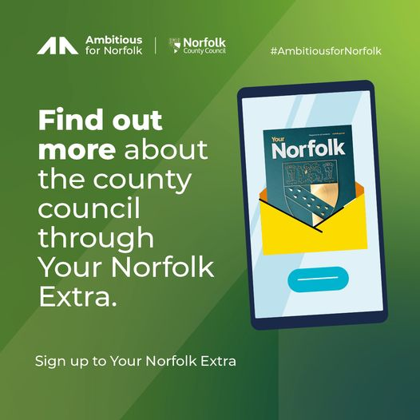
You can find out more about the county council through Your Norfolk Extra. You can register to receive it here: https://orlo.uk/YourNorfolkExtra_AlHMJ
Street lighting: Norfolk County Council is on course to hit its in house carbon emissions savings target by 2030
The project to upgrade street lighting across Norfolk to make it more energy efficient and environmentally friendly has been completed almost a year ahead of schedule. The change will see CO2 emissions on lighting maintained by Norfolk County Council cut by over 200 tonnes a year.
The work which replaced traditional High Intensity Discharge (HID) lighting with the latest generation of LED lanterns, started in August 2023 and involved replacing 16,800 HID lights with 15,531 LEDs. The change will mean that from November 2024 one hundred percent of Norfolk County Council's streetlighting will use low energy LEDs.
"The innovative new lanterns can be controlled by a Central Management System (CMS) which allows the streetlighting to be adapted to changing traffic patterns and need. The CMS also allows remote monitoring which will reduce the need to send inspectors out to monitor the lighting, saving time, money and reducing the carbon emissions of those teams travelling across the county. "
This final phase of the move to low energy LEDs will save an estimated 1,099,032 kWh of energy per year, equating to approximately £380,000 p.a. at the current electricity prices.
Since the first LED streetlights were installed in 2008, an estimate 71 million kWh have been saved, representing a reduction of over 22,200 tonnes in carbon dioxide emissions - equivalent to 6.7 million litres of diesel use.
Norfolk takes the top spot in national highways survey for second year in a row
Norfolk has come first for the second year in a row in the National Highways and Transport survey on roads and transport.
The annual survey showed again that the highest satisfaction among 29 UK counties and authorities was to be found in Norfolk which achieved an overall score of 49 the average overall score amongst our peers this year was 44.
People from across the county gave the highest above average scores in satisfaction with the condition of the highways, local bus services and traffic levels and congestion.
In total Norfolk was at or above the national average across 24 of the 27 Key Benchmark Indicators.
“In these difficult financial times we have to make some tough decisions when it comes to our budgets, we continue to deliver high satisfaction across all areas of this important service and focus our efforts and spending on all things that people tell us are most important to them, which are safe roads that are in good condition.”
Highlights from this year’s survey report include:
- Public transport- Norfolk achieved higher than average on all but 1 of the public transport metrics. This result demonstrates the importance of the improvements being made as part of the bus service improvement plan for the county.
- The provision of electric vehicle charging points– has seen an improvement of 31.3% from last year, increasing in score from 32 to 42. This was identified as a key priority for Norfolk County Council following the introduction of the Electric Vehicle strategy.
- Provision of cycle lanes – we ranked top for satisfaction with the provision of cycle lanes – up from 4th last year. This improvement demonstrated the importance of active travel schemes such as the Heartsease roundabout improvements which completed this year.
- Safety of children cycling to school has increased from coming 7th last year to 1st this year.
- Satisfaction with how we deal with potholes and damaged roads has increased from coming 6th last year to 3rd this year.
Short Journeys
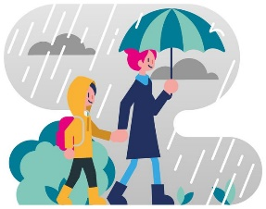
How do you travel for short journeys of 2 miles or less?
We’re running a survey, funded by Active Travel England, to understand how people across the county are making their regular short journeys. Whether you’re driving, walking, cycling, or using public transport, your feedback will help us to understand how people are moving in their local area and support future travel initiatives and campaigns.
The survey will take around 10 minutes to complete – and you could win one of 4 x £100 Love2shop vouchers!
Drinking and health
As we head towards the festive season, Norfolk Public Health is encouraging people to reflect on their drinking habits. Understanding what a unit of alcohol looks like and knowing how to avoid harm can help people make healthier and safer choices.
Health professionals recommend a limit of 14 units of alcohol per week. In Norfolk, although there’s an overall decrease in the average amount people drink, men over 40 remain more likely to drink above this limit.
For example, a single pint of beer is generally 2 units and a medium glass of standard wine (175ml) is just over 2 units, though these can vary with the strength of the drink.
Regularly drinking more than 14 units a week can seriously affect people’s health. Drinking less brings longer-term benefits, such as reducing the risk of developing heart disease, diabetes, stroke, liver damage and certain types of cancer.
Cllr Bill Borrett, Norfolk County Council Cabinet Member for Public Health and Wellbeing said: “With the festive season rapidly approaching, many of us will be getting into party mode - enjoying drinks as we celebrate with friends, family and colleagues. It’s great fun but the units can quickly add up.
“There is no completely safe level of drinking but keeping your weekly intake to under 14 units will lower your risk of alcohol related health issues and bring benefits such as better sleep and weight control, more energy and improved immunity.
“If you’re concerned about your drinking or want to get a better understanding of what 14 units looks like, head to our online tool, Ready to Change. You’ll find step by step guidance to help you monitor your drinking and develop habits for a healthier lifestyle.”
For those who are drinking most days, or regularly drink more than 14 units of alcohol a week, Norfolk County Council commissions DrinkCoach to help residents with managing their drinking. This free service is a great way to discuss your drinking and receive confidential expert guidance from a specialist via up to six online coaching sessions. To find out if you are eligible for the service, take the alcohol quiz here.
It’s easy to lose track of how much alcohol we drink each week – especially as the festive season approaches. Aiming to stick to the recommended 14 units brings great health benefits like better sleep, losing weight and feeling more energetic. Are you Ready to Change? Try our quiz to find out how much you’re drinking.
Winter Health Norfolk County Council commits over £1m to keep people warm this winter
As the nights begin to draw in and temperatures drop, health and care organisations in Norfolk and Waveney are supporting this year’s Warm and Well campaign to help residents during the winter months.
Norfolk and Waveney’s Integrated Care System (ICS) is encouraging residents to ensure their health and wellbeing is ‘winter ready’ by preparing in advance for seasonal illnesses and offering information and advice about how to stay warm and well this winter.
Combined with the ongoing cost of living pressures and the withdrawal of the winter fuel allowance, there is an increased probability that wider health determinants could have a major impact on both Norfolk and Waveney residents’ health and our care system. I strongly urge our residents to use the resources available through our Warm and Well campaign as their health and wellbeing is of paramount importance, particularly during the cold winter months.”
The Warm and Well campaign highlights some essential ways that residents can stay healthy, warm, and well this winter, including:
Getting their flu, COVID-19 and RSV vaccinations as soon as they’re offered them
Keeping themselves well by staying warm, keeping active, and keeping a well-stocked medicine cabinet so they are prepared for common winter illnesses
- Advice for people who look after someone at home and how to set up an emergency carer plan
- Signposting people to financial support that is available such as the Household Support Fund, and providing tips on how to make homes more energy efficient
Raising awareness of pension credit - people over state pension age and on a low income could be eligible for pension credit to help with living costs. Find out more at gov.uk/pension-credit or call 0800 99 1234
Encouraging use of the range of NHS services available across Norfolk and Waveney, including the NHS 111 service, community pharmacies, Walk-in Centre in Norwich and Minor Injuries Unit in Cromer
- Supporting people to look after their wellbeing and mental health.
This year there is a particular focus on vaccinations and for the first time, the NHS is rolling out RSV vaccine, respiratory syncytial virus, to people aged 75 to 79 and people who are at least 28 weeks pregnant.
Winter comes to us every year, but that doesn’t mean we have to suffer every year too. This year we are offering flu, COVID-19 and RSV vaccines to prevent vulnerable people from getting ill with horrible winter bugs. Please do take up these free jabs if you are offered them – it’s the best way to keep yourself well and ‘winter strong’.
“And remember, even if you got your vaccines last year, you still need to get this year’s doses as viruses change and protection fades over time.”
To access support and further information, visit www.winterwellnorfolkwaveney.co.uk.
Norfolk Gritting Maps
Norfolk Gritting Map
Giving Tree brings festive joy to children in care
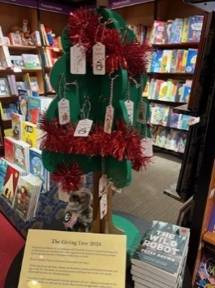
Norfolk County Council is delighted to announce the return of the Giving Tree appeal, a cherished Christmas initiative designed to bring joy to the county’s children in care.
The Giving Tree, located at the Castle Street Waterstones in Norwich, is decorated with hundreds of tags, each representing a child and the book they wish to receive for Christmas. This heart warming project has been a favourite among customers, with over 1,000 books purchased last year alone.
Customers are invited to select a tag from the tree, which includes brief details about a child and their desired book or genre. After purchasing the book, customers can take it to the till, where it will be collected by Norfolk County Council, wrapped, and delivered in time for Christmas.
The children will then receive the books on Christmas Day as a reminder that people in the county are thinking of them.
The Giving Tree is an initiative of the Norfolk Virtual School, which oversees the education of all children in care in Norfolk. The Giving Tree aims to support reading and learning by giving children in care improved access to books.
Ben Richardson, Manager of the Waterstones branch, said: "We are always really happy to have the Giving Tree in store because our customers really love it, and we want to help to support the county's looked after children.
"In the run up to autumn we have people coming into the store to ask us when the tree will be up, and customers find it really rewarding supporting the project. People particularly like that they are able to pick out a book for an individual child and know that they will be opening it on Christmas Day.”
The tree is in store now and books need to be bought by Sunday 1 December, to be wrapped and distributed to reach children in time for Christmas.
Plant trees

Are you passionate about preserving our beautiful county and creating a more sustainable future? The Busseys Community Tree Grant is now open, offering up to £2,500 for tree planting projects that benefit our community.
Deadline for applications: Tuesday 31 December 2024.
For more information on how to apply, visit https://orlo.uk/dJgXx
NCC trees
Norfolk County Council has launched projects for the new tree planting season which starts in November.
The One Million Trees for Norfolk subsidised tree scheme is now open for individuals, parish councils, community groups, businesses, schools, and landowners to apply for tree packs (and tree protection) at up to 50% off the original price.
As well as the usual range of tree packs available, this year, for the first time there are a limited number of single Norfolk Oak trees, grown at Gressenhall Community tree nursery, making it possible for more people to take part and be 'one in a million'.
Those interested can apply for subsidised tree pack here.

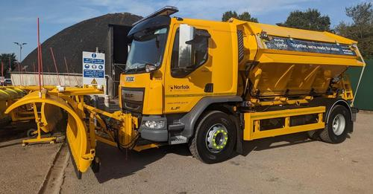
#NorfolkWinter is just around the corner, and while we’re not quite at the woolly jumper stage yet, our team is already gearing up to keep Norfolk's roads safe!
This year, we’re rolling out the most advanced gritting operation Norfolk has ever seen, with brand new gritters equipped with cutting edge technology. Our fleet of 58 gritters is now fitted with amazing auto-salting technology that will make road treatments faster, more accurate, and reduce waste by up to 15%!!
With new satellite navigation and upgraded weather stations across the county, we’re better prepared than ever to handle snow, ice, and whatever winter throws our way!
Keep an eye out for Gritty McGritter Face, The Grittenator, and the one and only Chittygrittybangbang doing their rounds! they’ll be working hard to keep you safe…. And we will of course keep you updated throughout the season via Facebook by letting you know when gritting is scheduled and offering tips and advice on travelling through winter.
Lithium batteries
Buying and disposing of
SCAMS
Scam Alert - Emails claiming 'Suspicious Virus Detected'
Cold Calling Alert - Telephone cold callers regarding solar panels
Scam Alert - Buying and selling on Facebook Marketplace
Scam Alert - Investment scams and fake cryptocurrency exchanges
Scam Alert - Emails claiming to be from 'Netflix'
Scam Alert - Text messages claiming to relate to 'UK Government Winter Heating Subsidy Office Benefit Payment Notice'
Rogue Trader Alert - Doorstep cold callers offering tree cutting and garden work
Scam Alert - Emails claiming to be from 'Tesco'
Cold Calling Alert - Telephone cold calls regarding 'loft insulation'
Scam Alert - Facebook posts claiming to offer 6 months free bus travel
Scam Alert - Automated telephone cold calls claiming to be from HMRC
Rogue Trader Alert - Doorstep cold callers claiming issues with properties' roofs
Scam Alert - Fake DVLA emails
Rogue Trader Alert - Doorstep cold callers offering to cut trees and hedges

